**Sportspot Project, Report**

**Database Systems**

**12th December 2025**

**By: Rami Mazaoui, Yasmine Espachs Bouamoud, Rabab Saadeddine**



**Overview**

SportSpot is a **sports field booking platform** built with React (frontend), Node.js/Express (backend), and MySQL (database), ssssThe system allows admins to manage the platform, field owners to view and manage their fields, and customers to browse, book and rate fields.

**System Architecture**

**Core Tables (10):**

**Primary Entities:**

**Users- Central authentication and user management**

**FieldOwners- Business profiles for field owners**

**SportFields - Sports facility records**

**Bookings - Reservation transactionsss**

**Payments - Financial transactions**

**Reviews - User feedback system**

**Supporting Entities:**

**UserWallets - Digital wallet system**

**WalletTransactions - Wallet transaction log**

**PaymentMethods - Supported payment channels**

**Refunds - Refund request management**

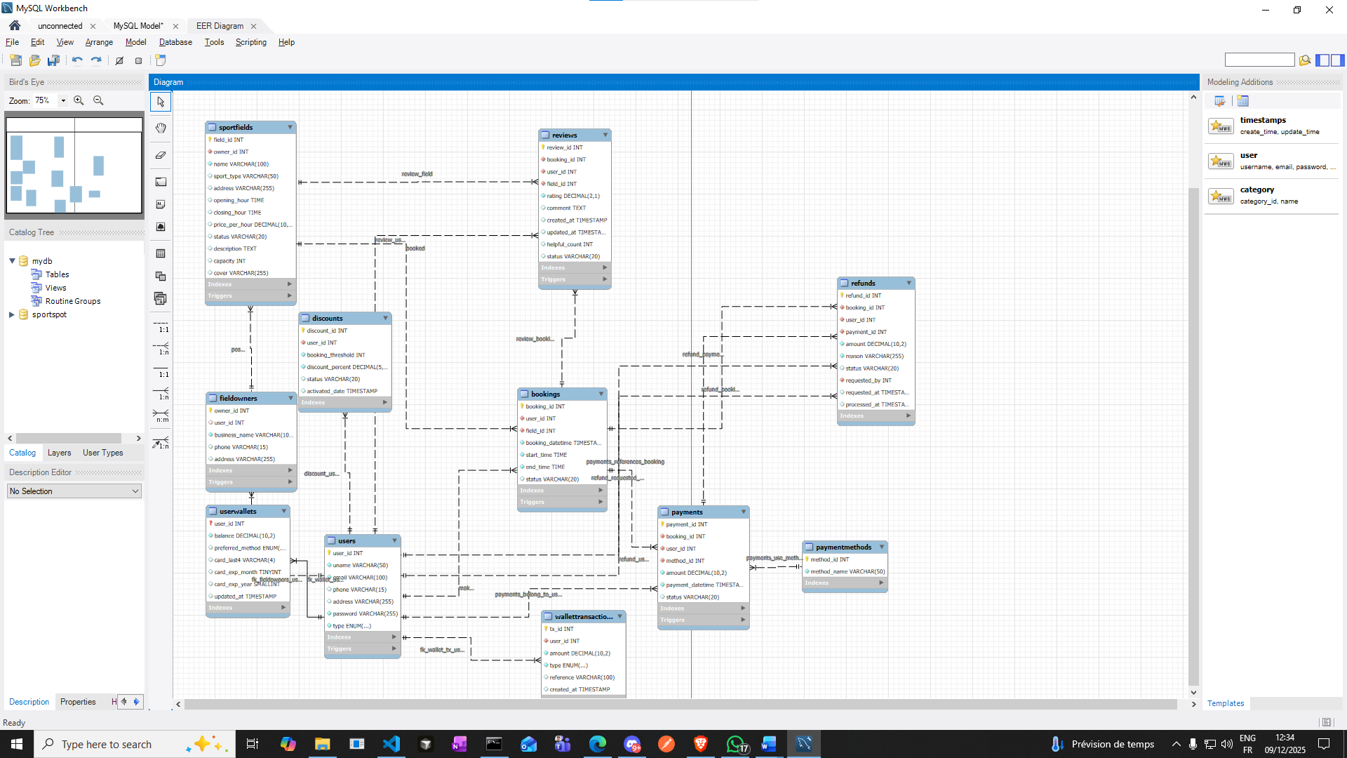

**# User Roles & Permissions**

**Admins: Can create fields on behalf of owners; full CRUD(create, read, update, delete) on fields, users, bookings, payments, and refunds; manage discounts and maintenance windows; view reports.  
  
Field Owners: Create fields, Manage assigned fields; view and respond to bookings; track revenue and payouts; view reviews for their fields.  
  
Customers: Browse and search fields; book and manage reservations; pay via card, PayPal, or wallet; request refunds; submit and edit reviews (one per booking) via MyReviews.**

**Technical Stack**

**Frontend (React 18)**

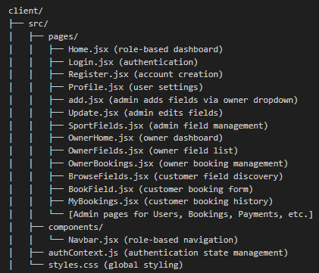

(Structure of files with purpose)

**Backend (Node.js/Express)**

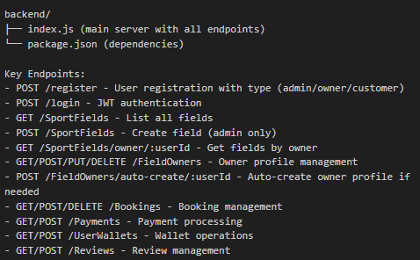

**Key Features**

**🛡️ Authentication & Authorization:  
JWT-based authentication with bcrypt hashing, RBAC-backed protected routes, and an AuthContext for session state.  
  
📍 Field Management:  
Admin-created fields for owners; owners can create fields, manage availability, pricing, status, and cover images; maintenance windows block booking.  
  
📆 Booking System:  
Overlap protection, operating-hour validation, a full status lifecycle (pending, confirmed, cancelled, completed), and automatic payment linkages.  
  
💳 Payments & Wallet:  
Supports Visa, Mastercard, PayPal, and wallet payments; validates wallet balance; provides transaction history and a refund workflow with an audit trail.  
  
⭐ Review System:  
One review per booking using an upsert pattern; default status is published; rating bounds enforced; MyReviews page for customers; reviews visible to owners.  
  
📊 Analytics & Automation:  
Performance and spending views; enforcement triggers; stored procedures for availability search, payment processing, cancellation, and booking history.**

## **Challenges and Solutions**

**Challenges included trying to cover all possible problems by analyzing the user’s journey from start to end. We picked time slot conflict detection, payment integrity, maintaining normalization, and implementing business automation rules. All were solved using constraints, triggers, and stored procedures.**

**We could not implement all the triggers in the application due to time constraint, but our team is constantly working on it and will be done before the presentation occurs.**

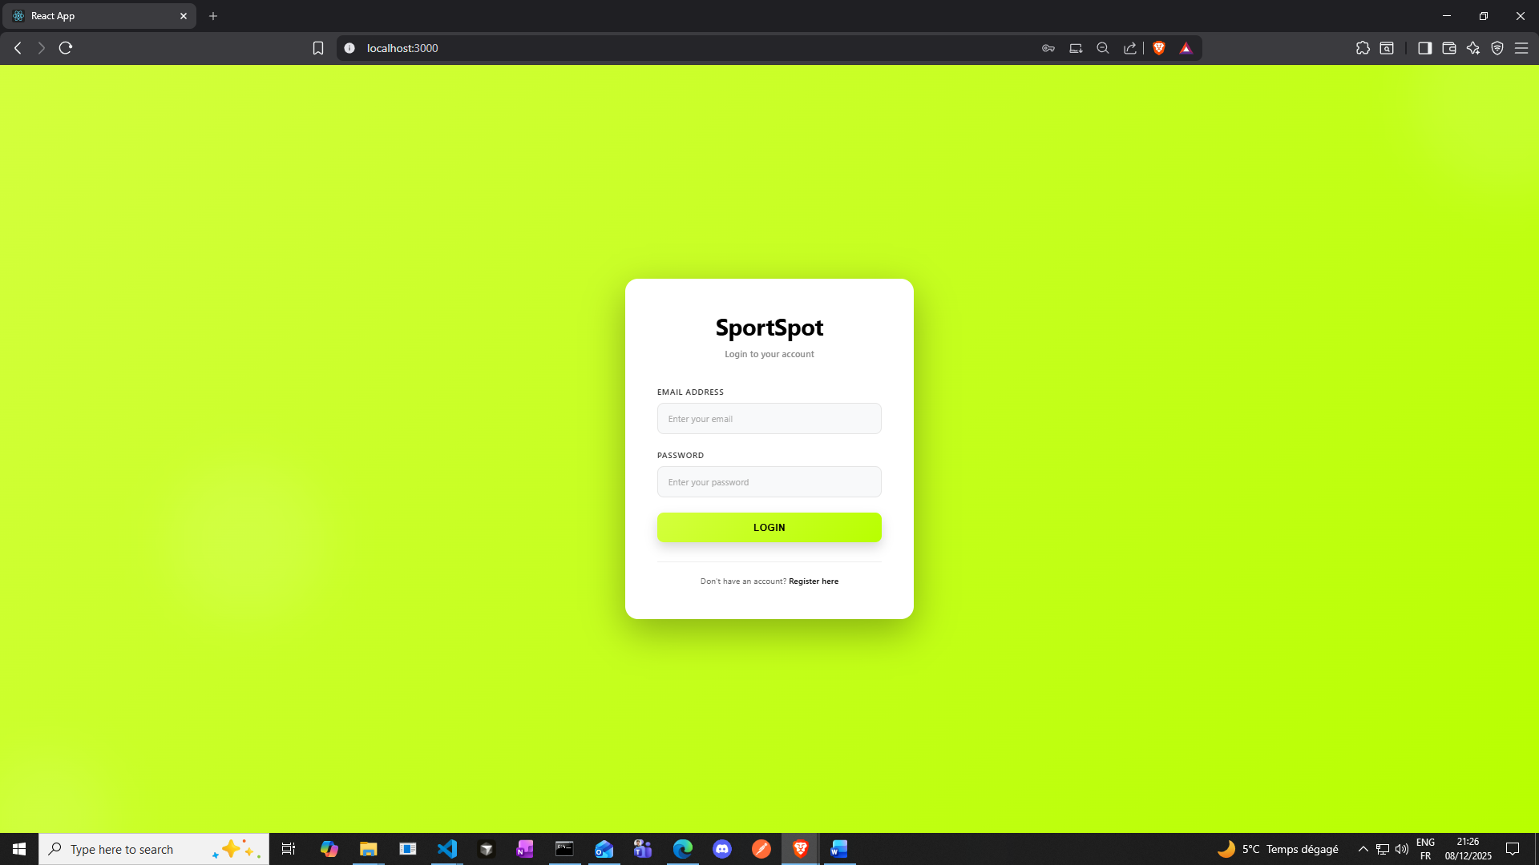

**Test Scenario 1: Admin Setup**

**Step 1: Register as Admin**

* **Go to**[**http://localhost:3000/register**](vscode-file://vscode-app/c:/Users/seqon/AppData/Local/Programs/Microsoft%20VS%20Code/resources/app/out/vs/code/electron-browser/workbench/workbench.html)
* **Fullname: Rami Rami**
* **Phone number : 0611121314**
* **Email: ramirami@aui.ma**
* **Address : headquarters admin**
* **Password: 123456789**
* **User Type: Customer ( we’ll assign admin to him with sql query)**

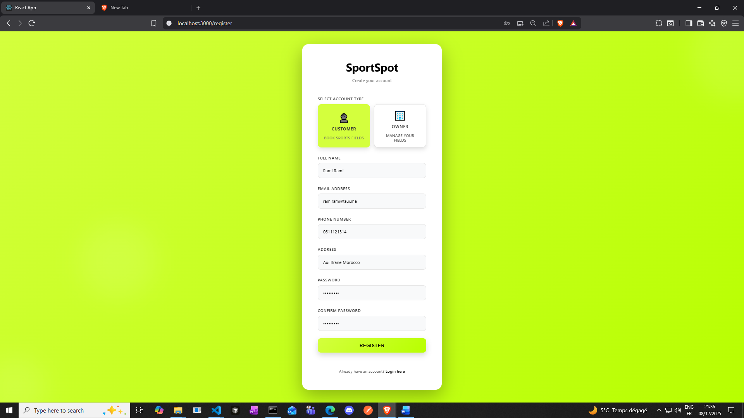

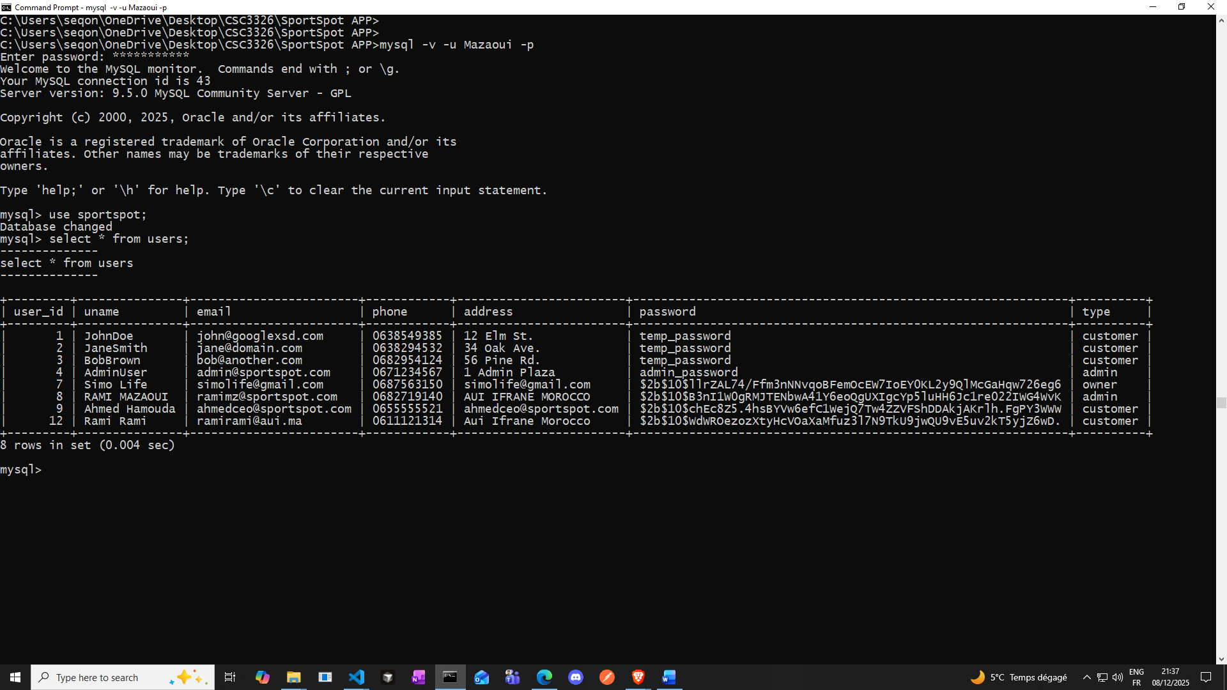

**(added in the database)**

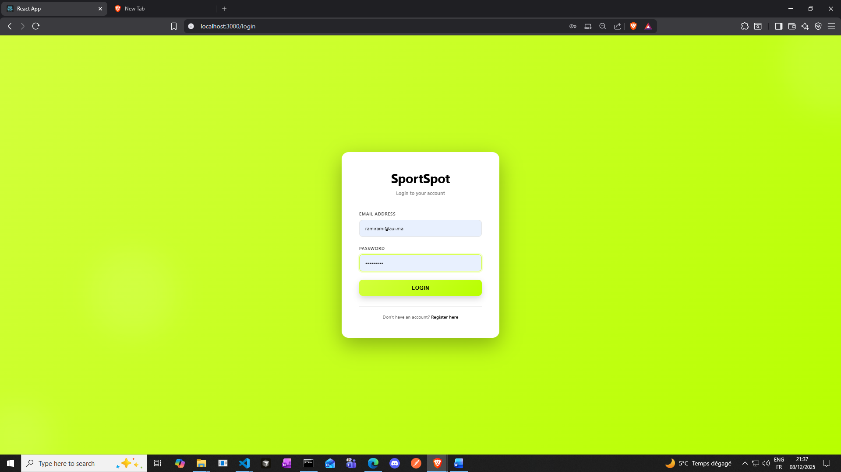

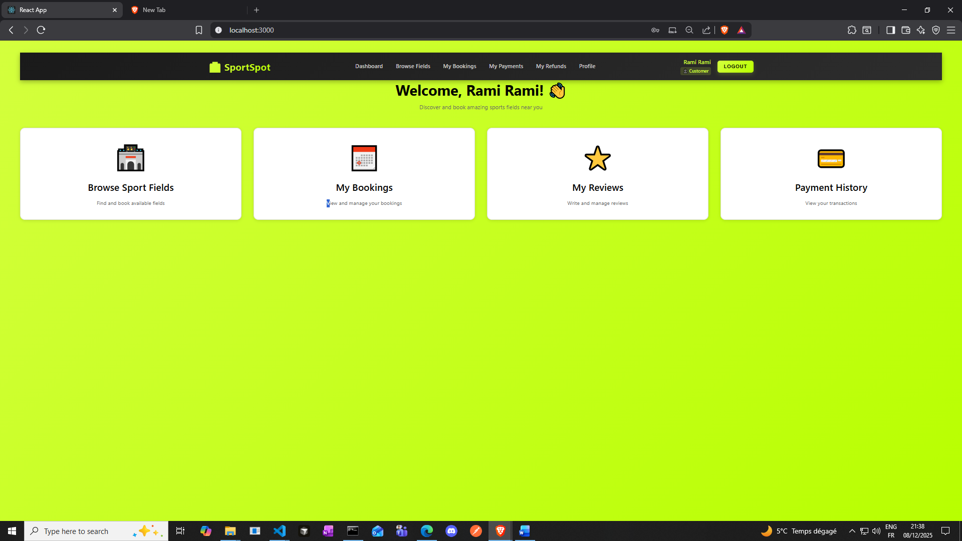

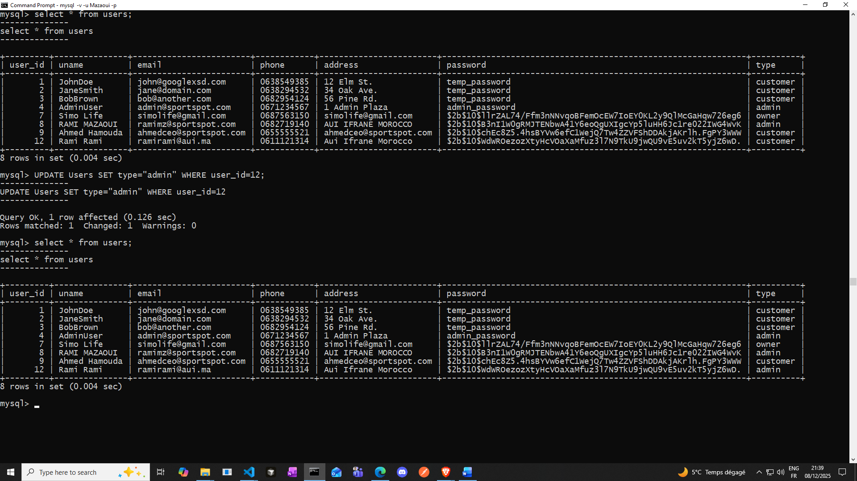

**Changed the role to admin**

**Step 2: Login as Admin**

* **Go to**[**http://localhost:3000/login**](vscode-file://vscode-app/c:/Users/seqon/AppData/Local/Programs/Microsoft%20VS%20Code/resources/app/out/vs/code/electron-browser/workbench/workbench.html)
* **Login with admin credentials**

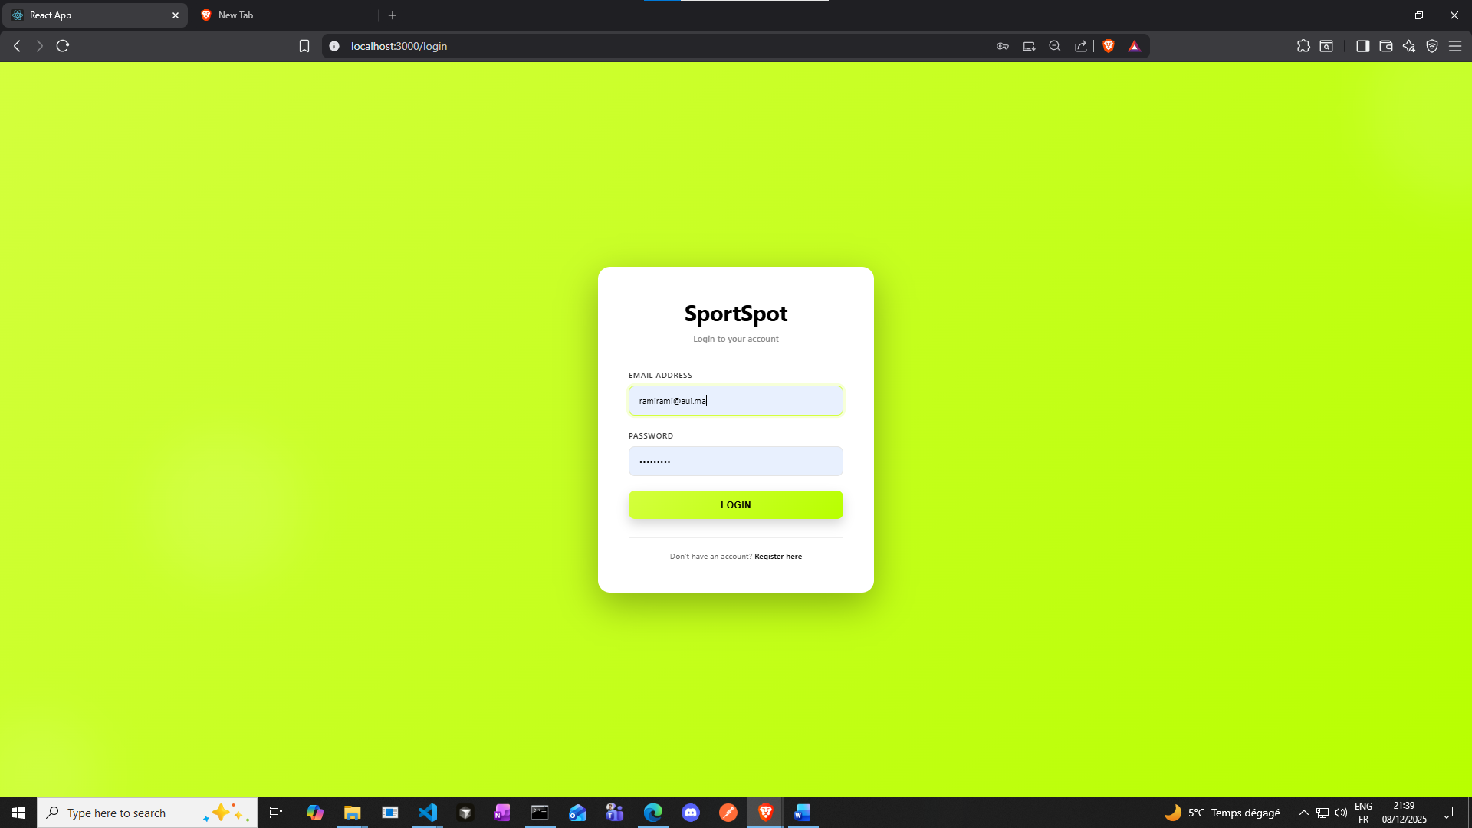

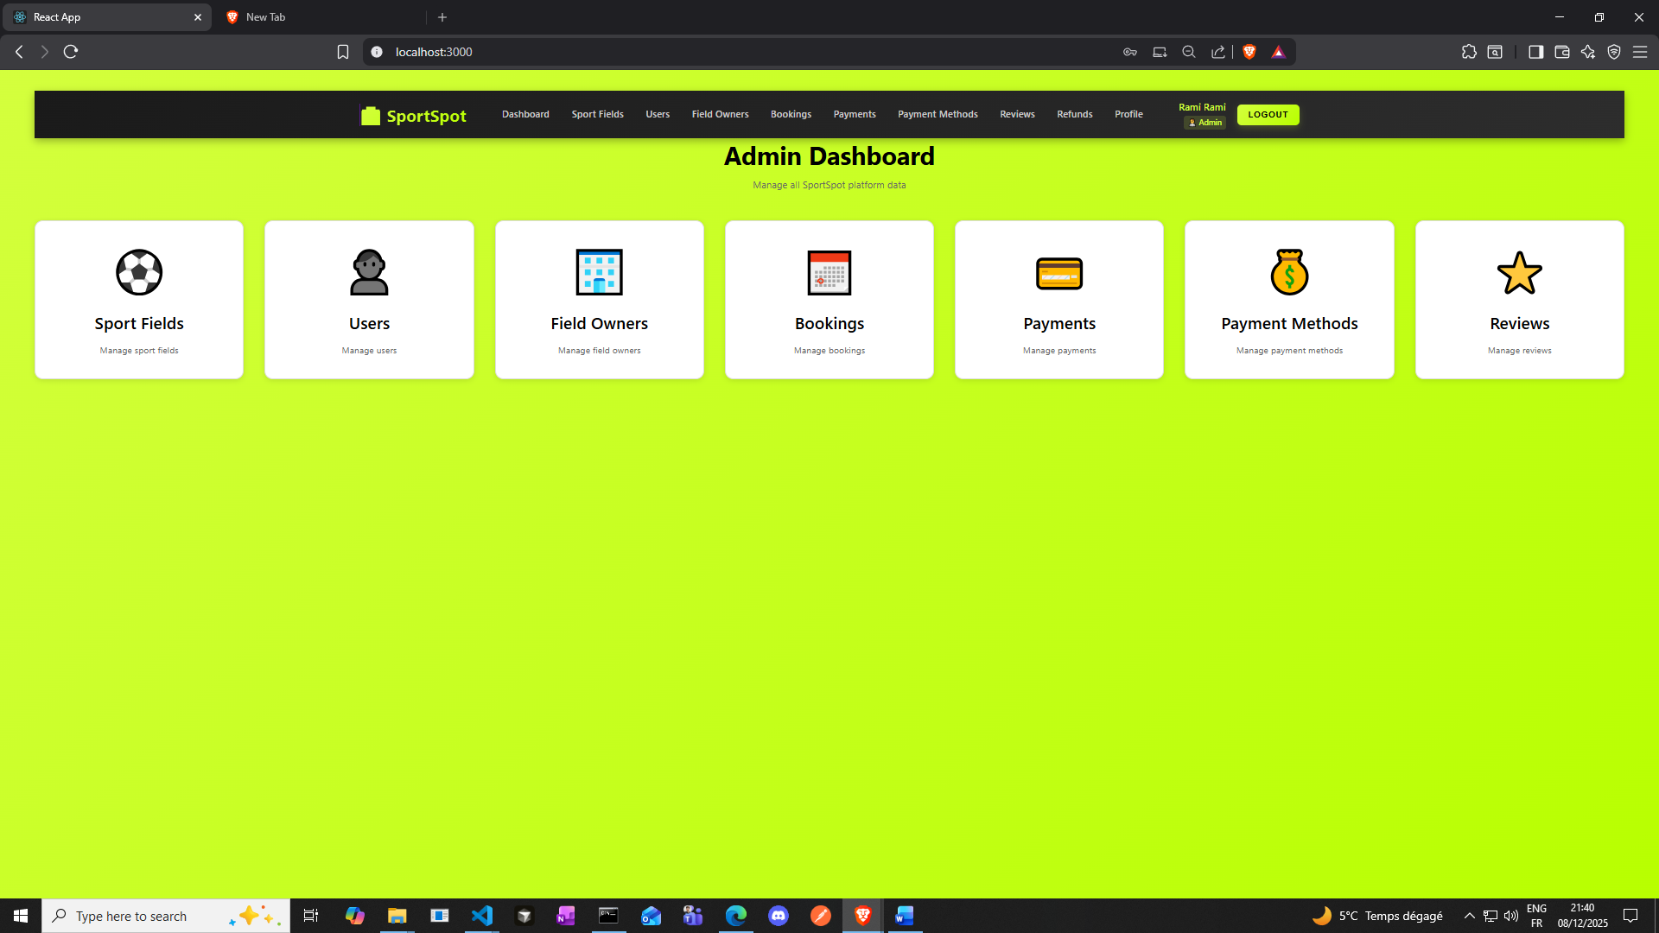

**Next Step: Create Field Owner (Go to Field Owners page)**

* **Click "Field Owners" in navbar**
* **Click "Add Field Owner" button**
* **Fill form:**
  + **Business Name: "Premium Tennis Courts"**
  + **Phone: 05550123**
  + **Address: 123 Tennis Lane, Sports City**

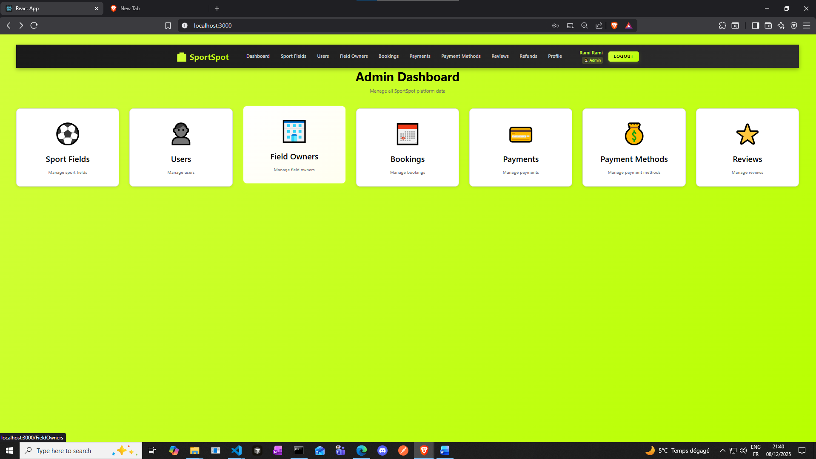

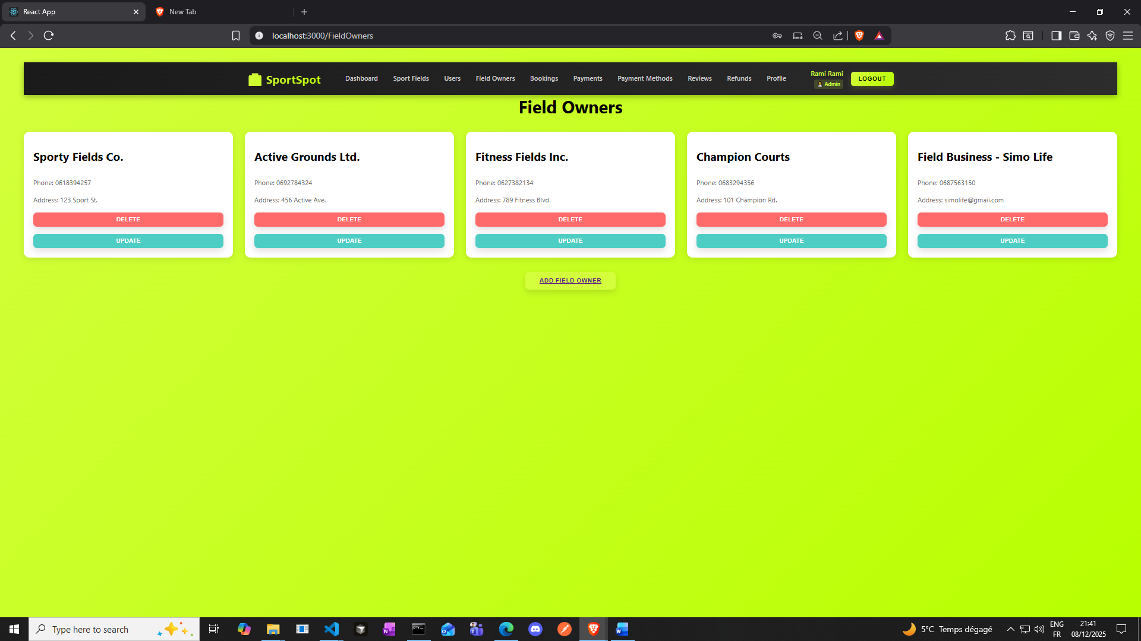

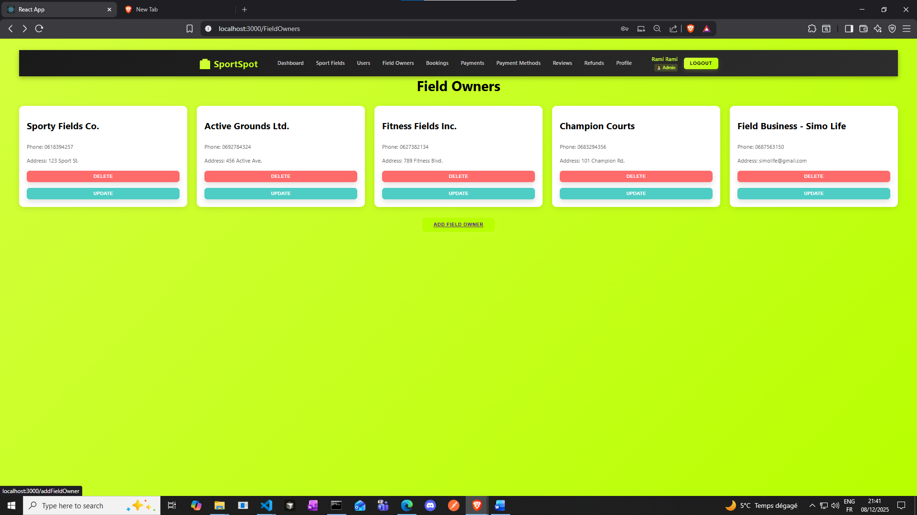

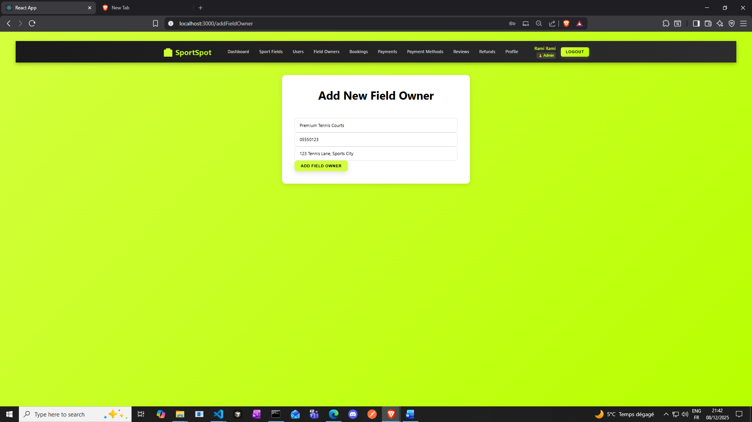

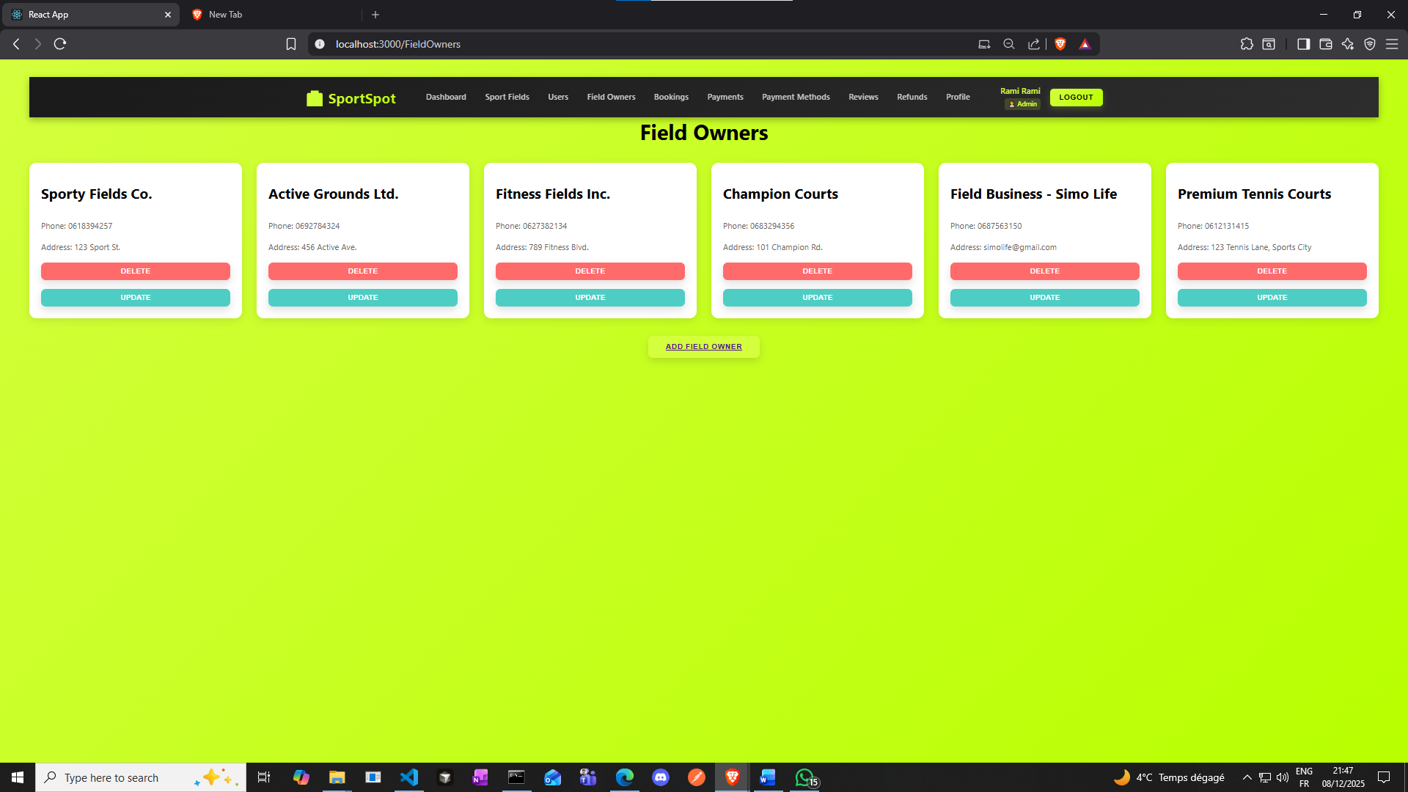

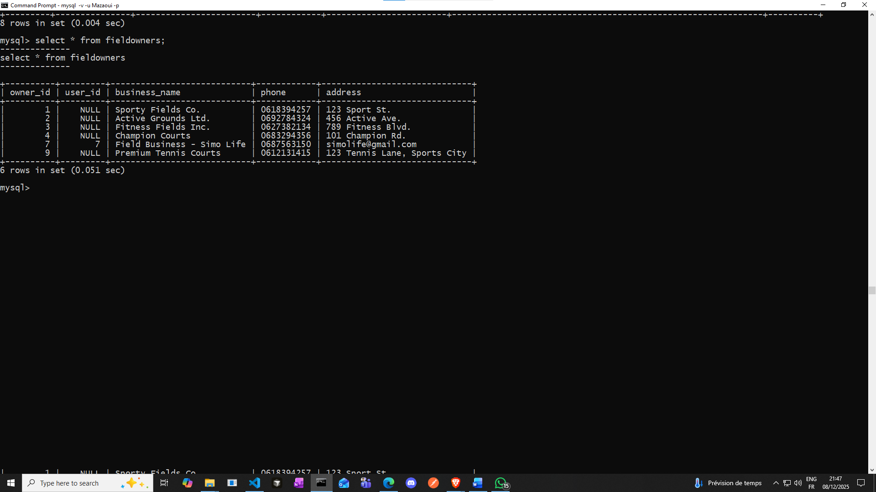

**Fieldowners user_id could be null if these were added by an admin and not an actual user account of type owner on the app.**

**Next Step**

**: Add Sport Field (Go to Sport Fields page)**

* **Click "Sport Fields" in navbar**
* **Click "Add Sport Field" button**
* **Fill form:**
  + **Select Owner: "Premium Tennis Courts" (from dropdown)**
  + **Field Name: "Court A - Professional"**
  + **Sport Type: "Tennis"**
  + **Address: 123 Tennis Lane, Sports City**
  + **Opening Hour: 06:00**
  + **Closing Hour: 22:00**
  + **Price per Hour: $50.00**
  + **Status: Available**
  + **Capacity: 4**
  + **Description: "Professional tennis court with lighting"**

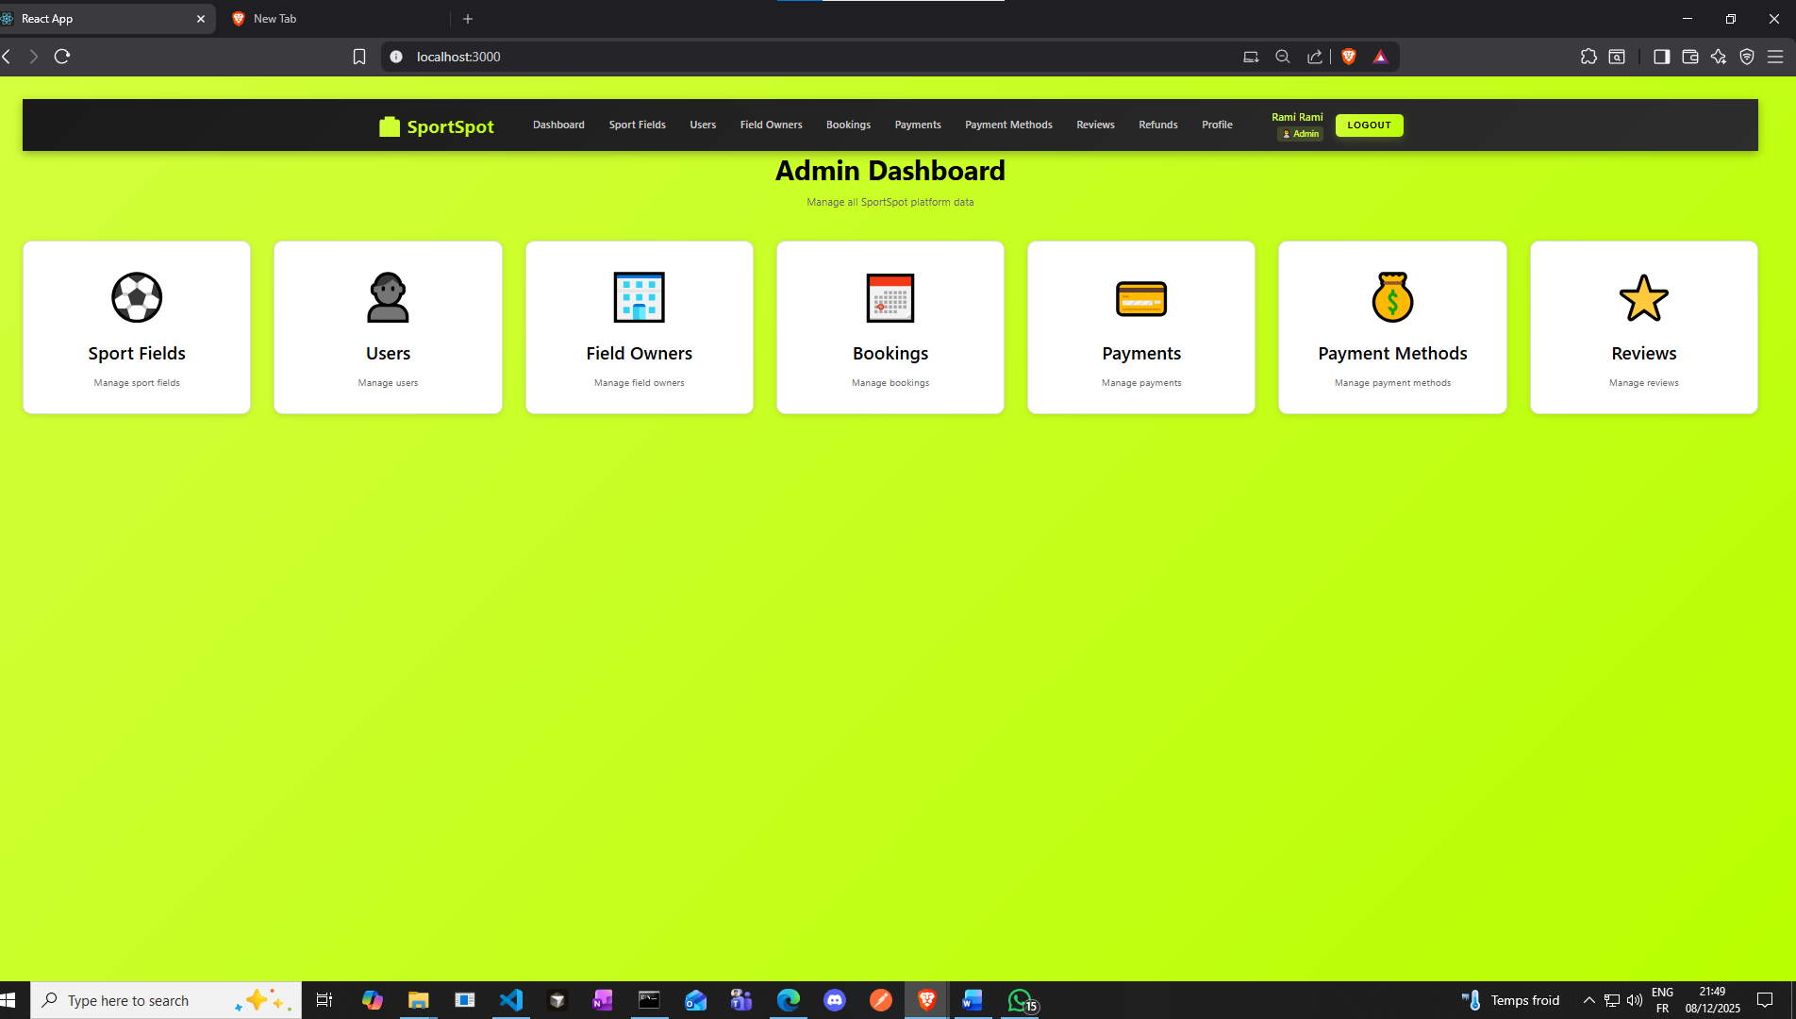

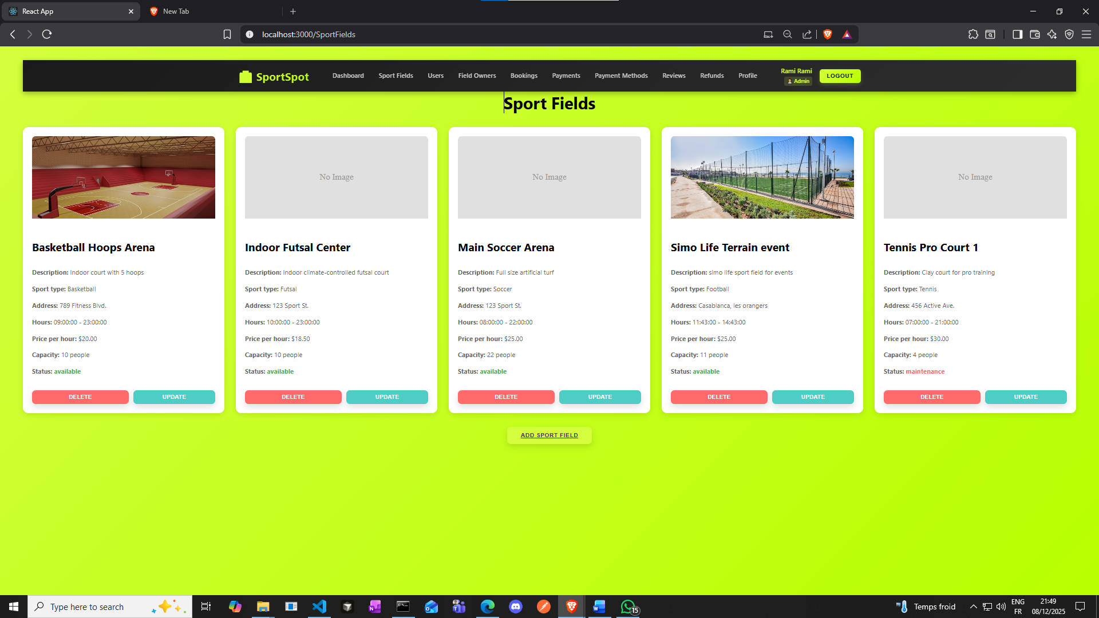

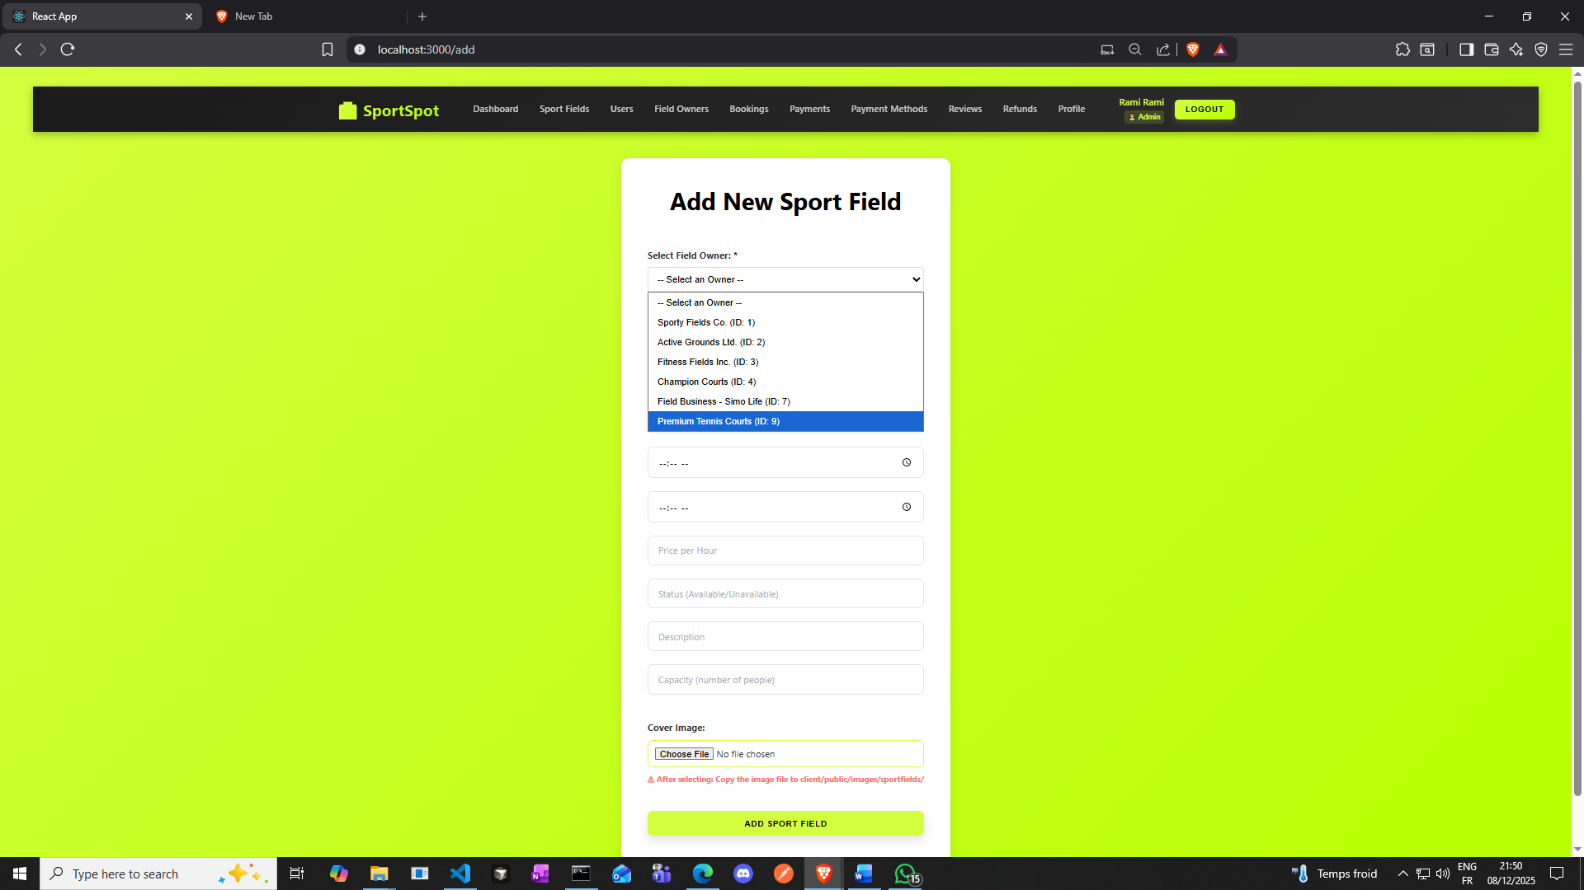

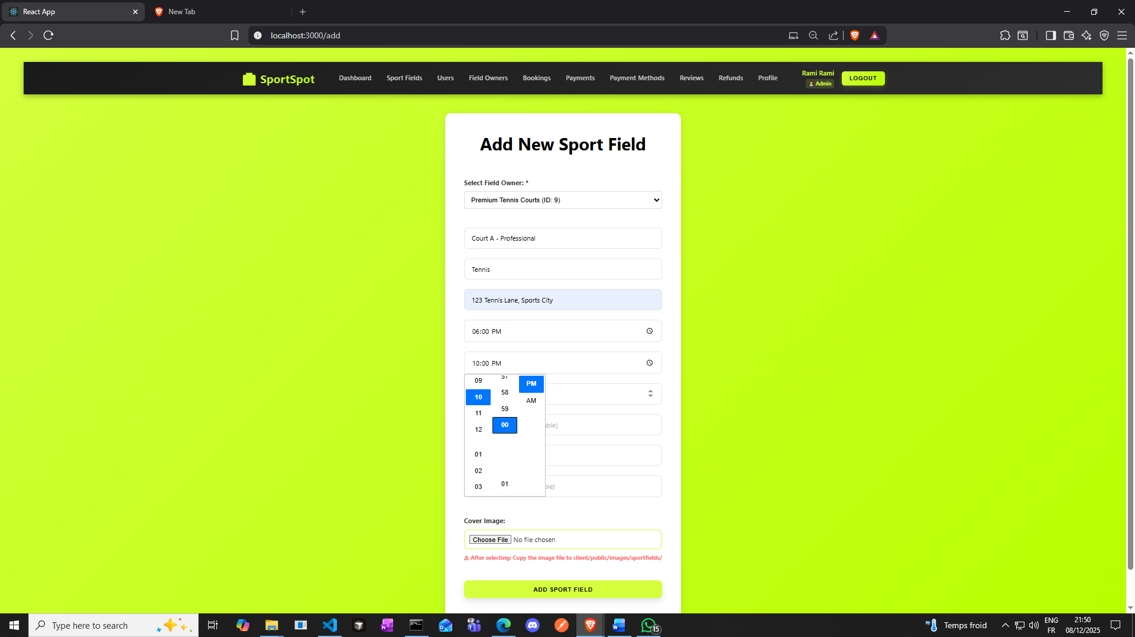

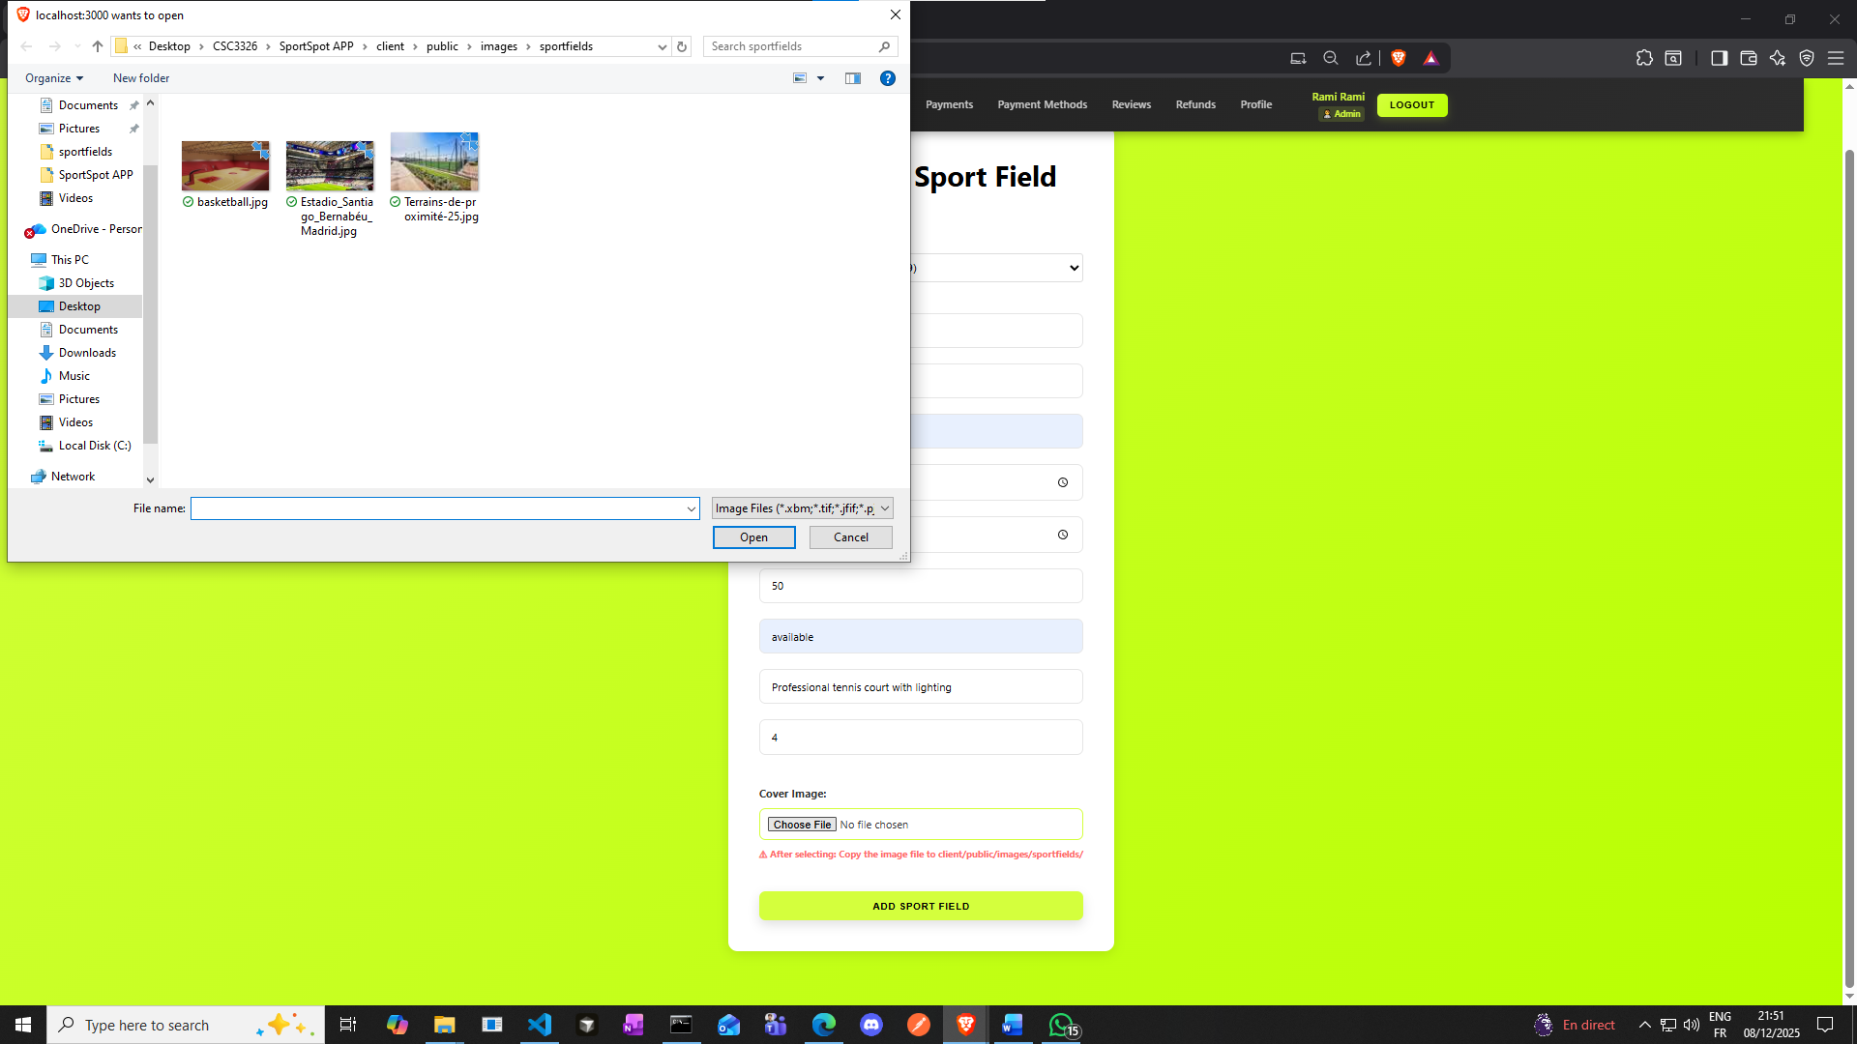

**Add a pic from client/public/images/sportfields**

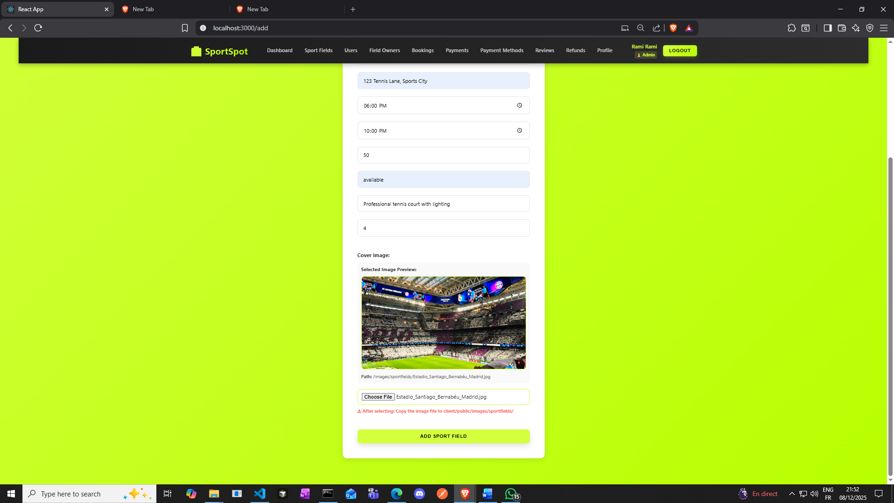

**Click on the button add sport field**

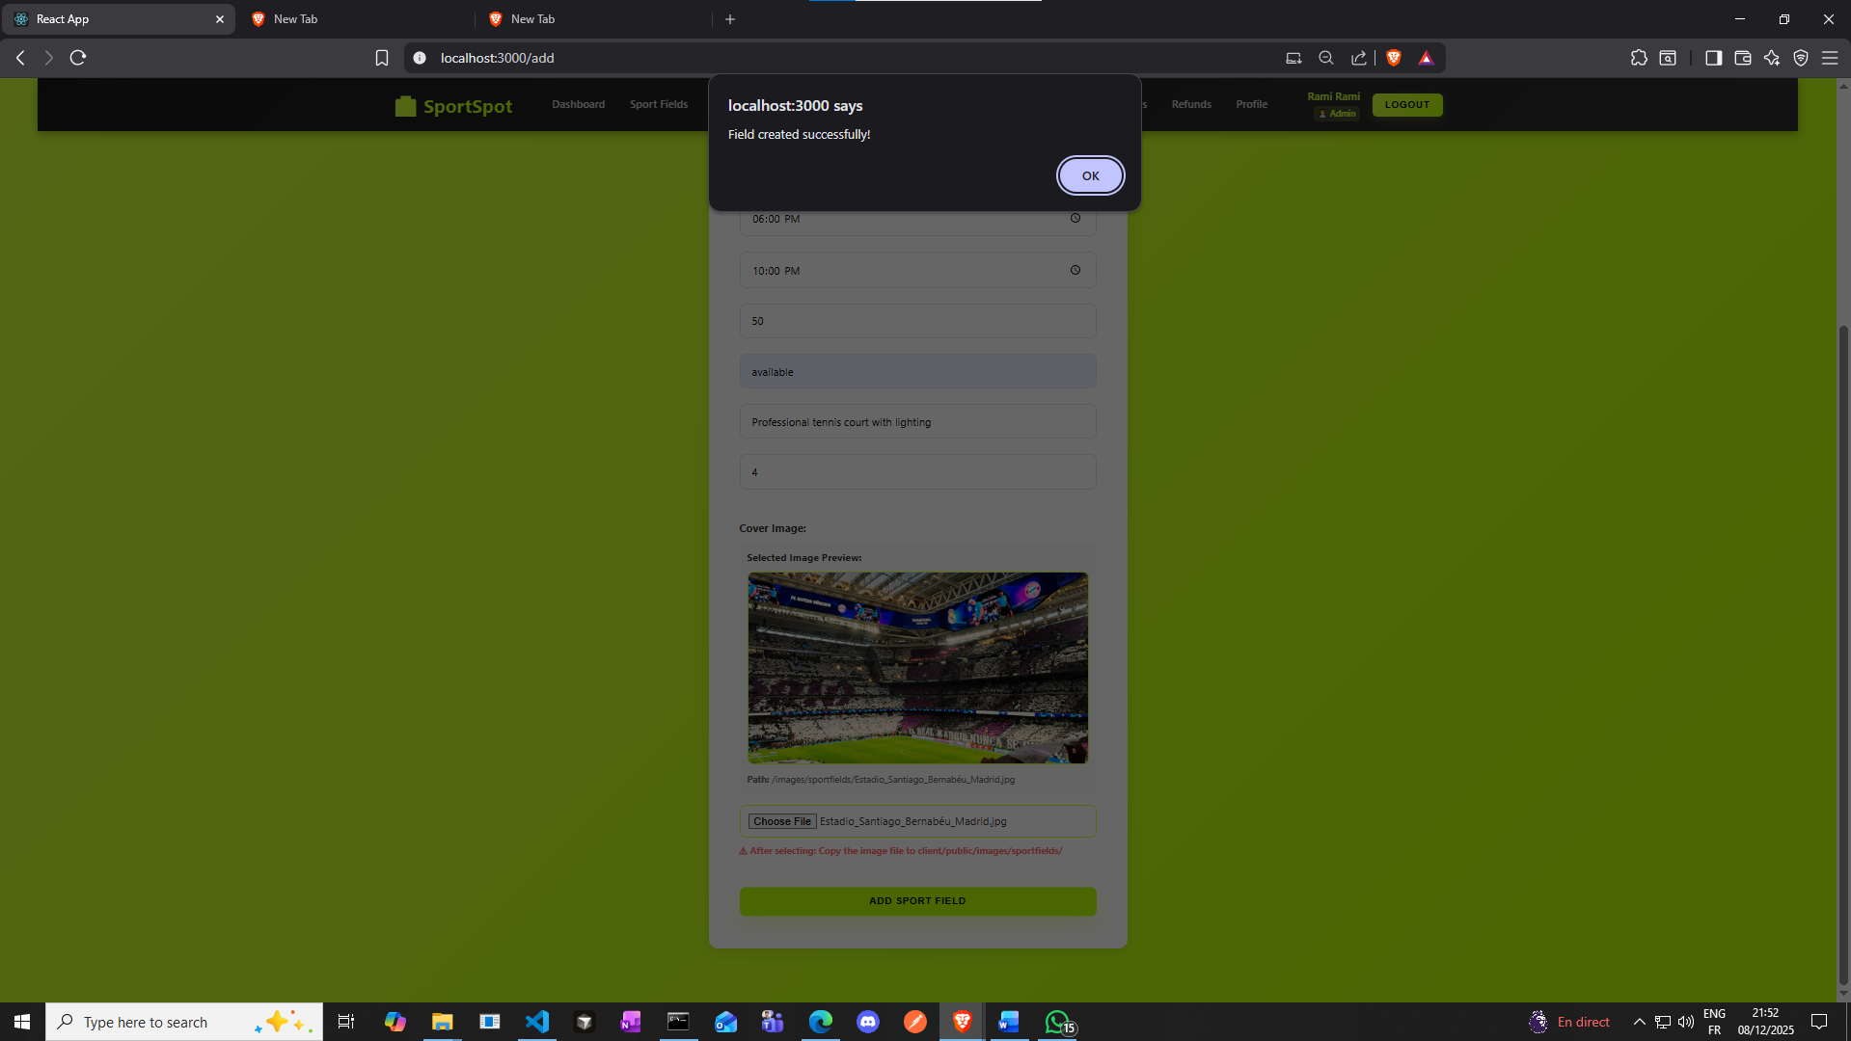

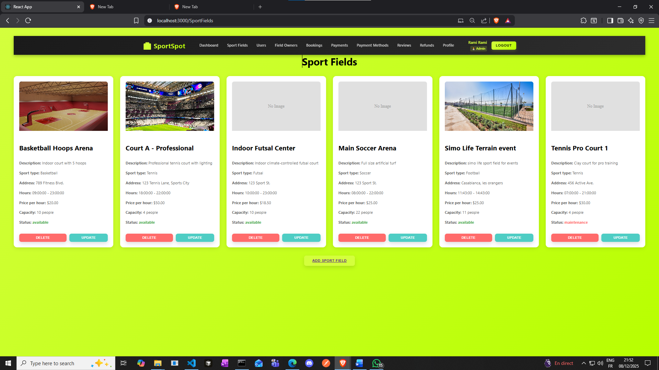

**And here is it added**

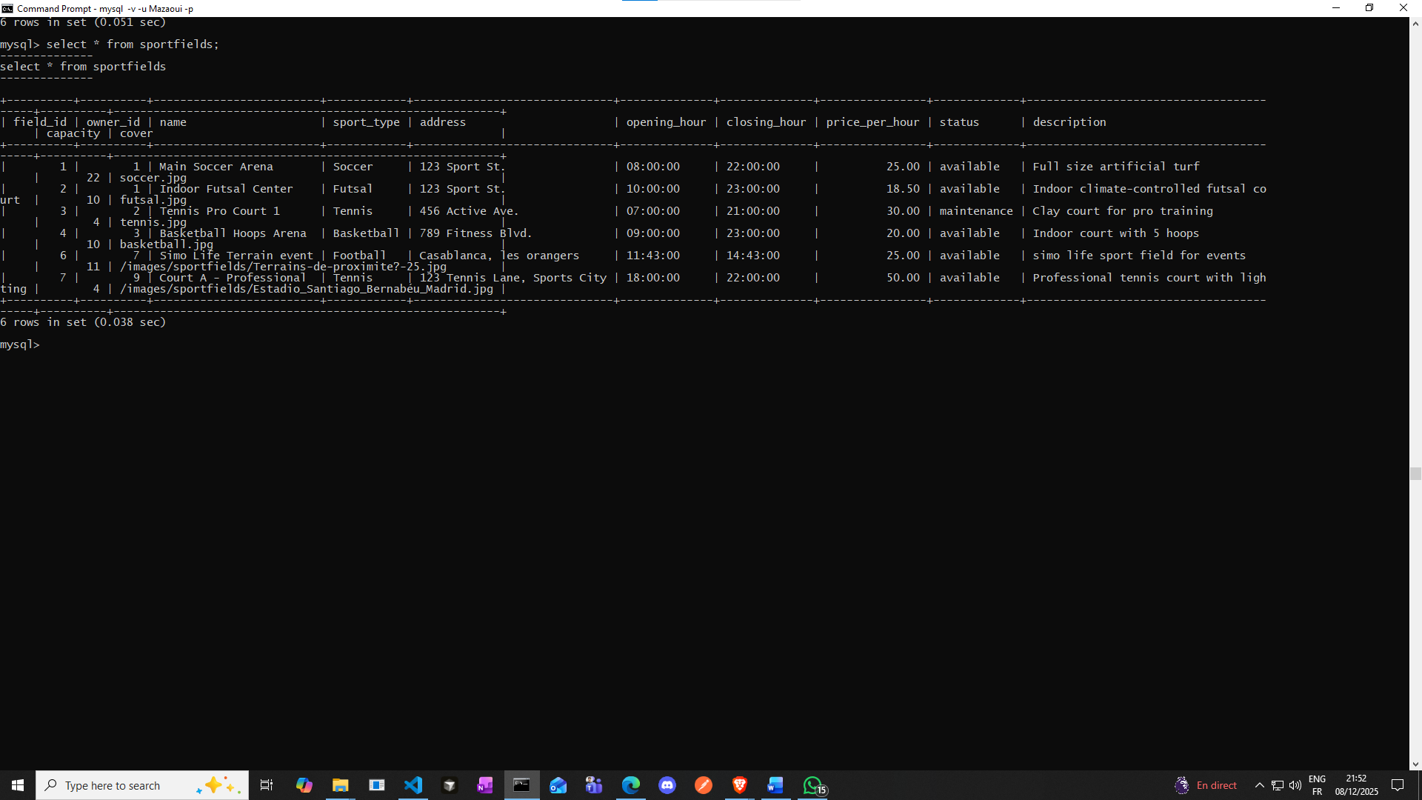

**Owner Dashboard**

**Next Step : Make an account and Login as an Owner**

* **Go to**[**http://localhost:3000/login**](vscode-file://vscode-app/c:/Users/seqon/AppData/Local/Programs/Microsoft%20VS%20Code/resources/app/out/vs/code/electron-browser/workbench/workbench.html)
* **Login with owner credentials**
* 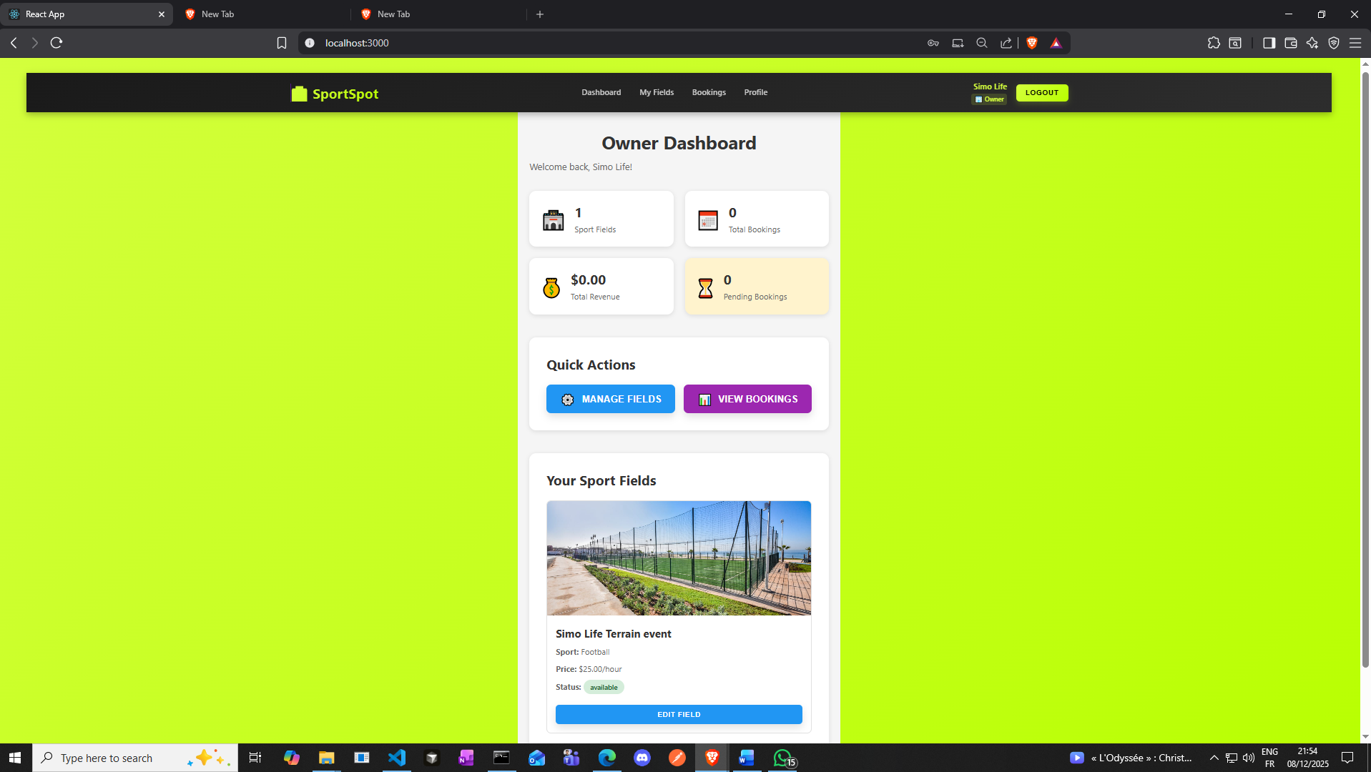

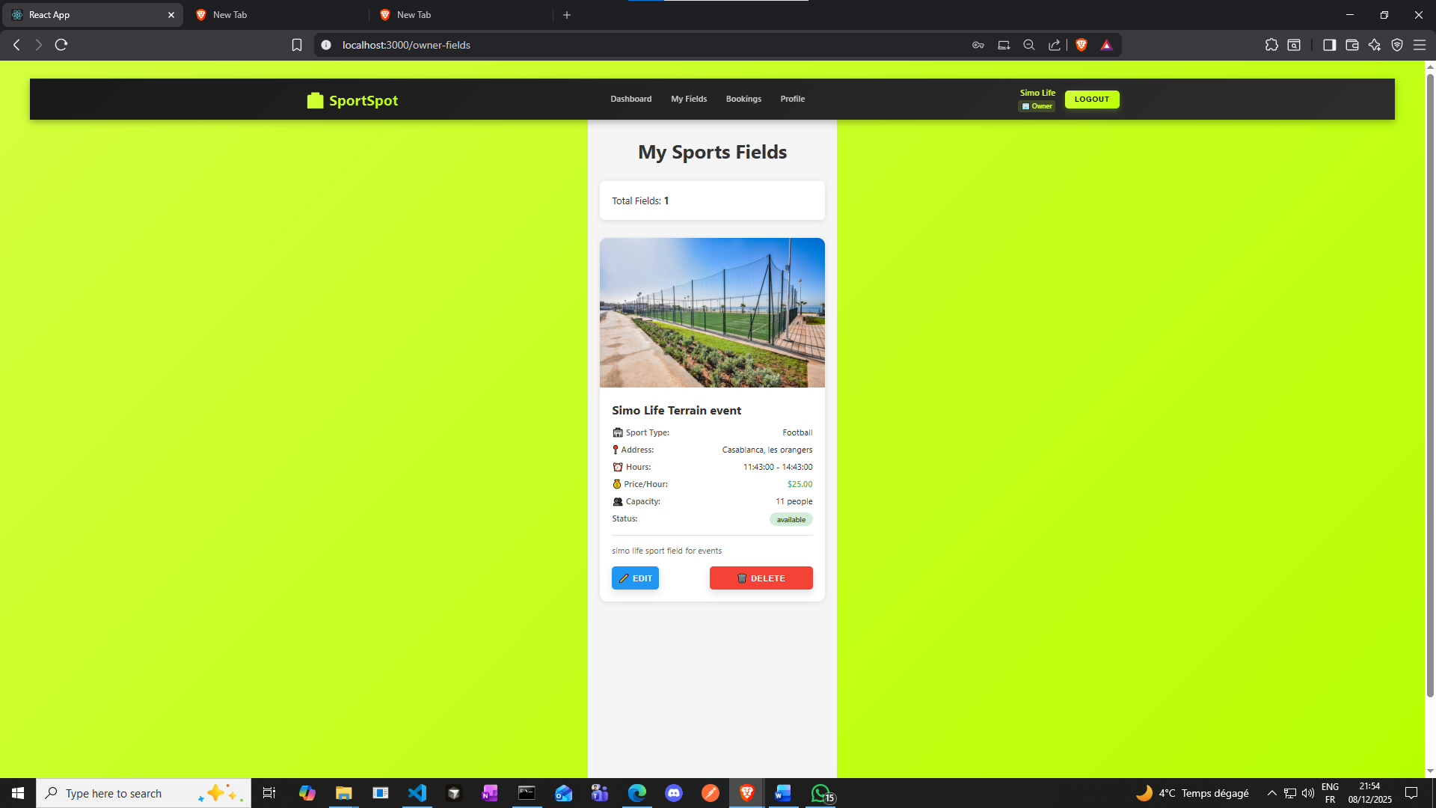

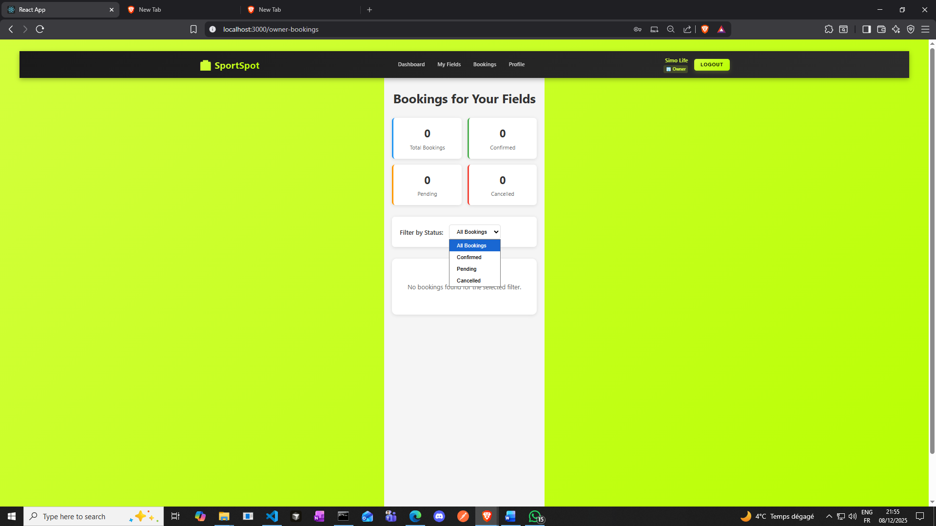

**Customer Dashboard**

**Next Step : Register and login as Customer**

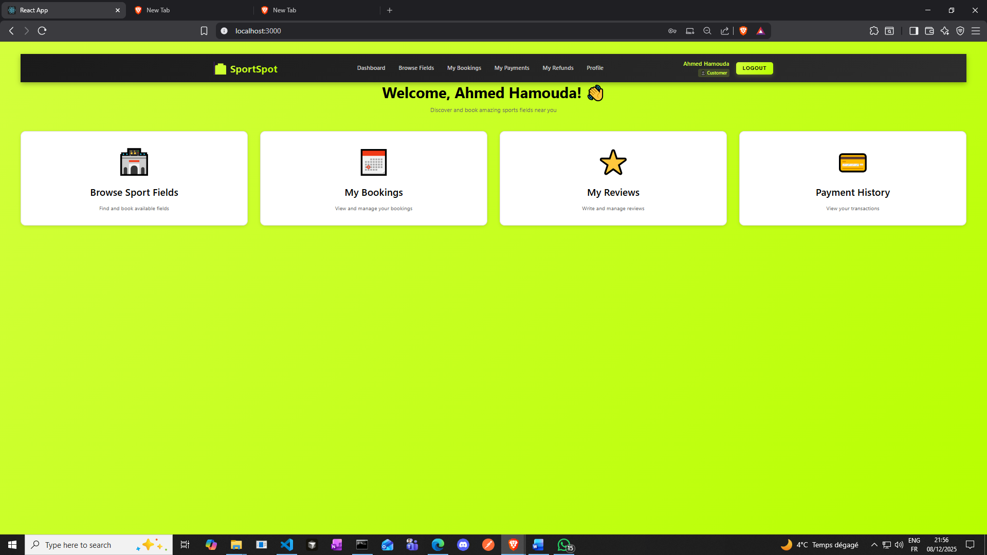 **Browse Fields**

* **Click "Browse Fields" in navbar**
* 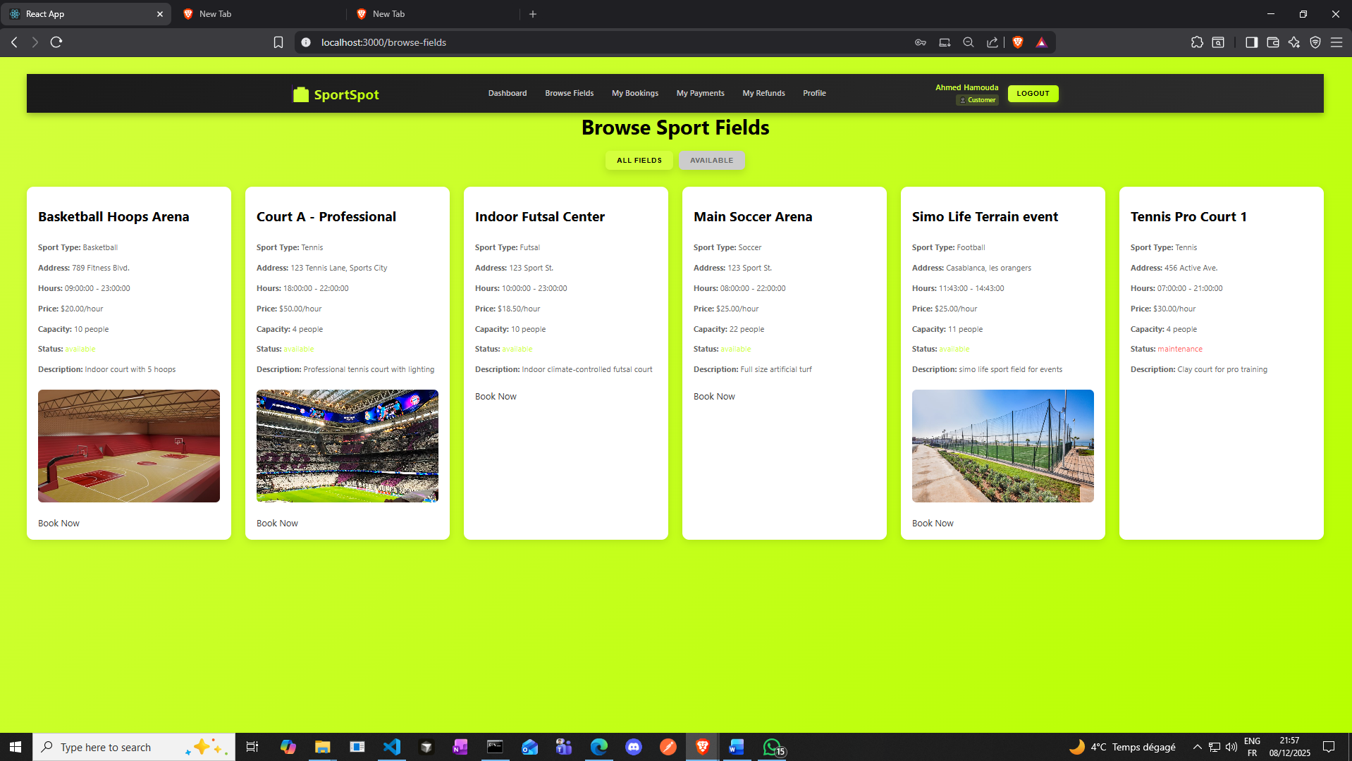

**Book a Field**

* **Click on "Court A - Professional"**

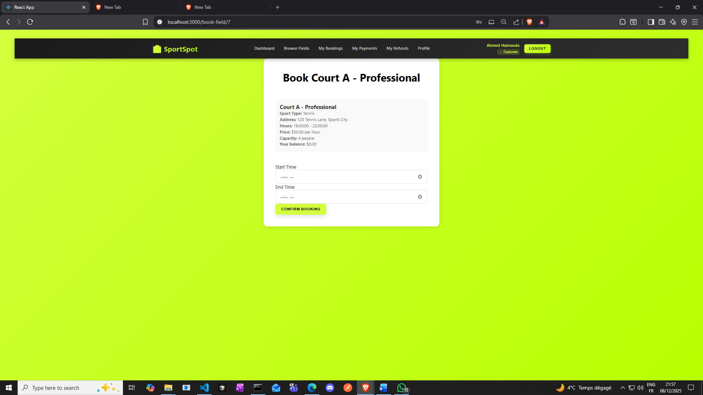

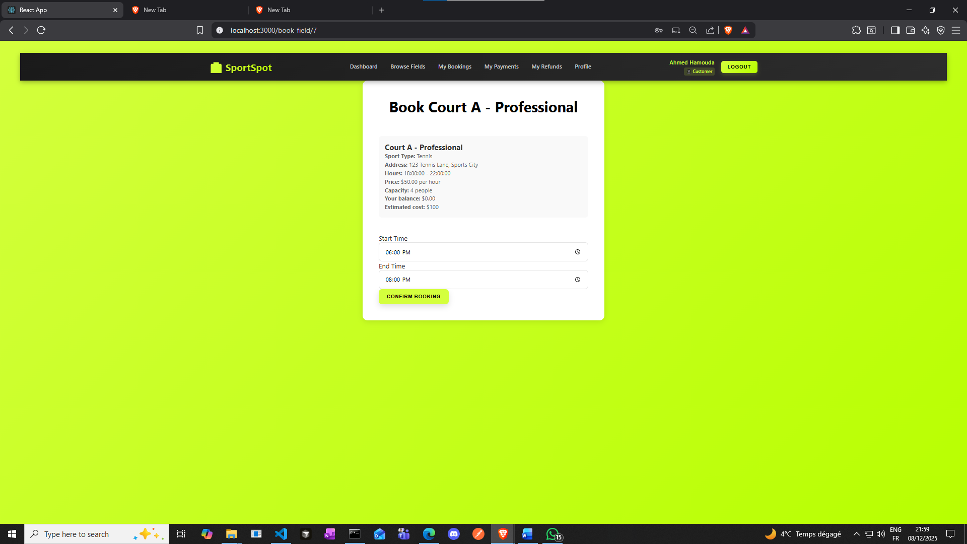

**From 6 to 8 pm for example**

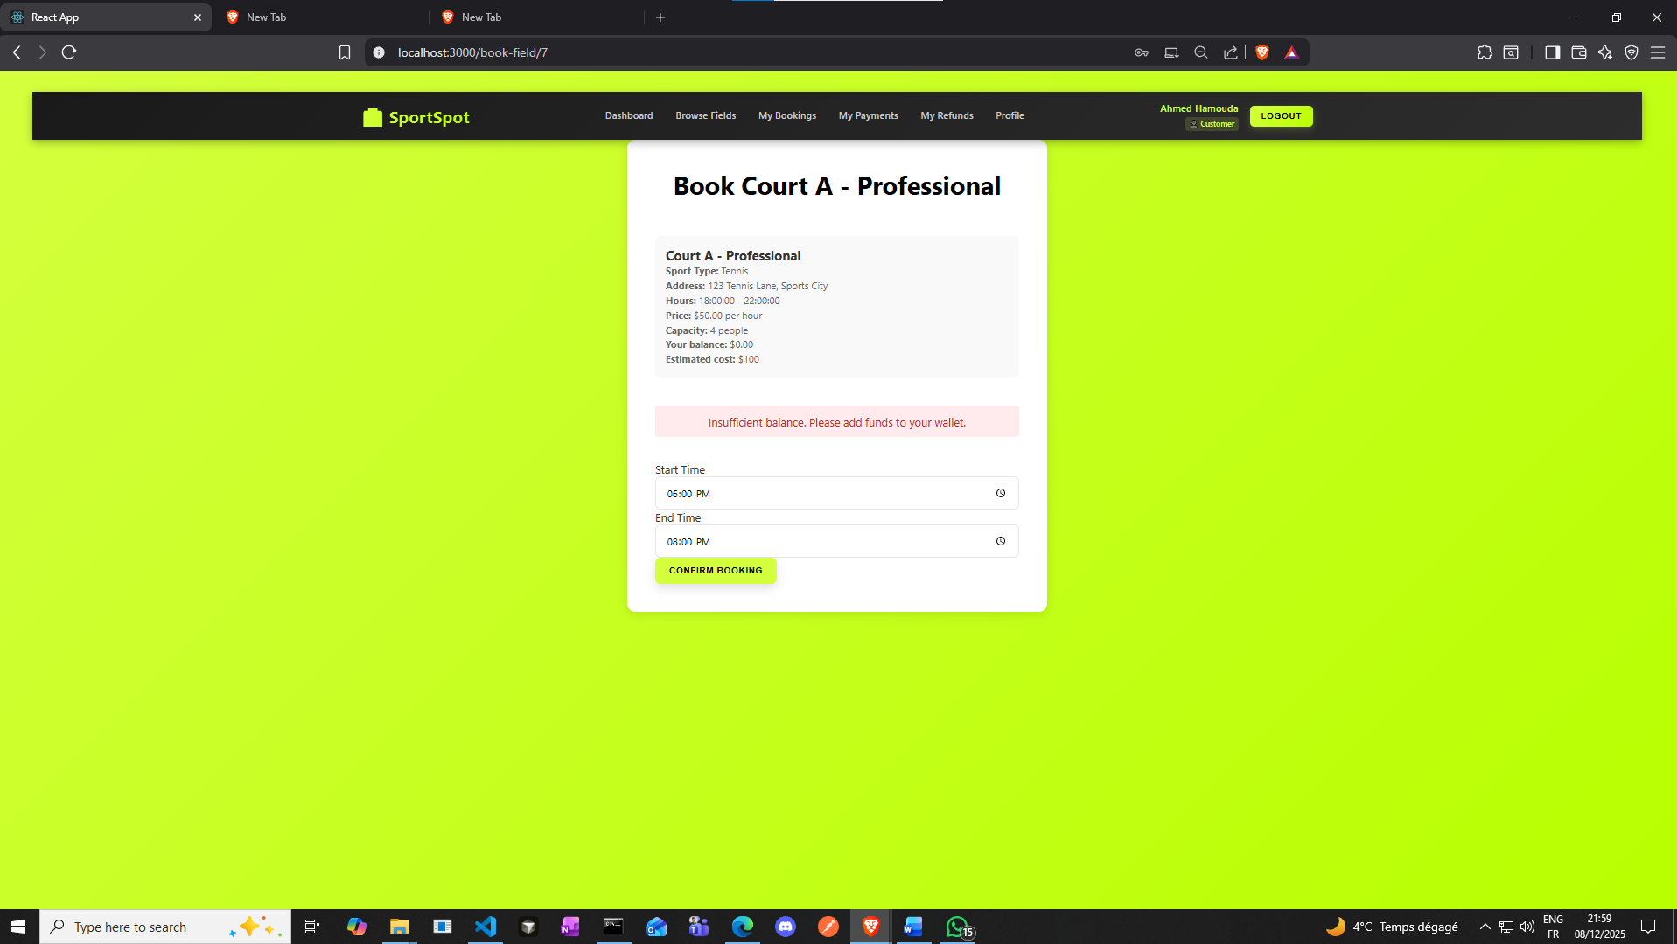

**Oups you need money**

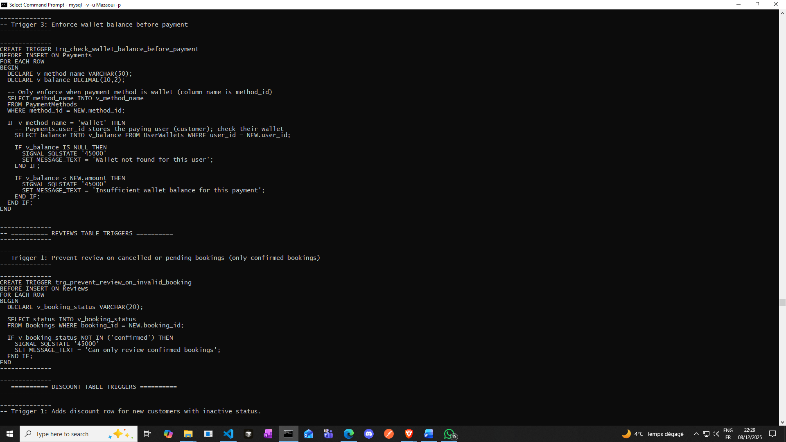

**Trigger 3 is the trigger that took care of it**

**WALLET BALANCE VALIDATION TRIGGER trg_check_wallet_balance_before_payment**

**PURPOSE:**

**This BEFORE INSERT trigger prevents payment transactions when a user's wallet balance**

**is insufficient. It enforces a critical business rule at the database layer: users**

**cannot complete wallet-based payments if their balance is less than the payment amount.**

**HOW IT WORKS:**

**1. Executes BEFORE every INSERT on the Payments table**

**2. Looks up the payment method name using the method_id (e.g., 'wallet', 'credit_card')**

**3. If payment method is 'wallet':**

**- Retrieves the user's current balance from UserWallets table**

**- Compares balance against the NEW payment amount**

**- If balance is insufficient, raises SQLSTATE '45000' to block the insert**

**4. If payment method is not 'wallet', the trigger allows the payment through**

**Go to Profile**

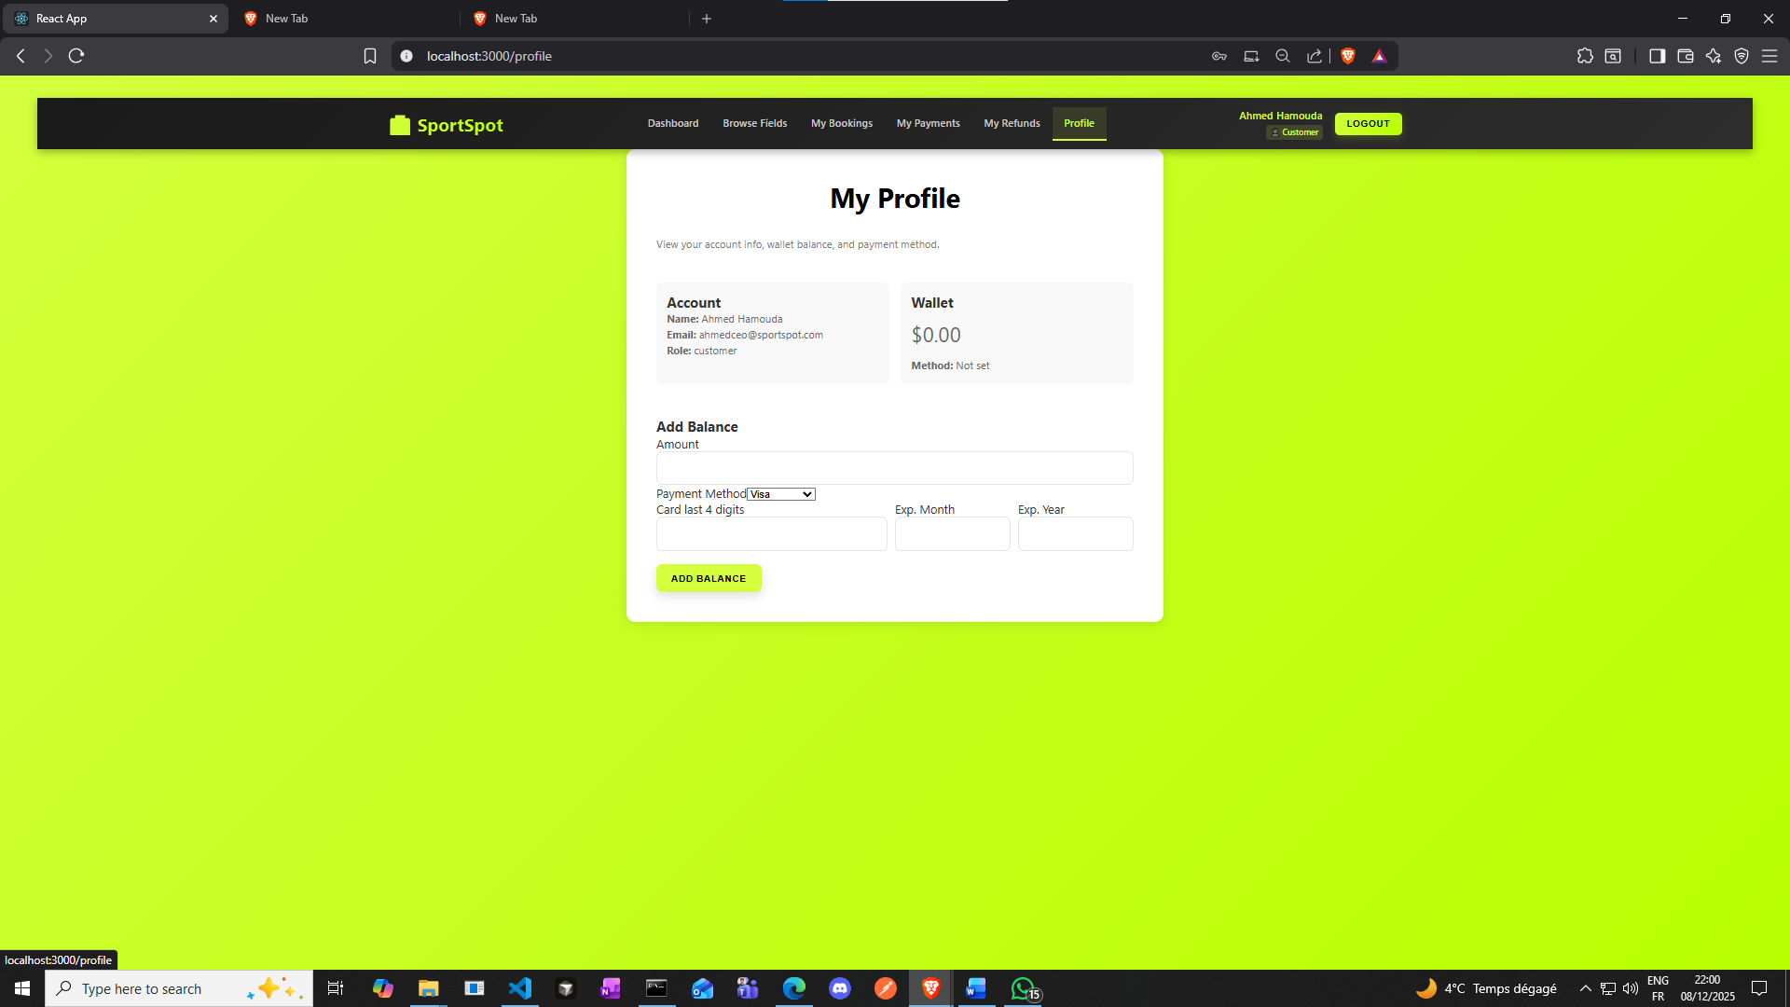

**Fill your balance**

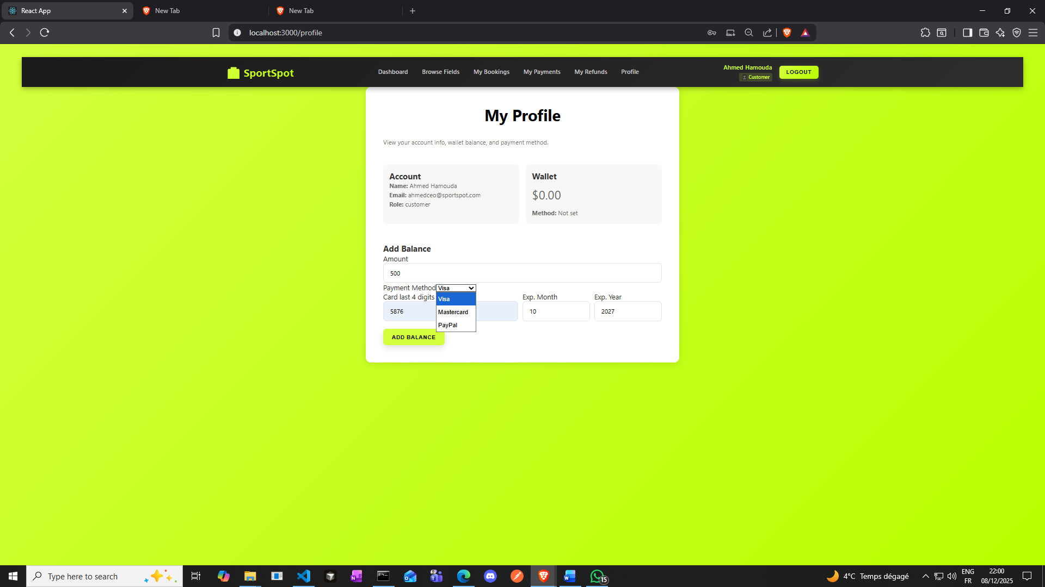

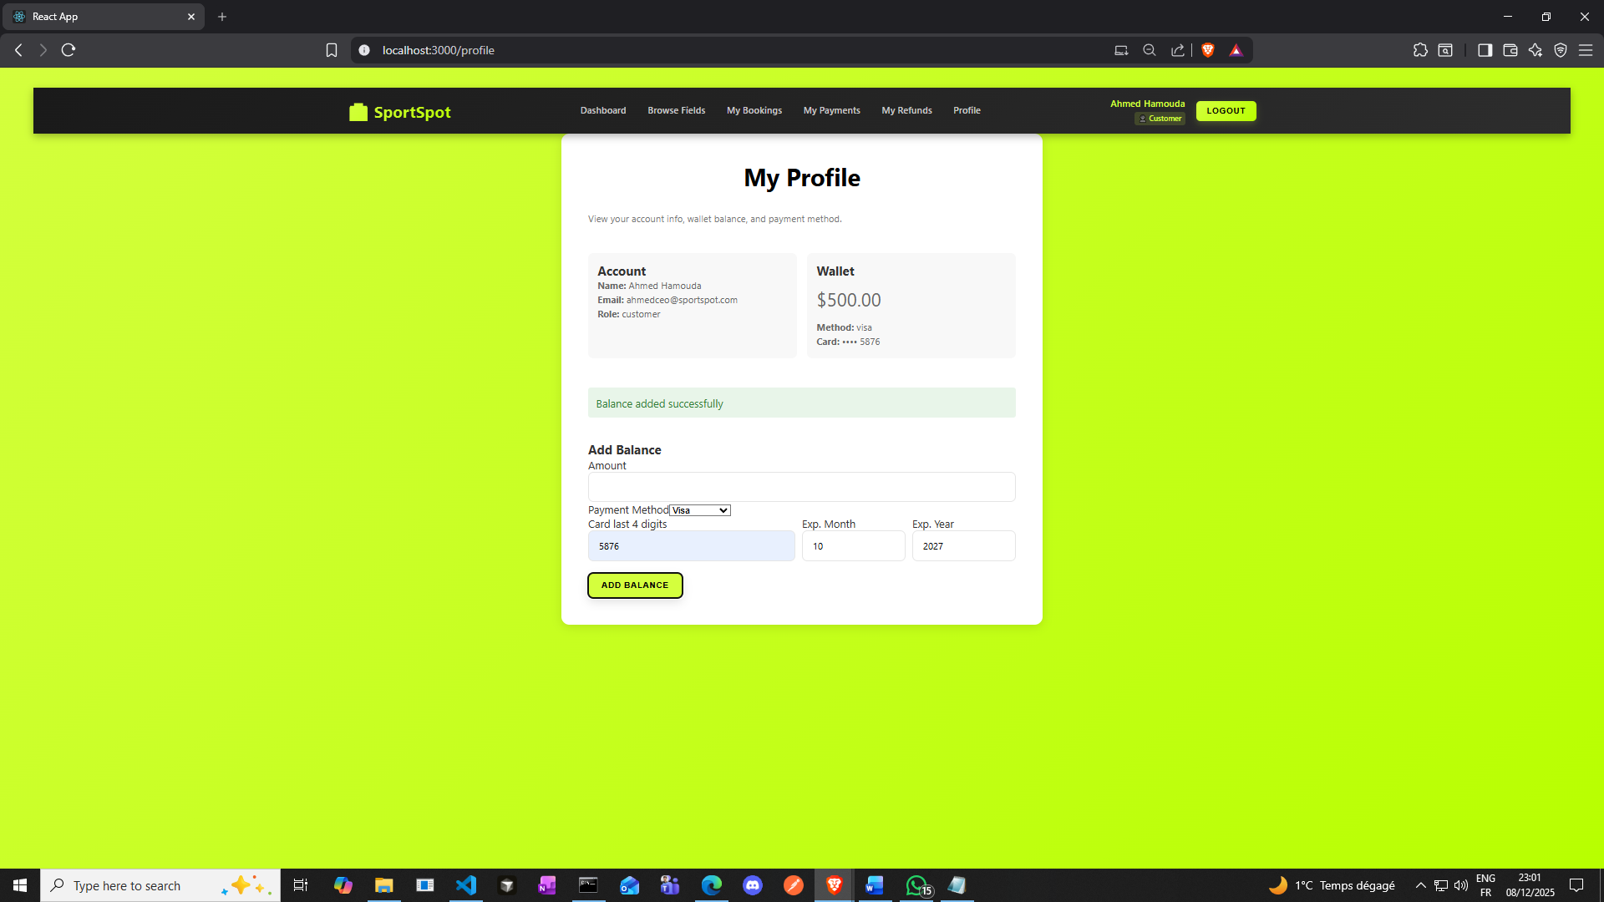

**Now let’s book again**

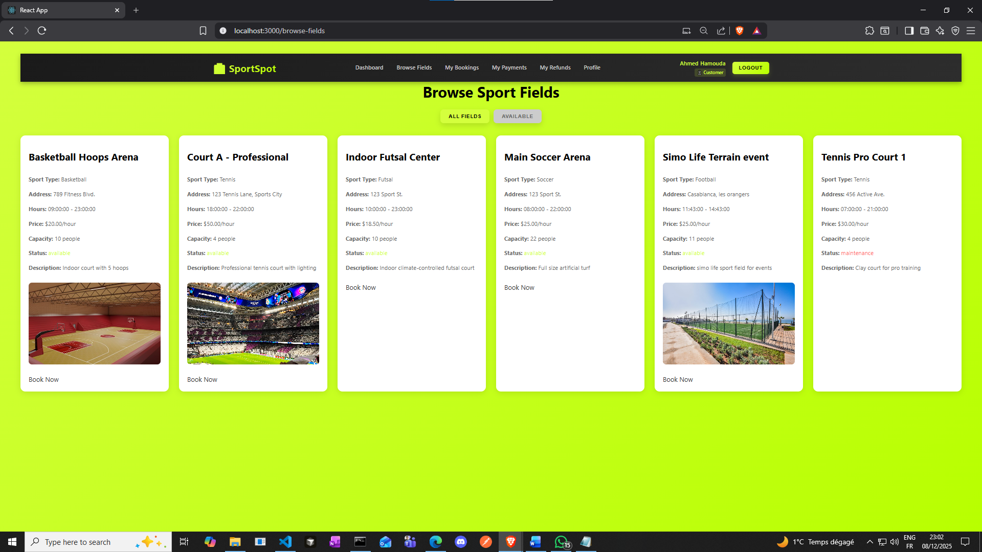

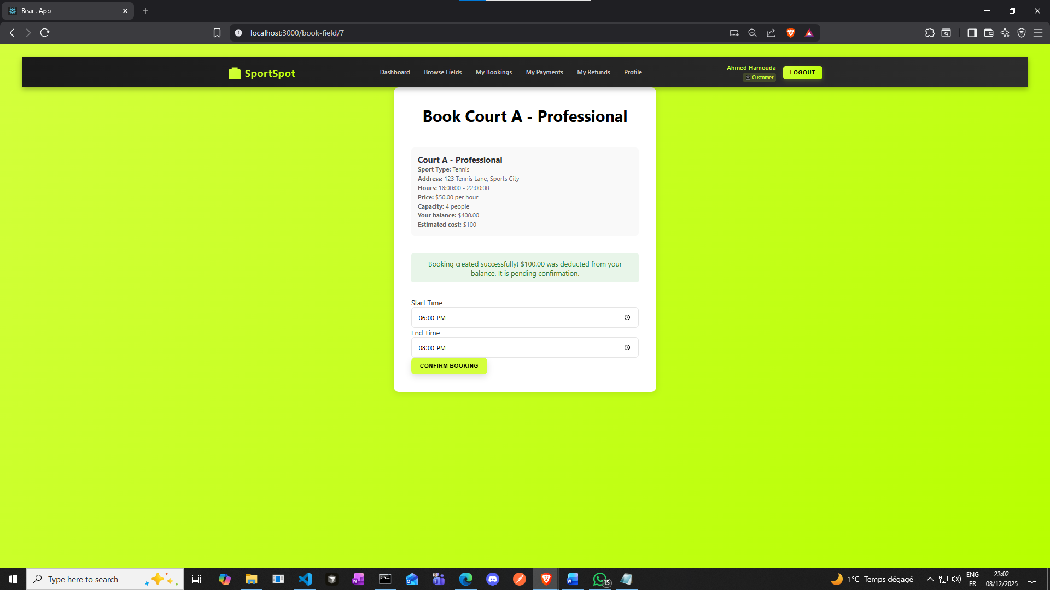

**Then you’ll get directed to your bookings page automatically**

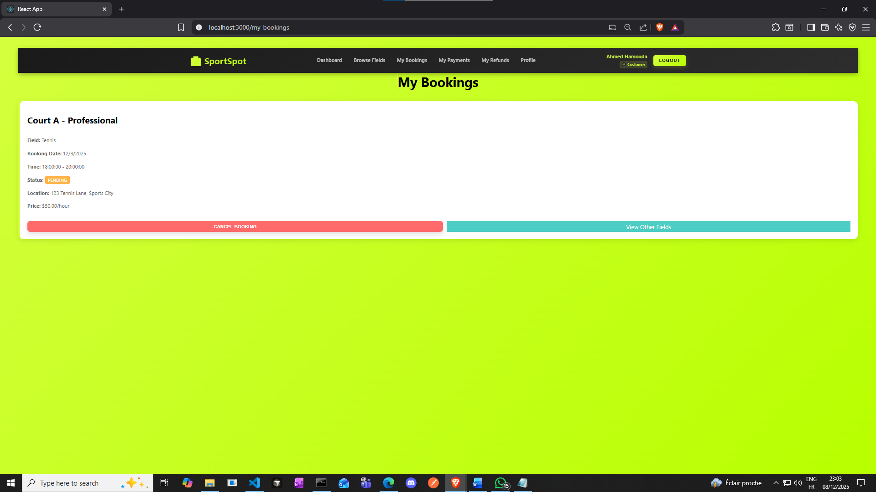

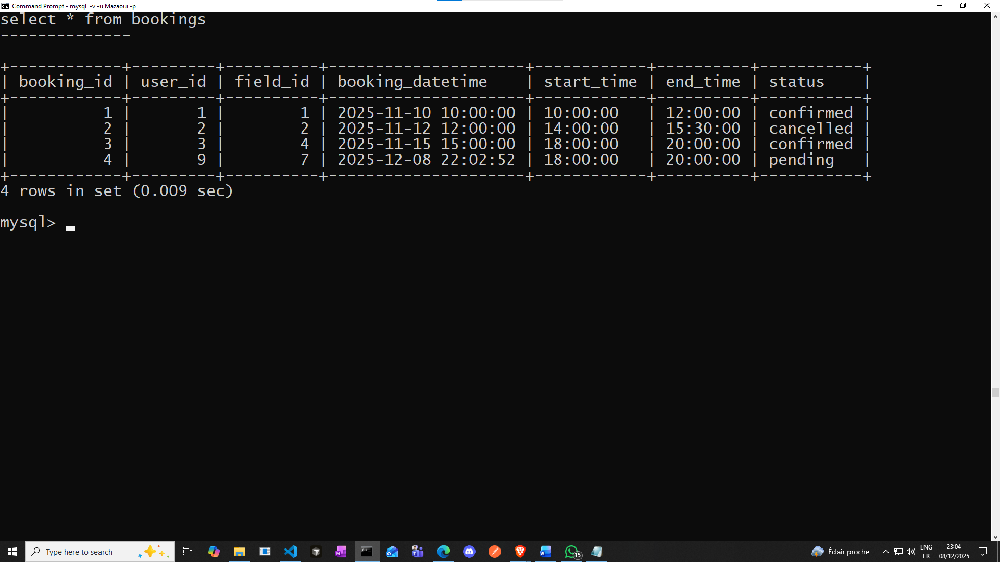

**now let’s see the case of an owner registered user account willing to check his fields that were booked**

**let’s book one of Simo (an owner) fields**

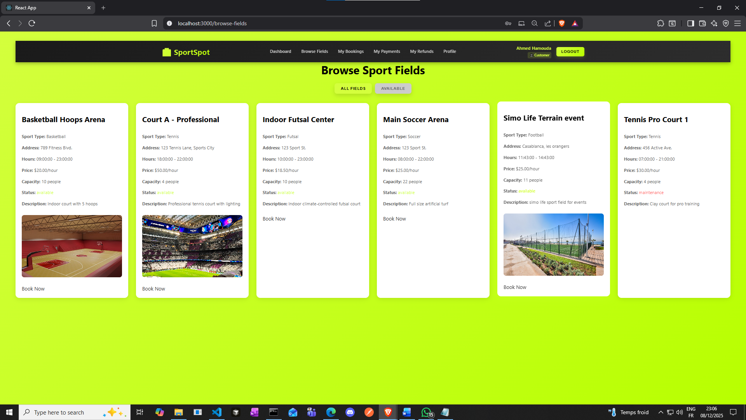

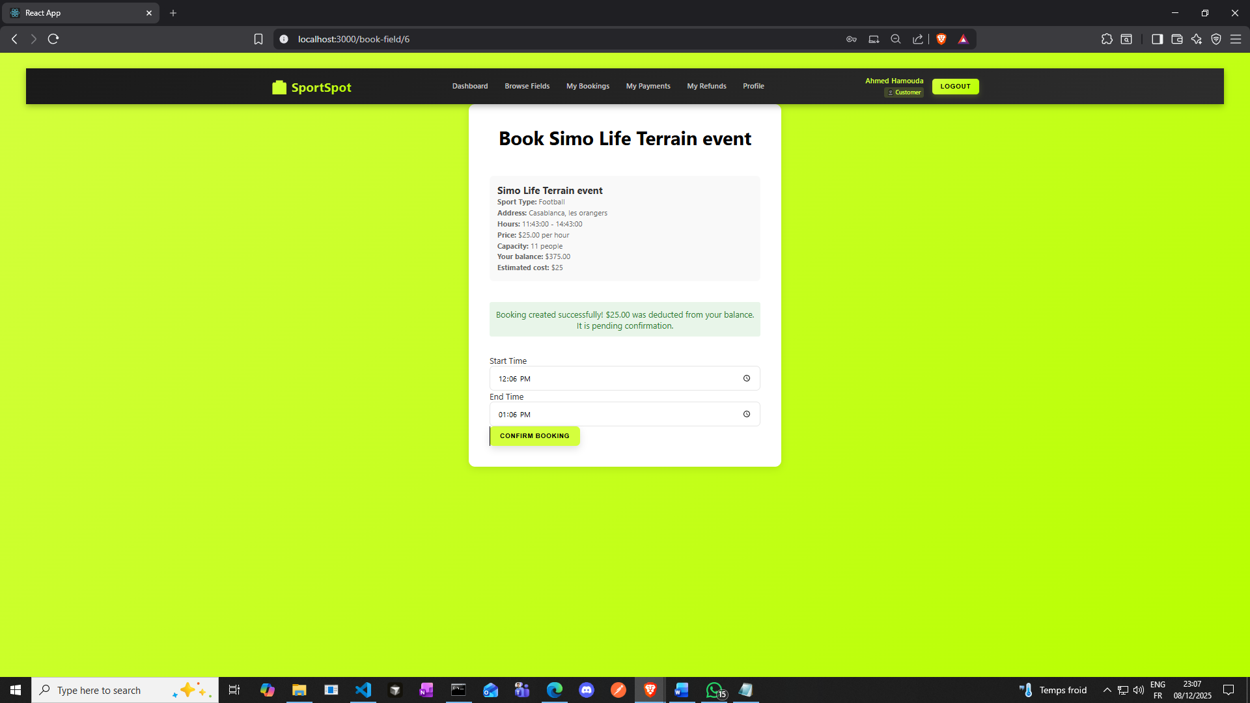

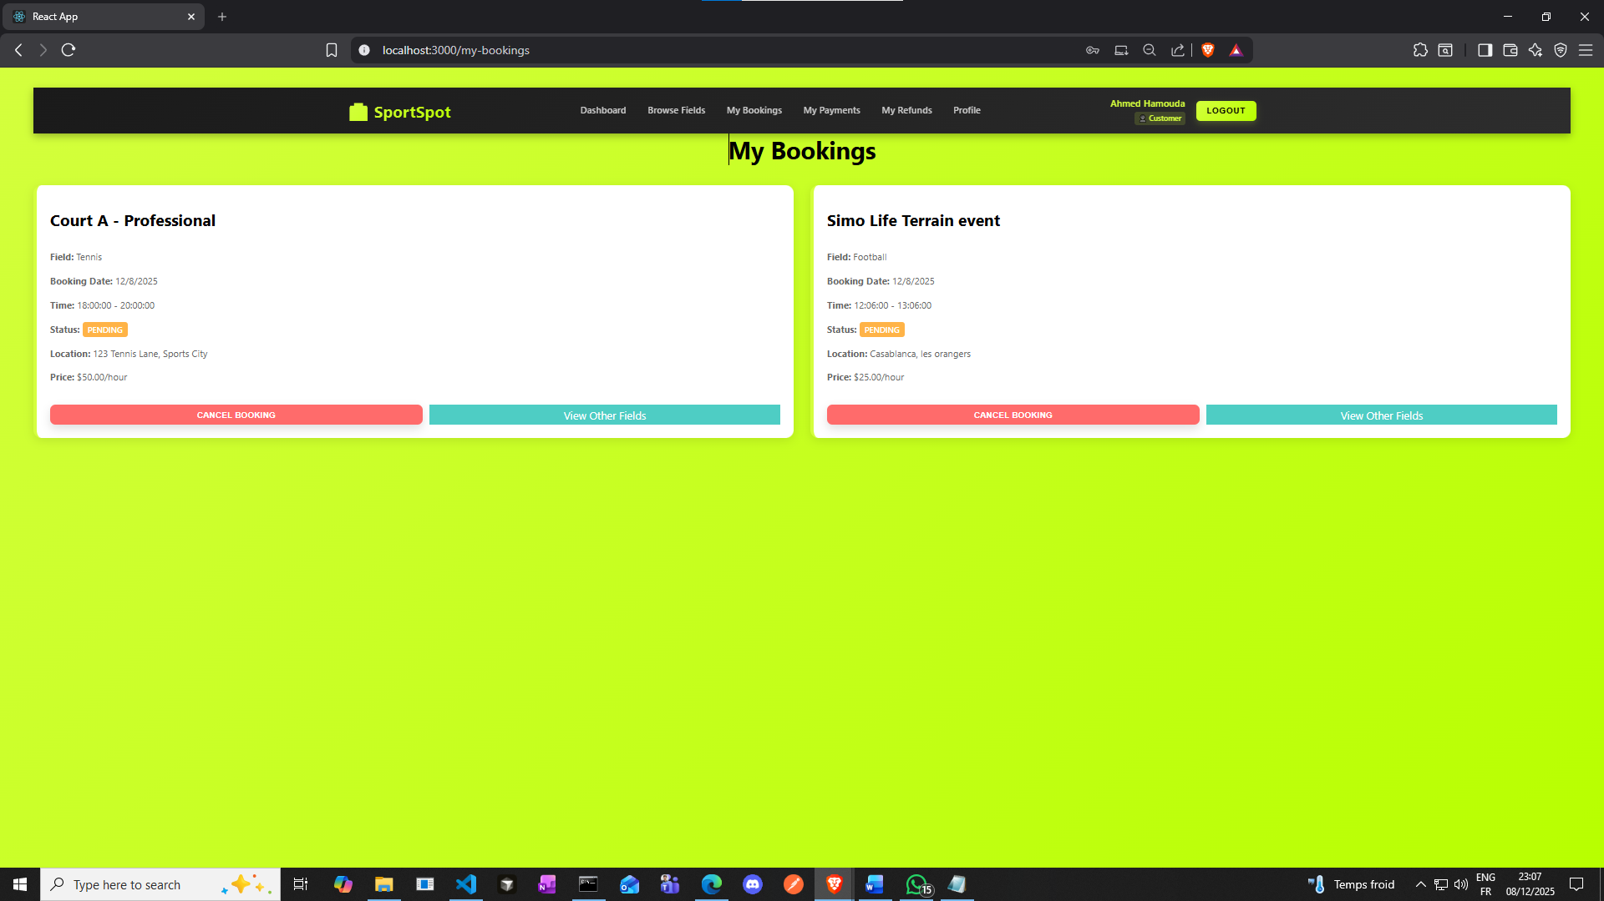

**And of course our backend server keeps track of everything**



**Now if we logged into Simo’s account who is an owner:**

**We’ll see this**

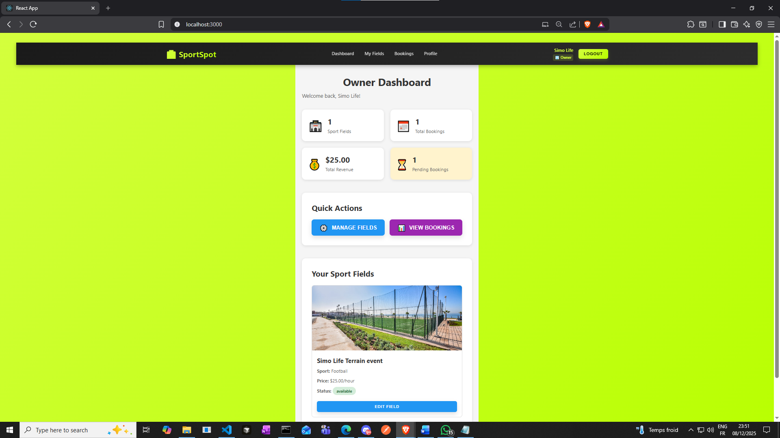

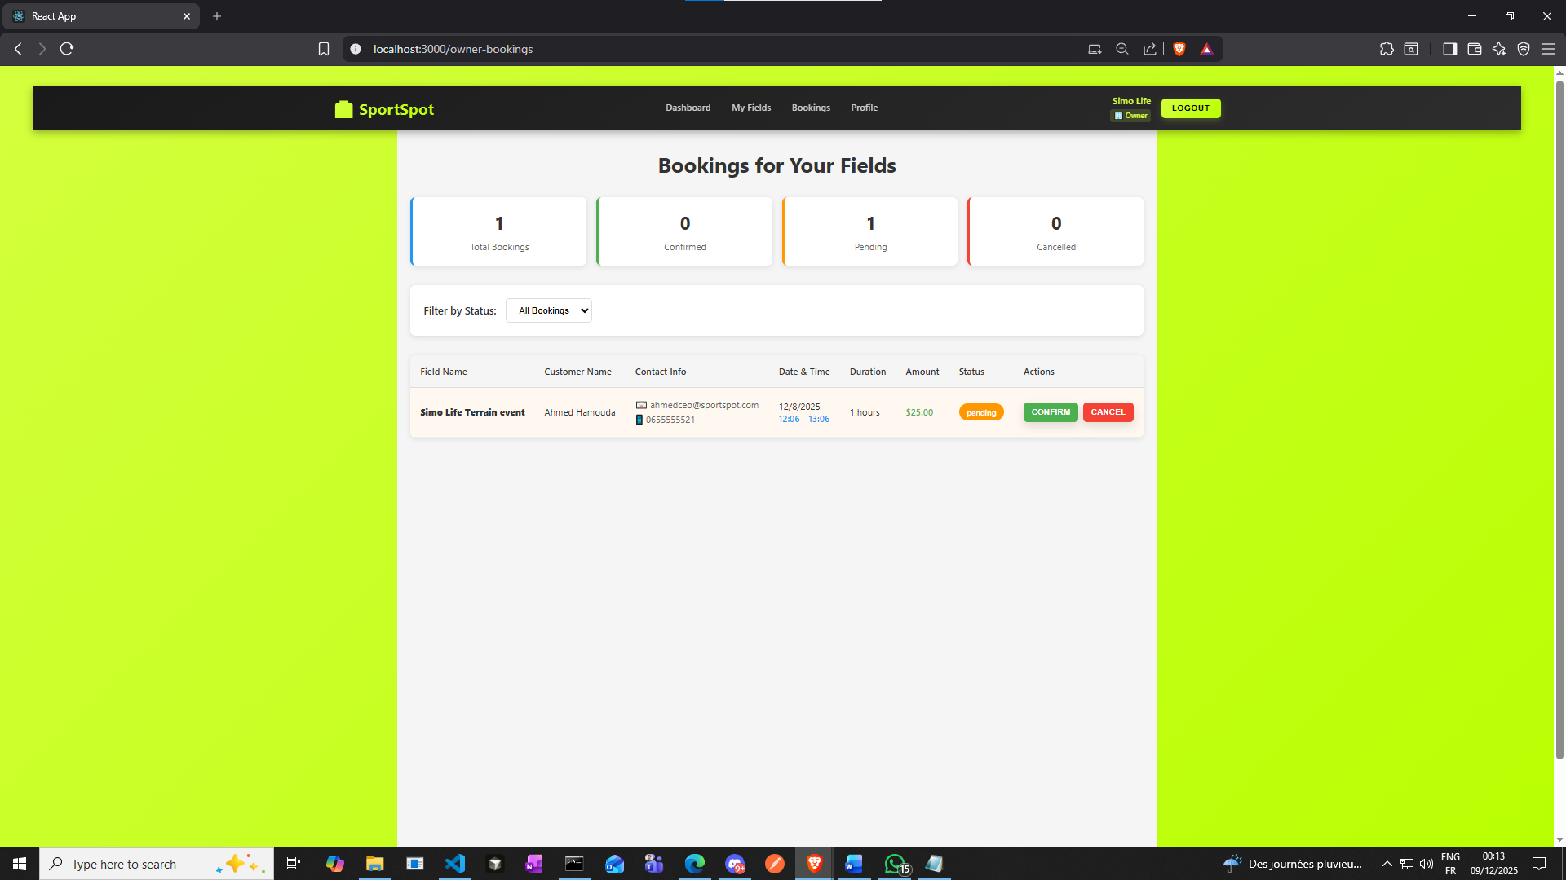

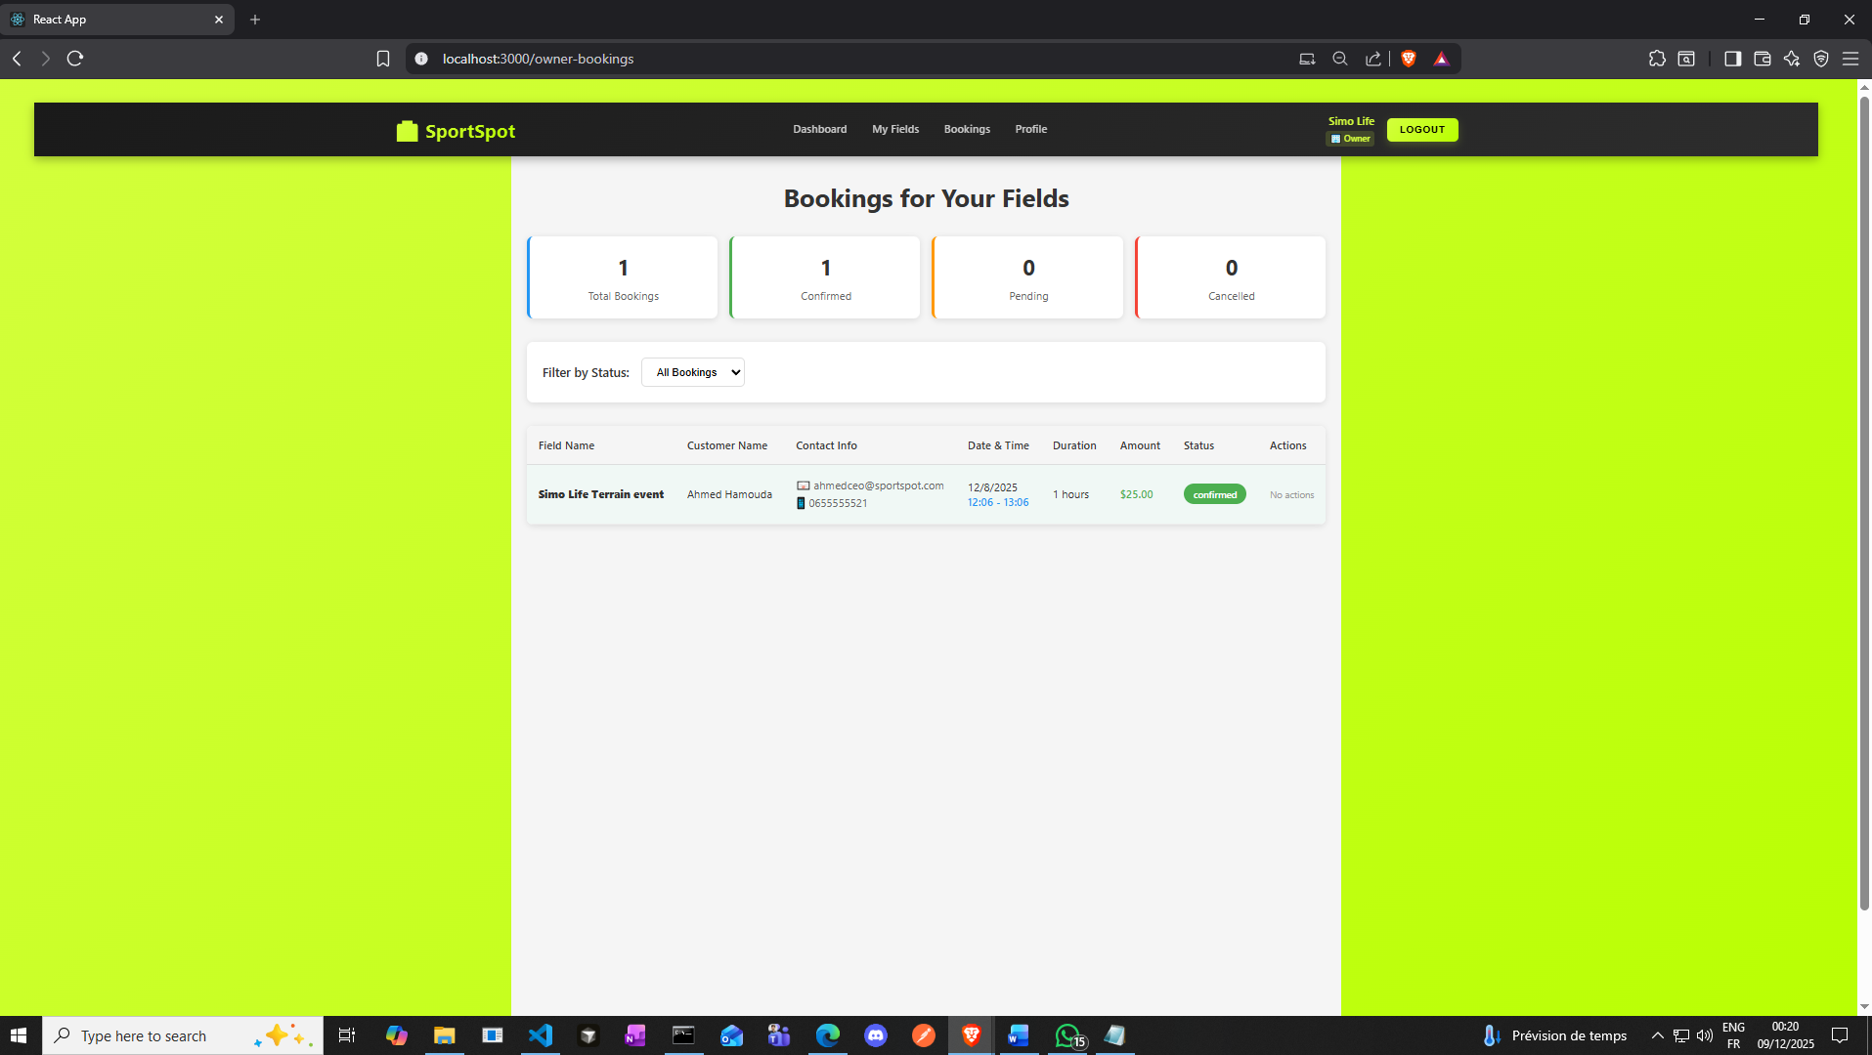

**The owner confirmed the booking**

**(before, I faced a problem in creating this feature since Issue was When owner clicked "Confirm" or "Cancel" button, the backend threw error: "ER_BAD_NULL_ERROR: Column 'user_id' cannot be null" and the Root was the Cause: The frontend sends only**[**{ status: "confirmed" }**](vscode-file://vscode-app/c:/Users/seqon/AppData/Local/Programs/Microsoft%20VS%20Code/resources/app/out/vs/code/electron-browser/workbench/workbench.html)**when confirming a booking, but the backend's PUT endpoint tried to update all columns (user_id, field_id, booking_datetime, etc.) at once. Since these fields were undefined in the request, they were set to NULL, violating the NOT NULL constraint on user_id.**

**Solution: so I added conditional logic to check if the request contains full booking details or just a status update**

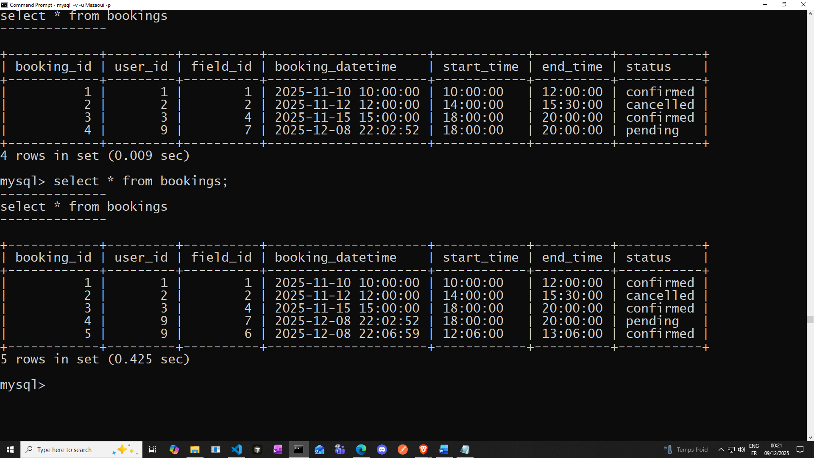

**Next Step: Customer Leaves Review**

* **Login as Customer**
* **Go to booking details**
* **Leave review:**
  + **Rating: 5 stars**
  + **Comment: "Excellent facility! Well-maintained and great service."**

**Now since the booking is confirmed, and Ahmed Hamouda played, now he can leave a review**

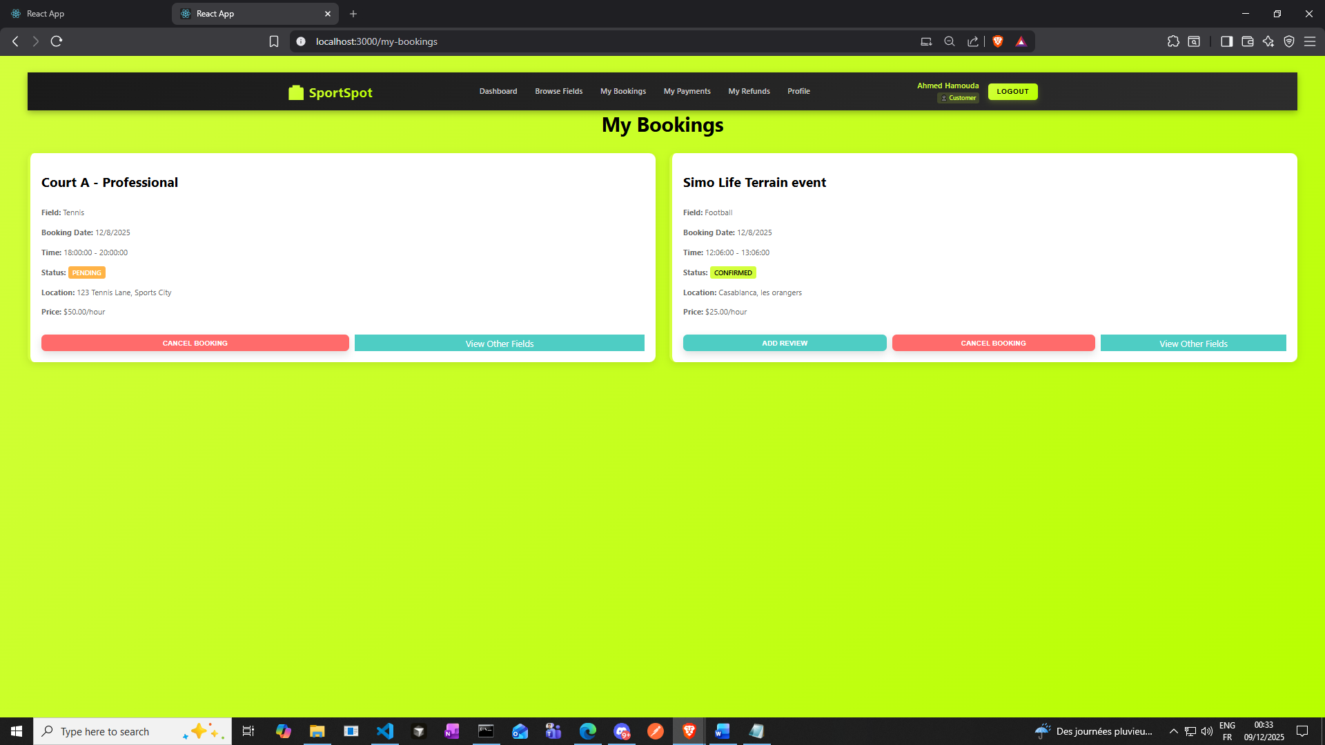

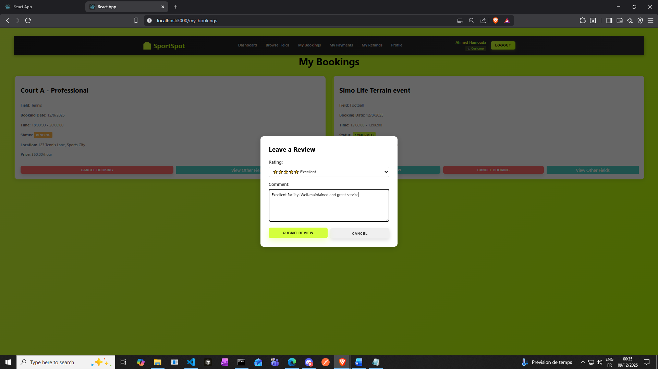

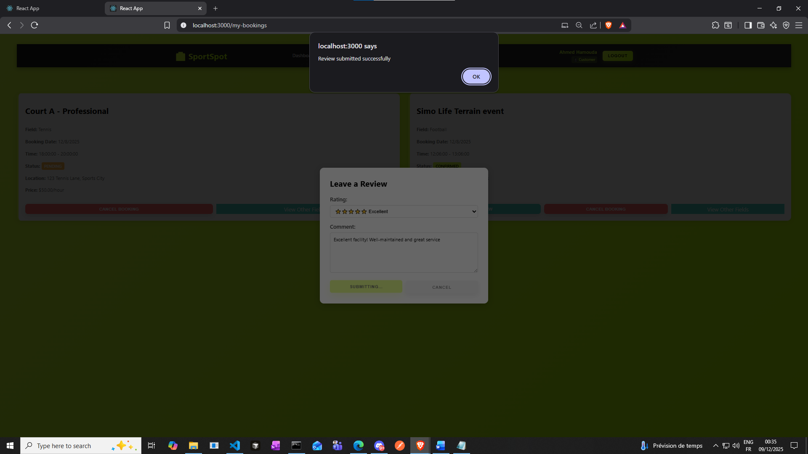

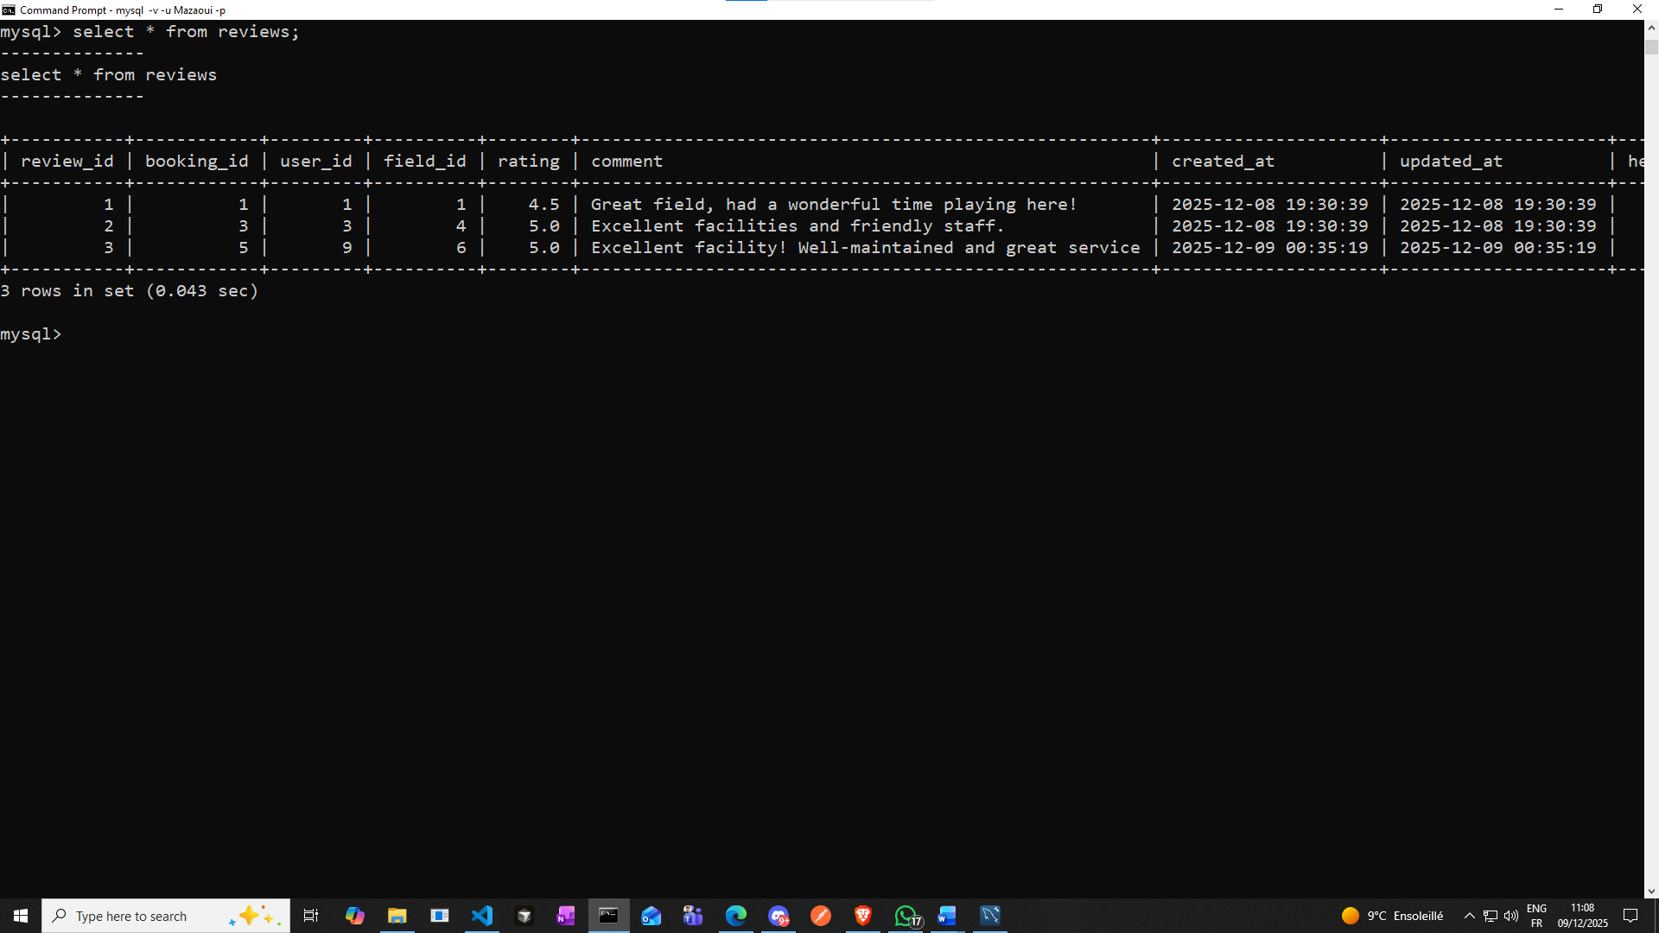

**Now let’s try an interesting query which one of the interesting ones you’ll find in our db_queries_ctes_views_correlatedqueries_aggregatefcts.sql**

**Latest reviews with reviewer and field context (last 20)**

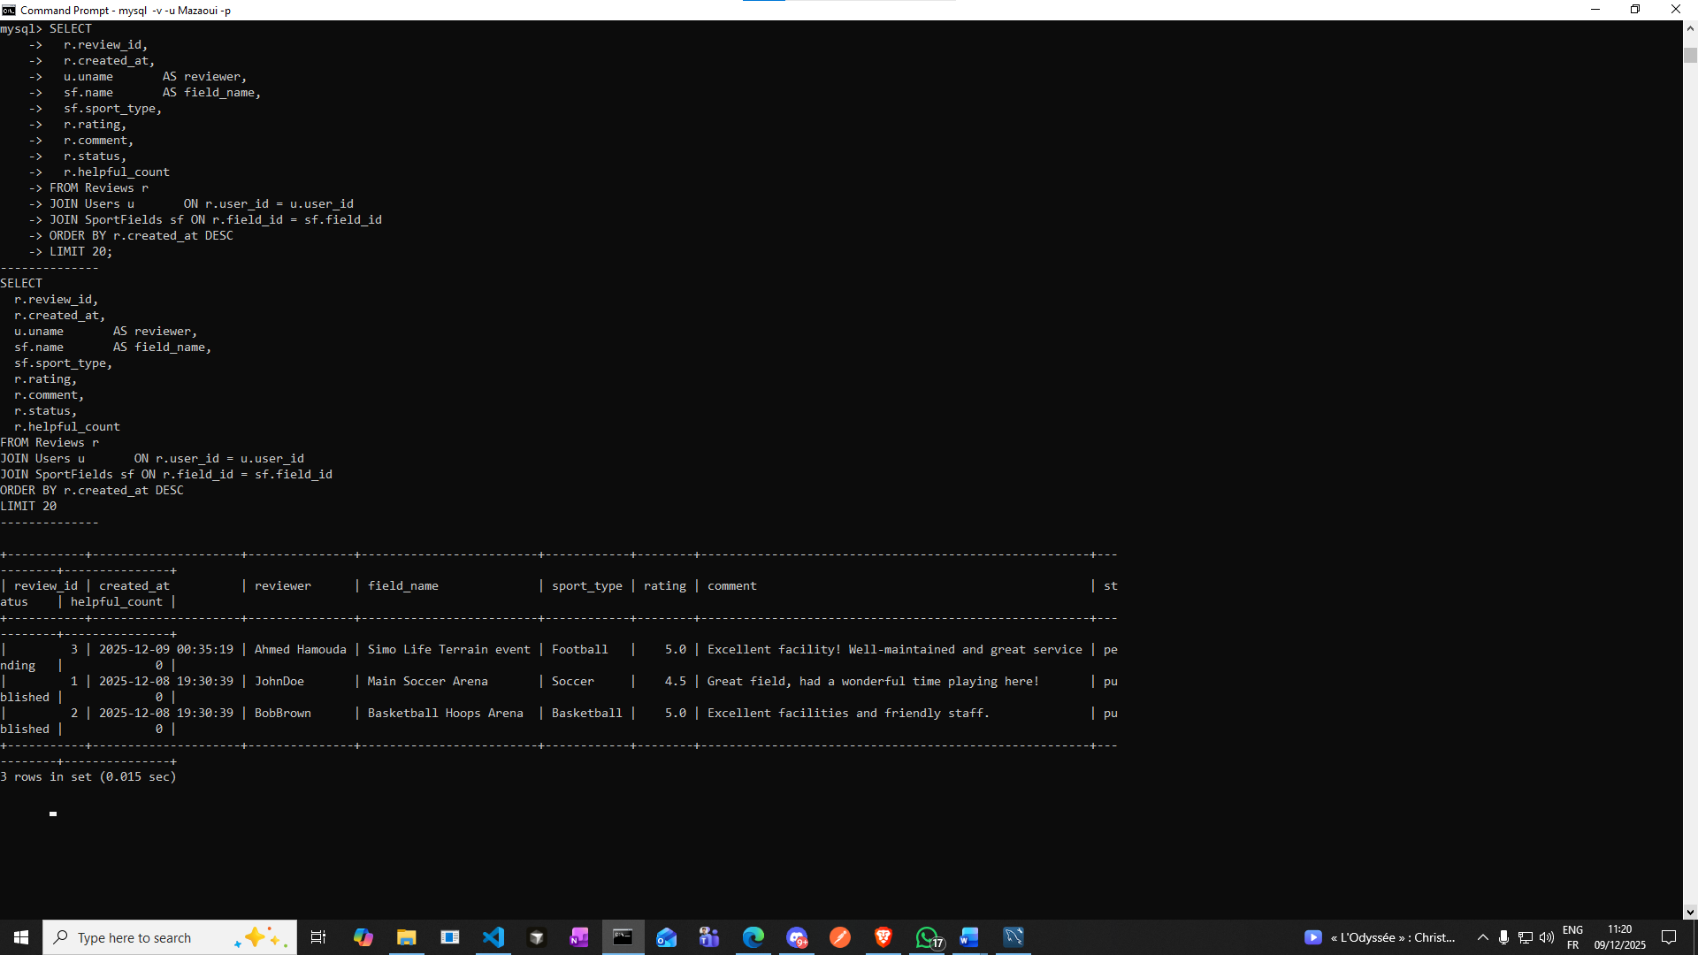

**Here I faced a problem: when customers submitted reviews for confirmed bookings, the reviews were successfully stored in the database, but they did not appear in the field's average rating, review count, or latest comment on the Browse Fields and Owner Fields pages. The rating still displayed "No reviews yet" even after submitting a review. The reason was that the backend endpoints (GET /SportFields and GET /SportFields/owner/:userId) were aggregating only reviews with status = 'published', but the frontend was submitting reviews with status = 'pending', causing newly submitted reviews to be excluded from rating calculationssss. Additionally, the Reviews table has a UNIQUE KEY on booking_id, meaning only one review per booking is allowed, but the original backend code didn't handle this gracefully, it would throw a 500 error if a customer tried to update their review. The initial POST /Reviews endpoint also used callback based queries instead of promise based ones, making error handling inconsistent. To fix this, I changed the default status to 'published' by updating the backend POST /Reviews endpoint to default new reviews to status = 'published' instead of 'pending', and updated the frontend MyBookings component to explicitly send status: 'published' when submitting reviews, ensuring reviews appear in field ratings immediately. I also converted POST /Reviews to use async/await with promise-based queries (dbAsync), I added a logic to check if a review already exists for the booking and update it if it does rather than inserting a duplicate, and added input validation to ensure all required fields are provided before processing. The result is that reviews now appear immediately in field ratings and comments on Browse Fields and Owner Fields pages, and customers can submit and update reviews without encountering errors.**

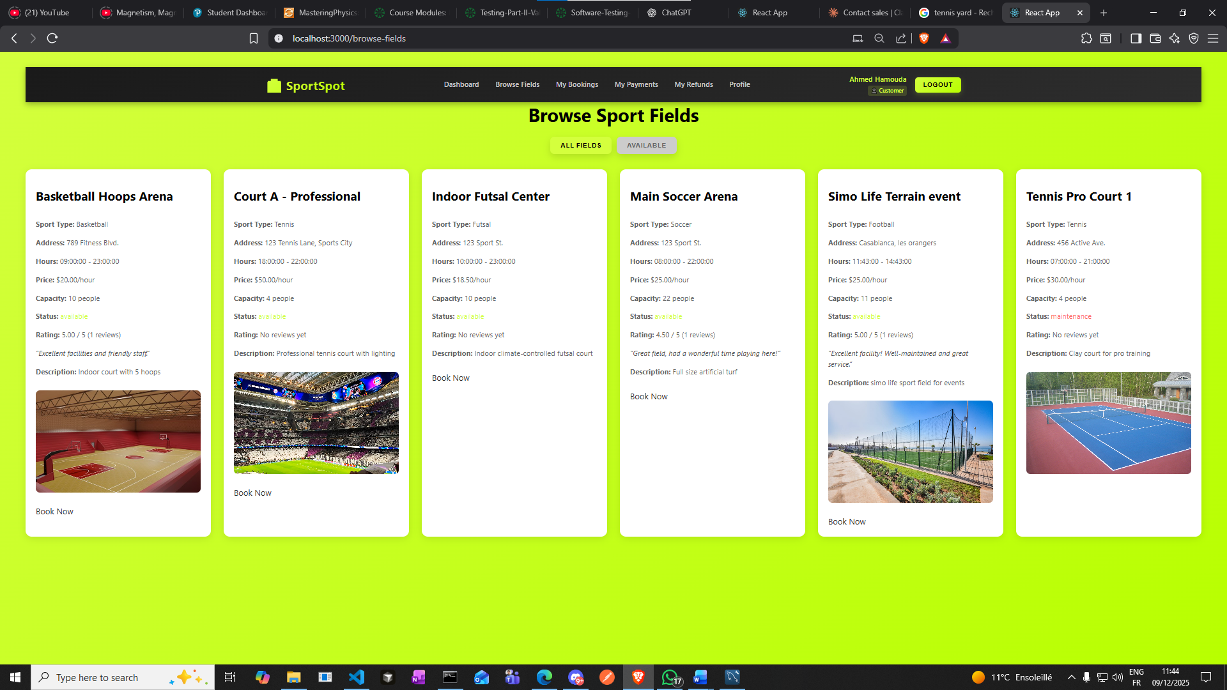

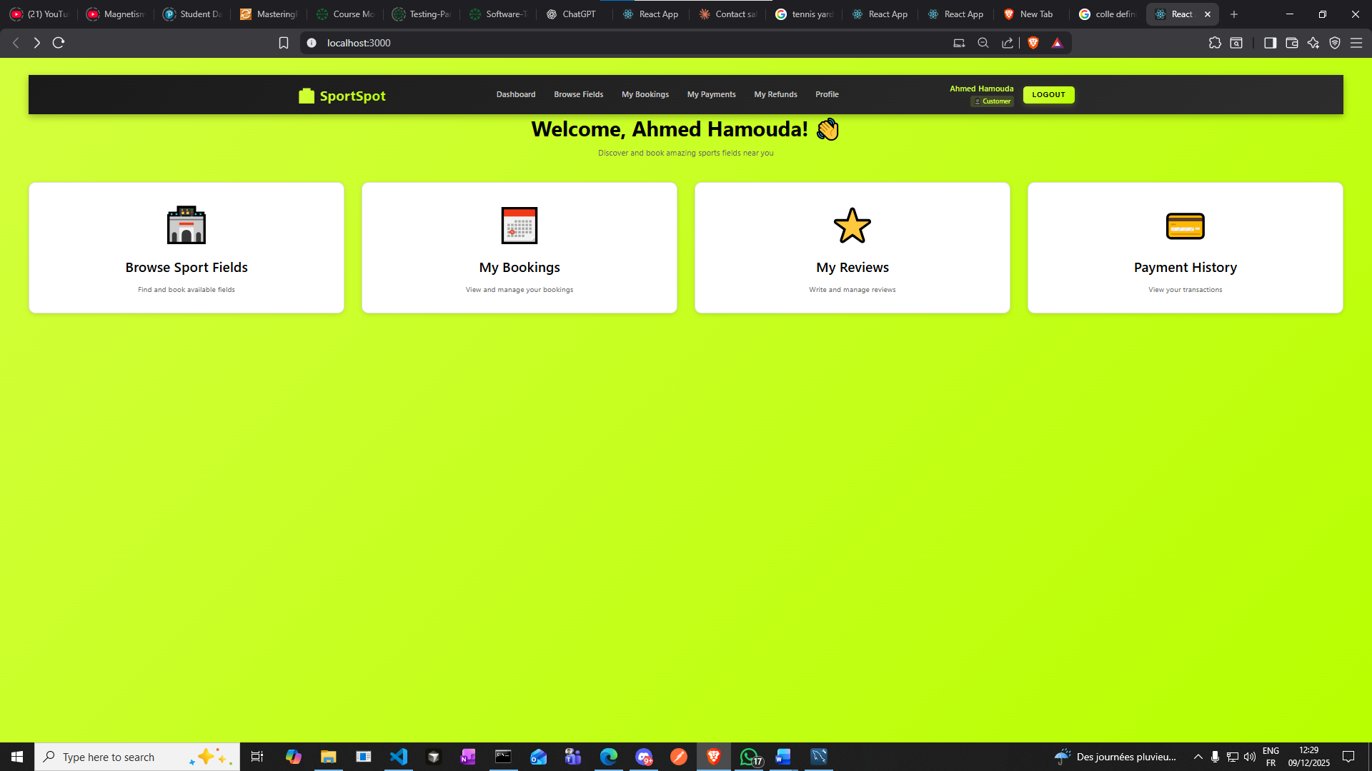

**Here we can see all of our reviews that we did to all fields that we booked and revieweds**

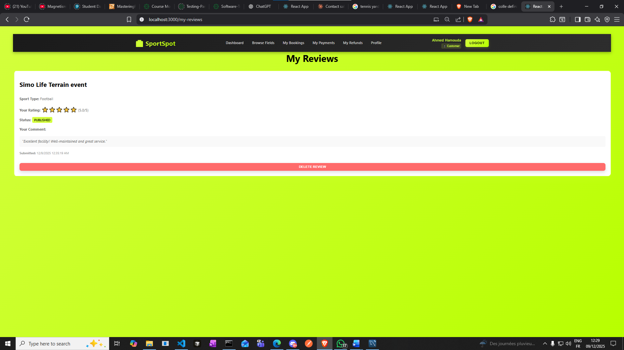

**Now let’s test a scenario again:**

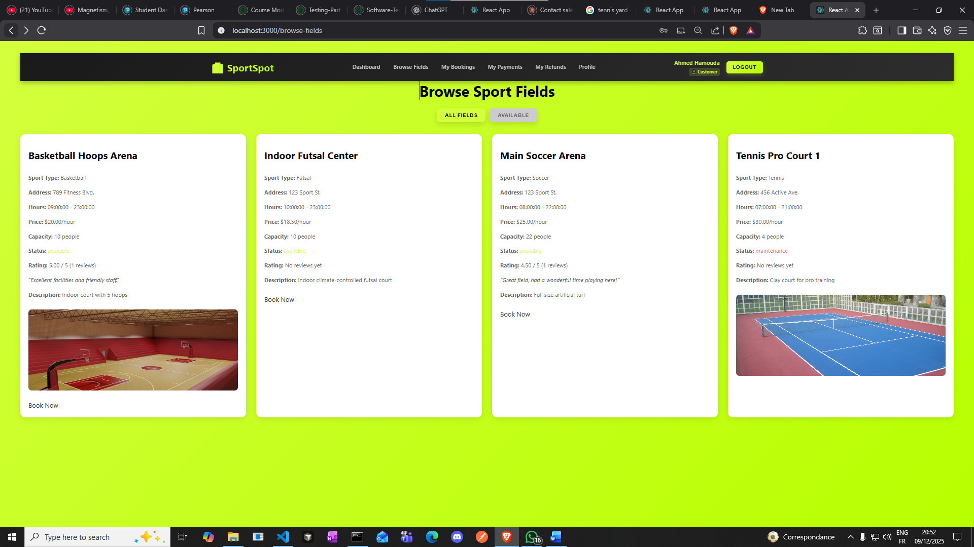

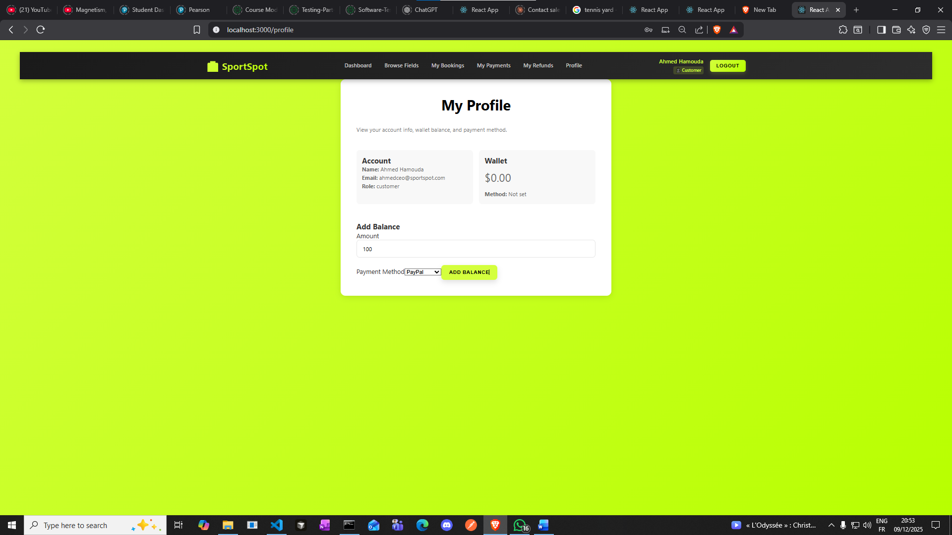

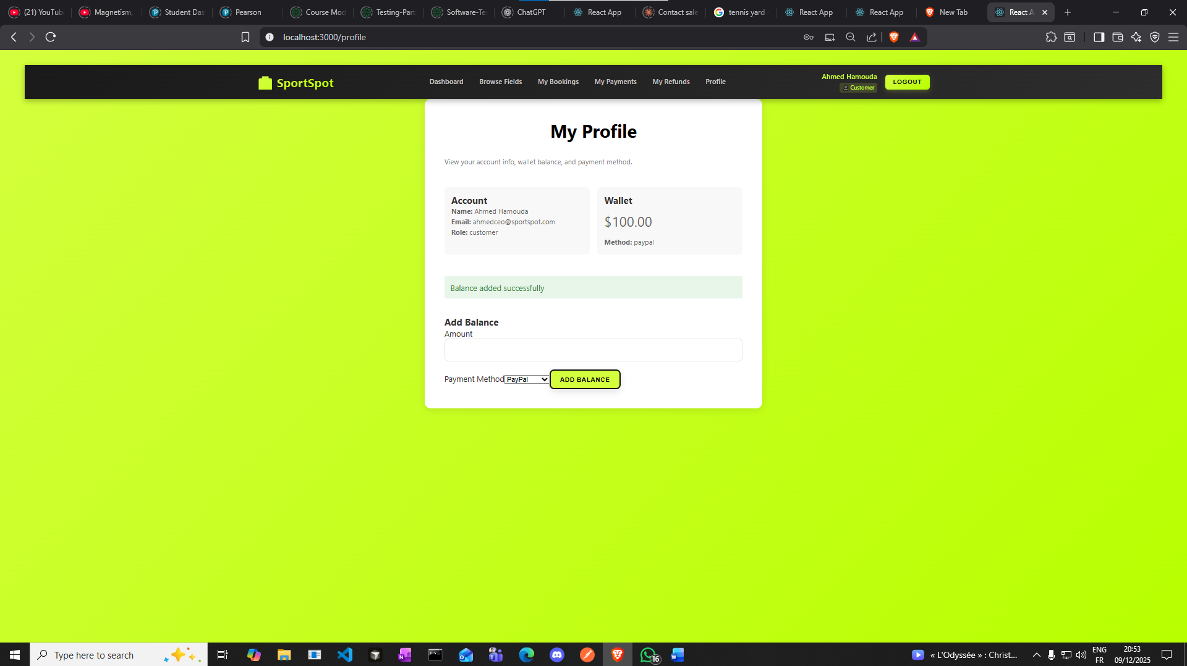

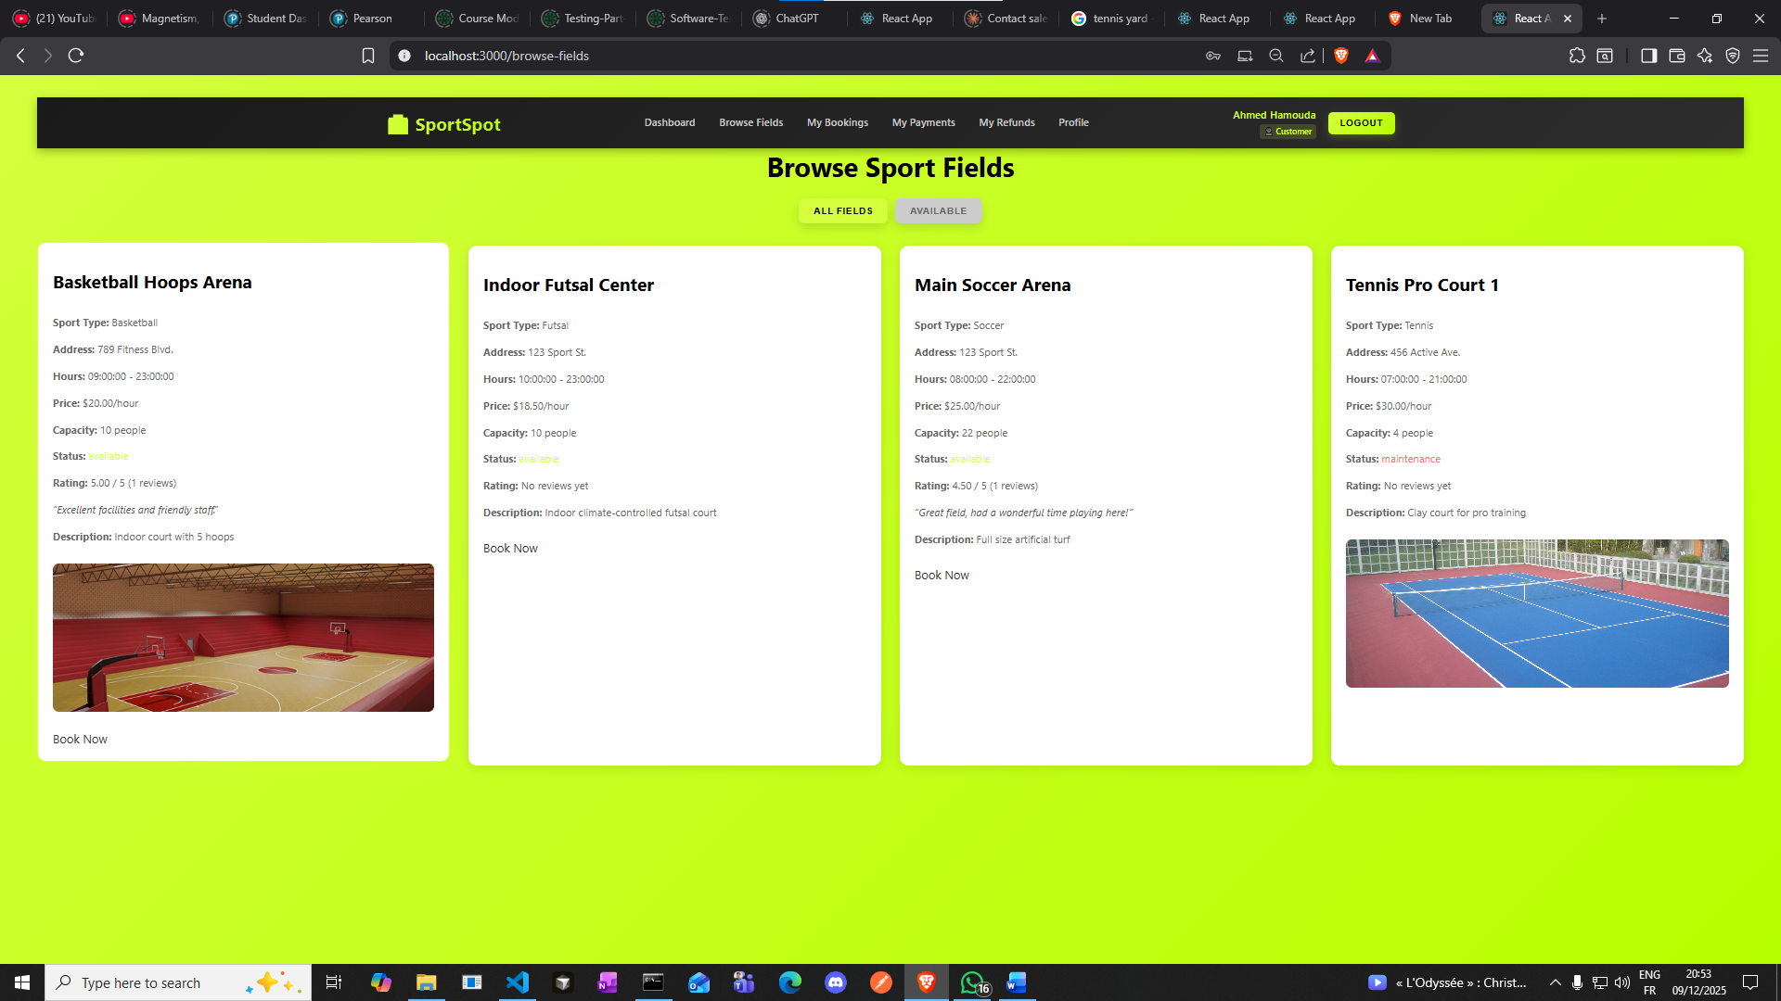

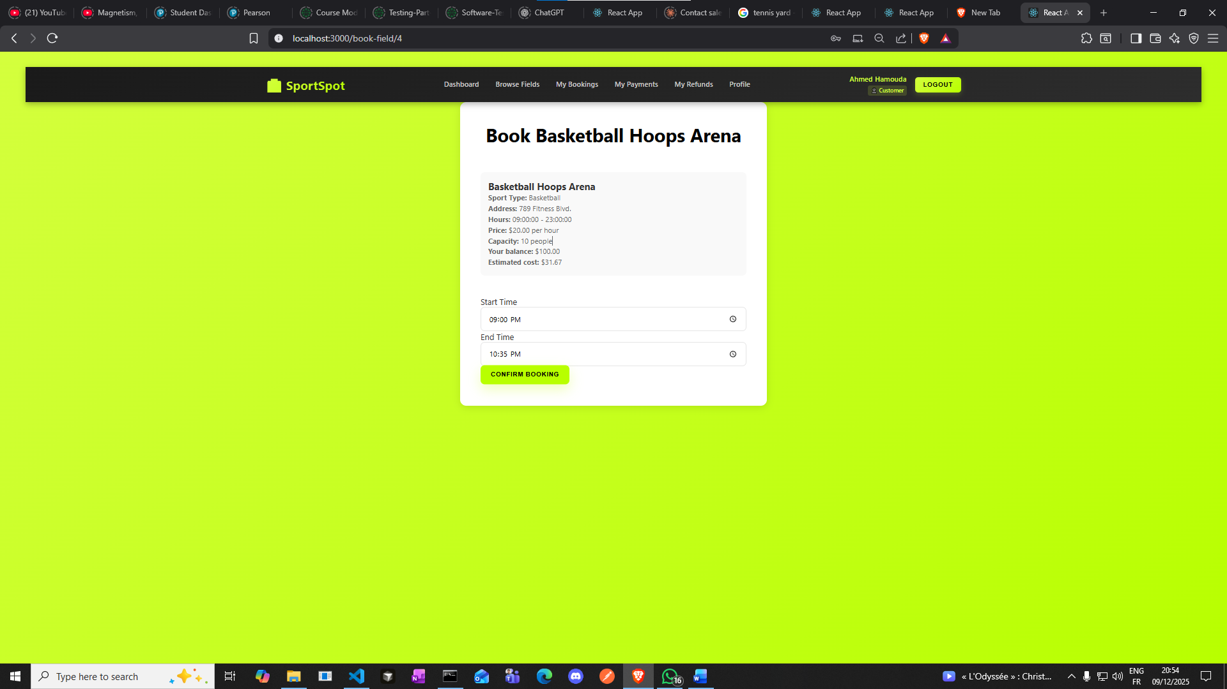

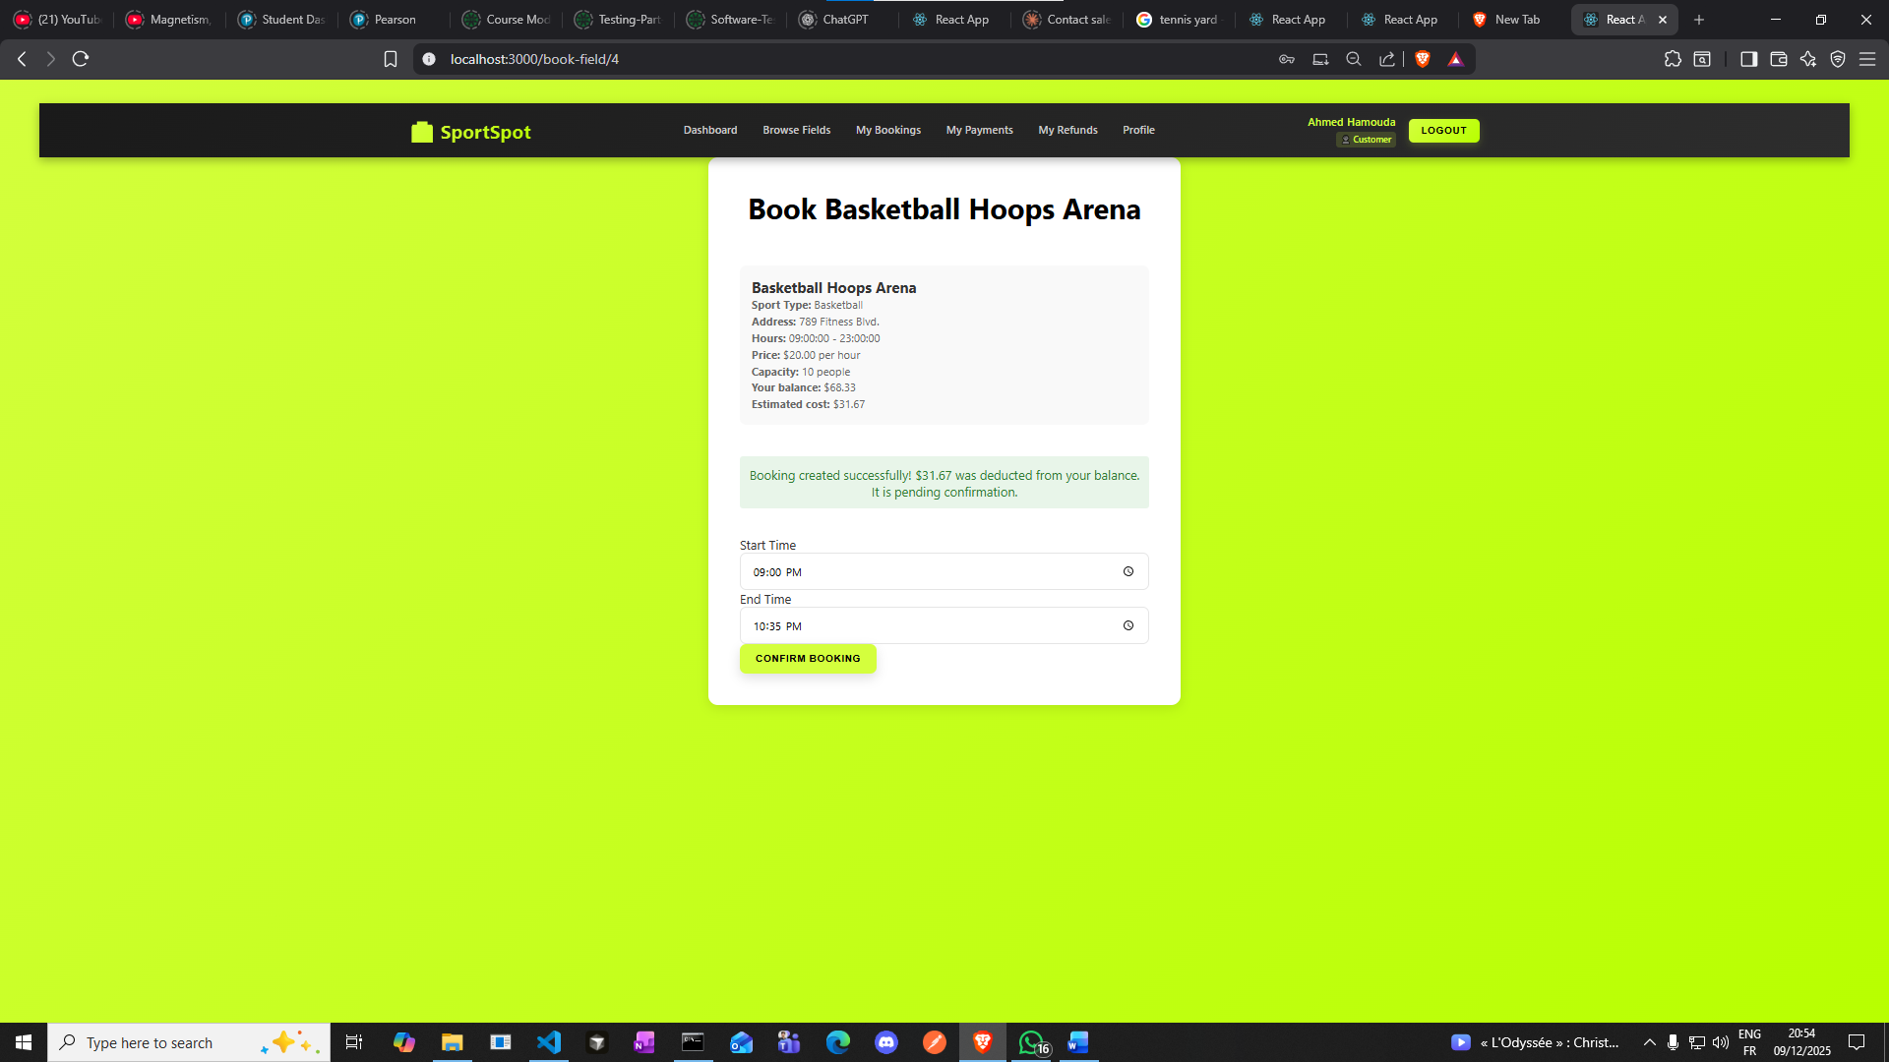

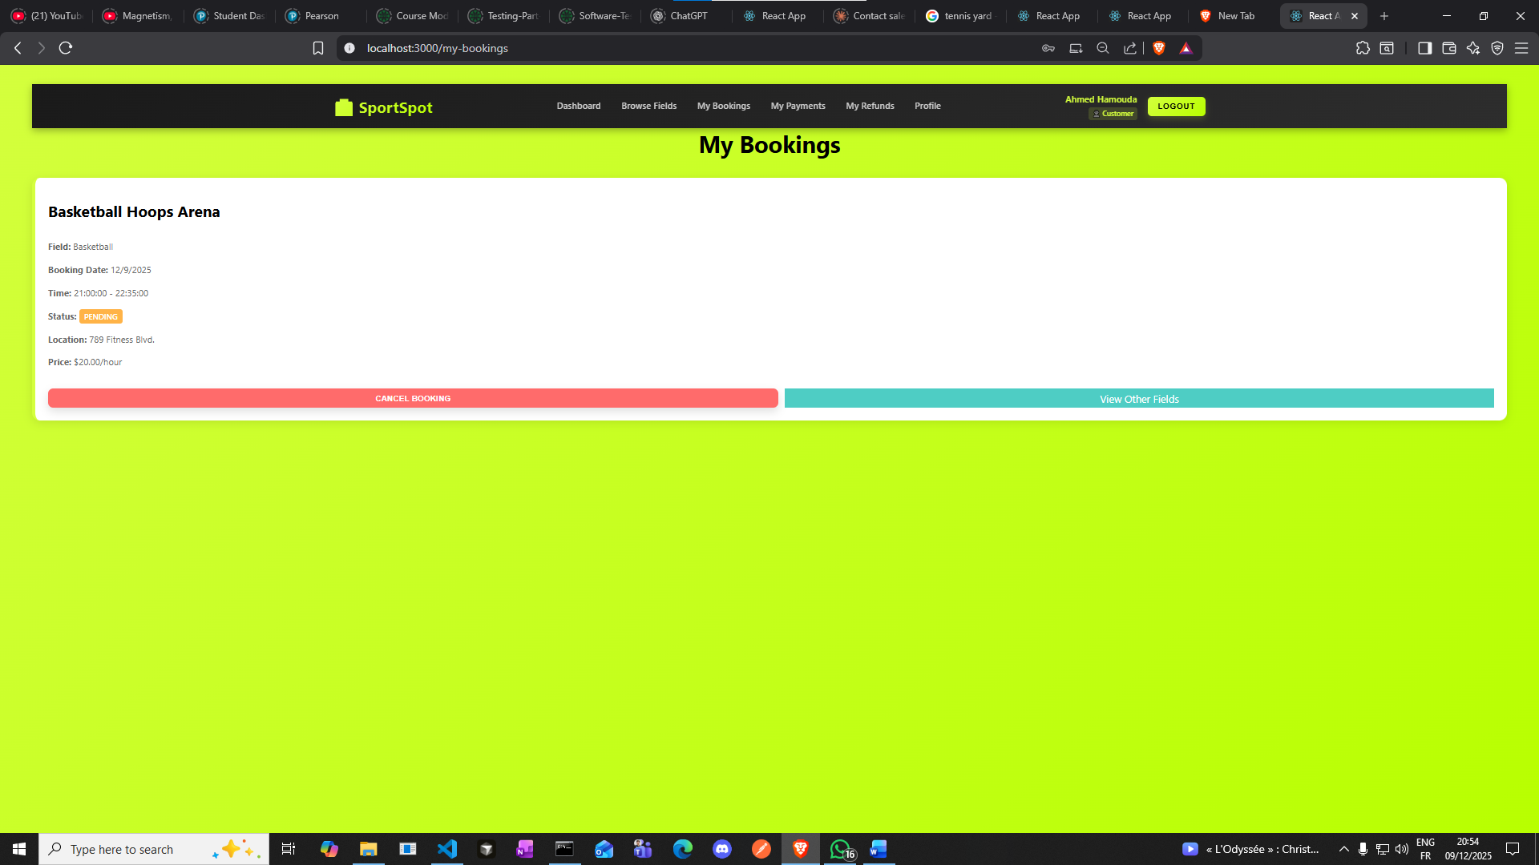

**Let’s cancel this booking through database:**

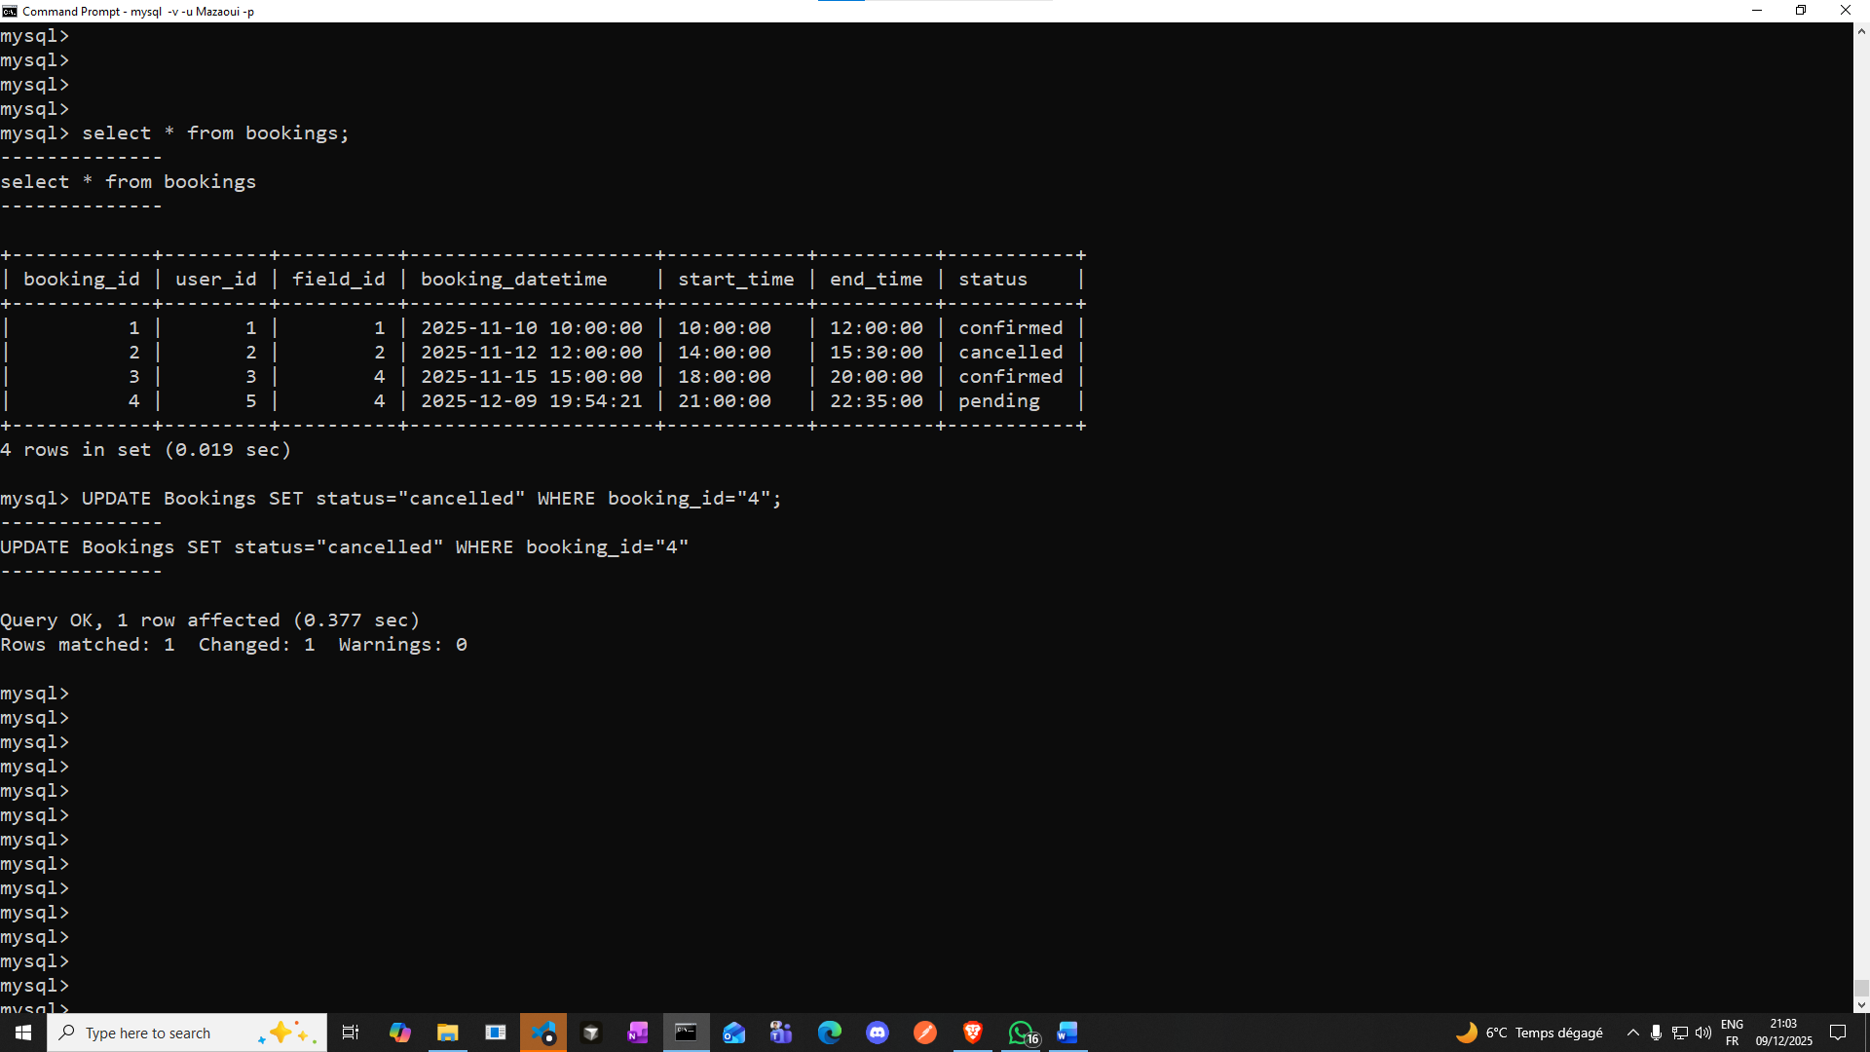

**Refresh our webpage**

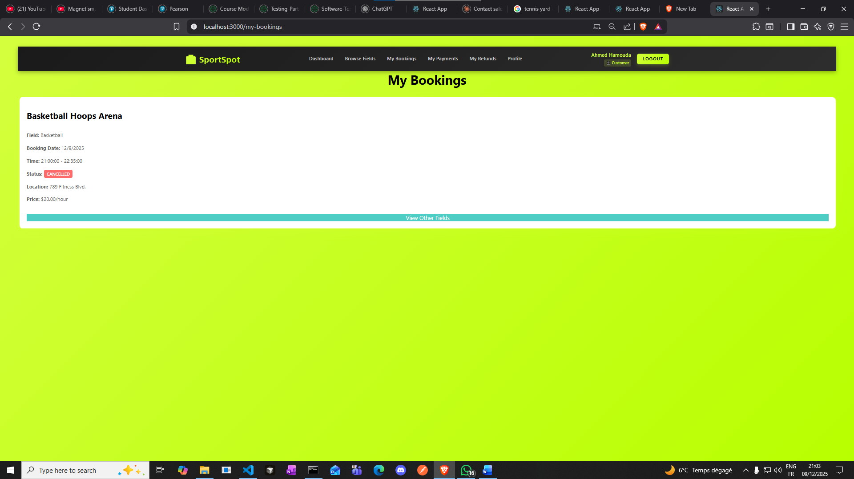

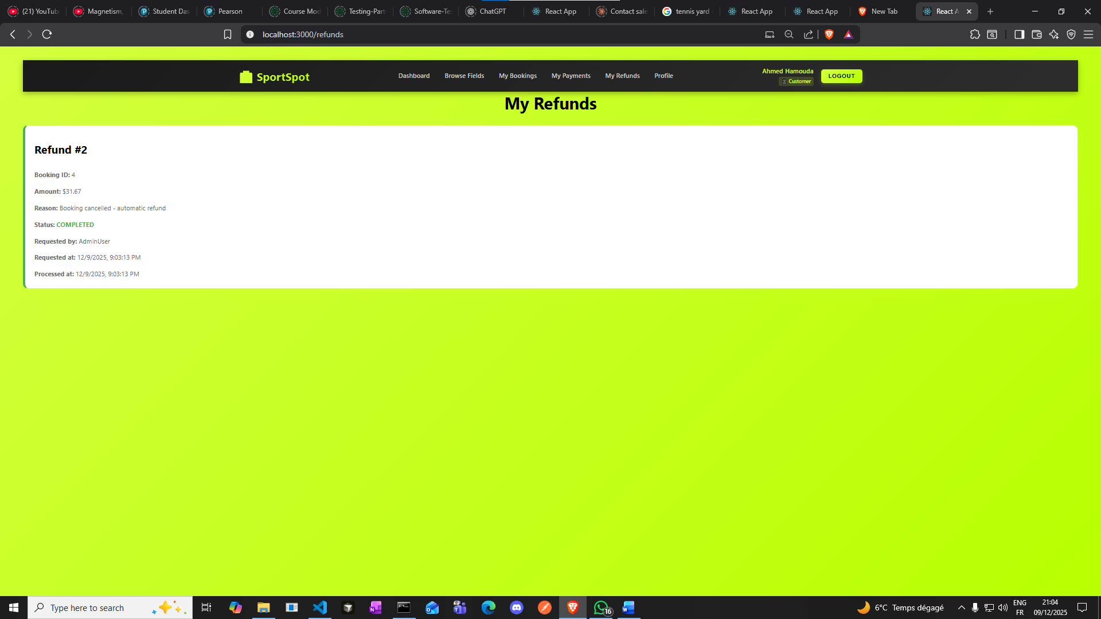

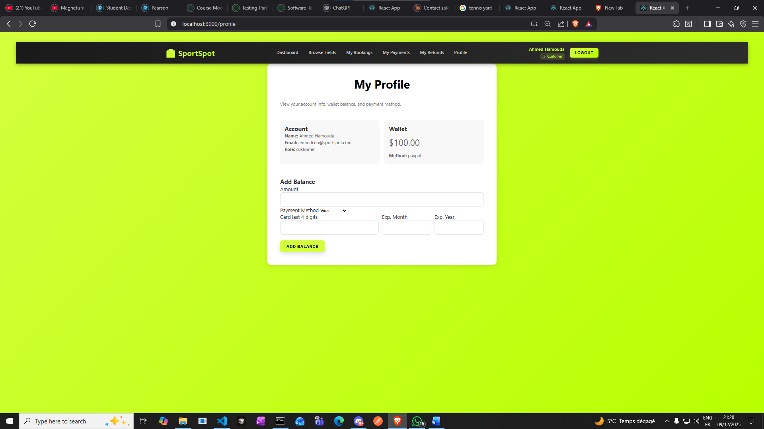

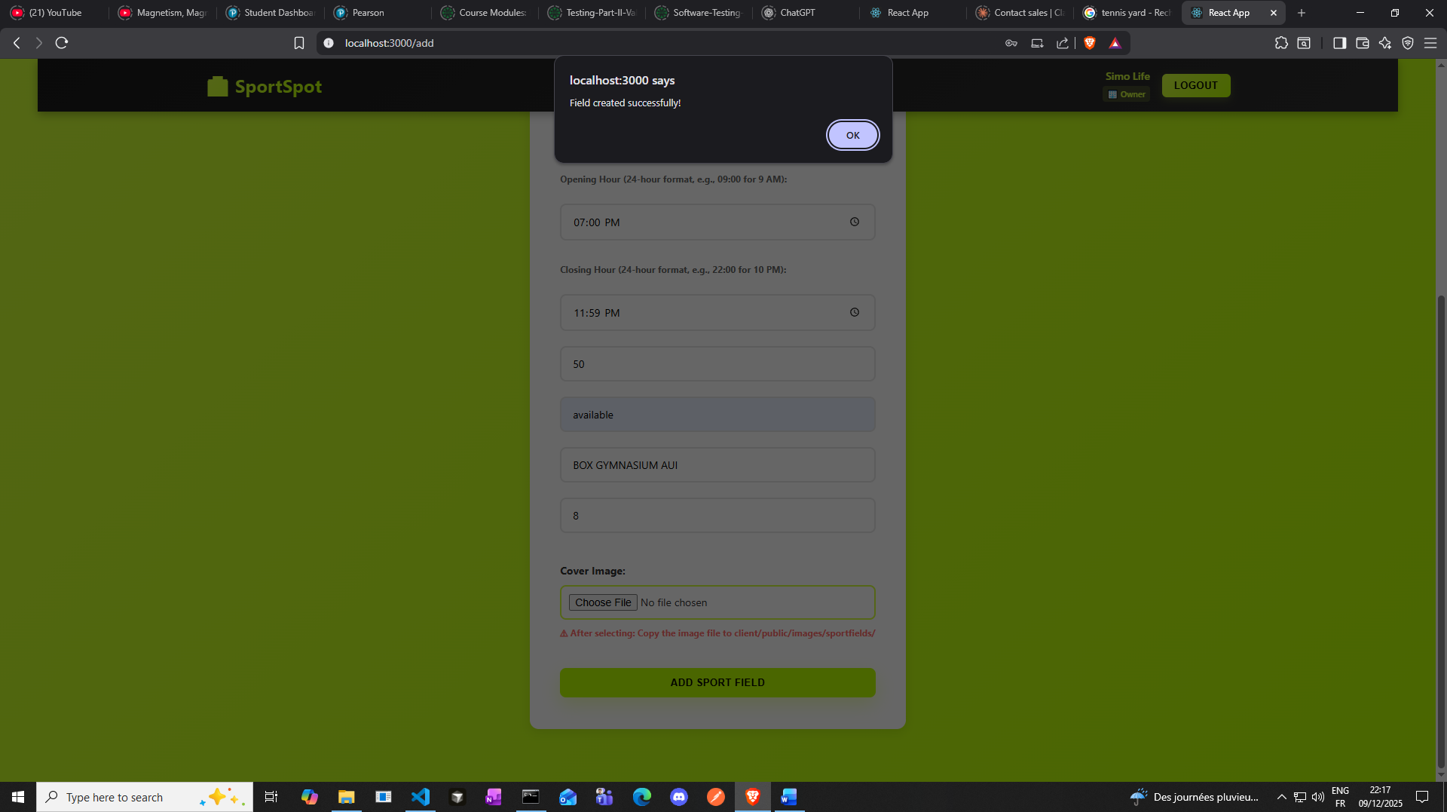

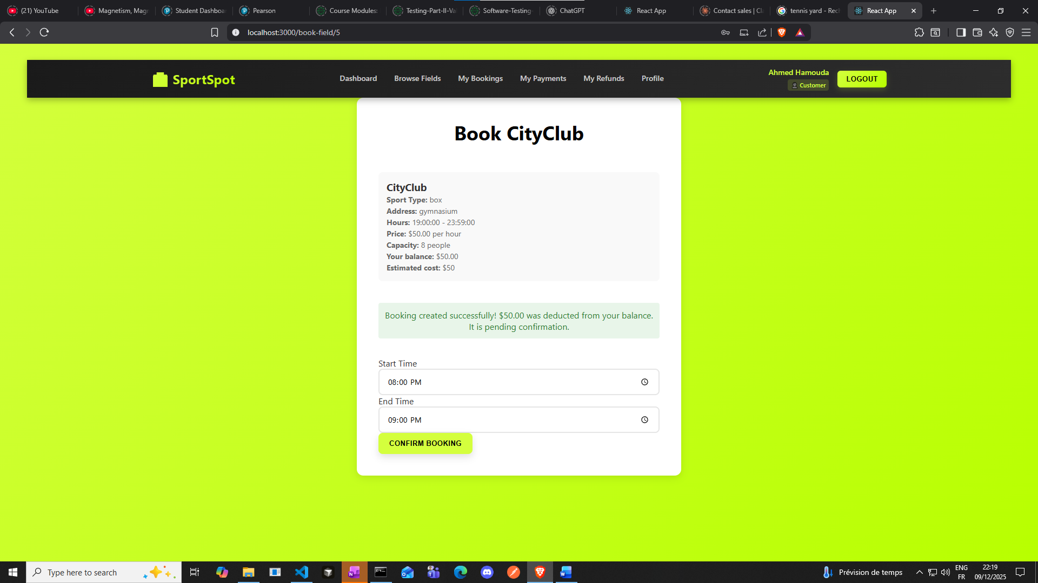

**Triggers Test:**

**Test trg_user_validate_phone_insert**

**Should FAIL (invalid phone format)**

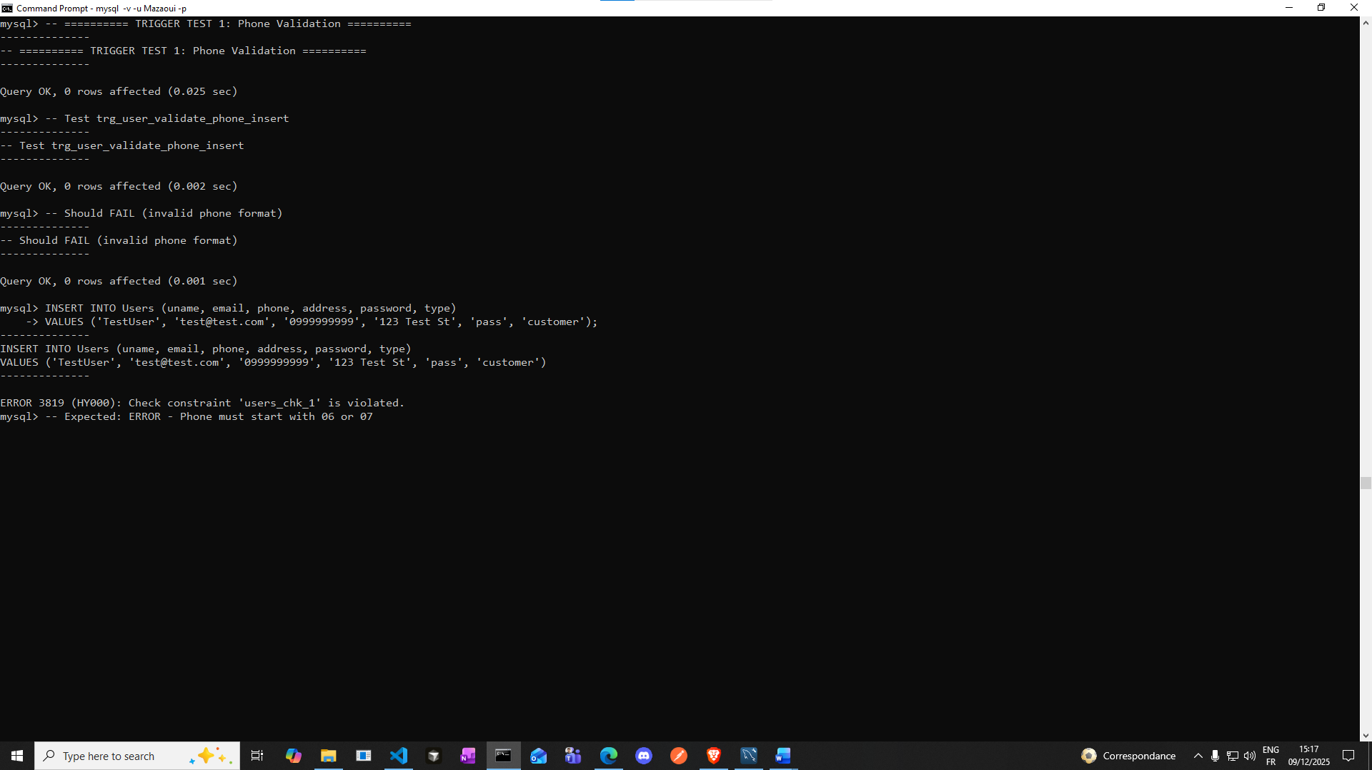

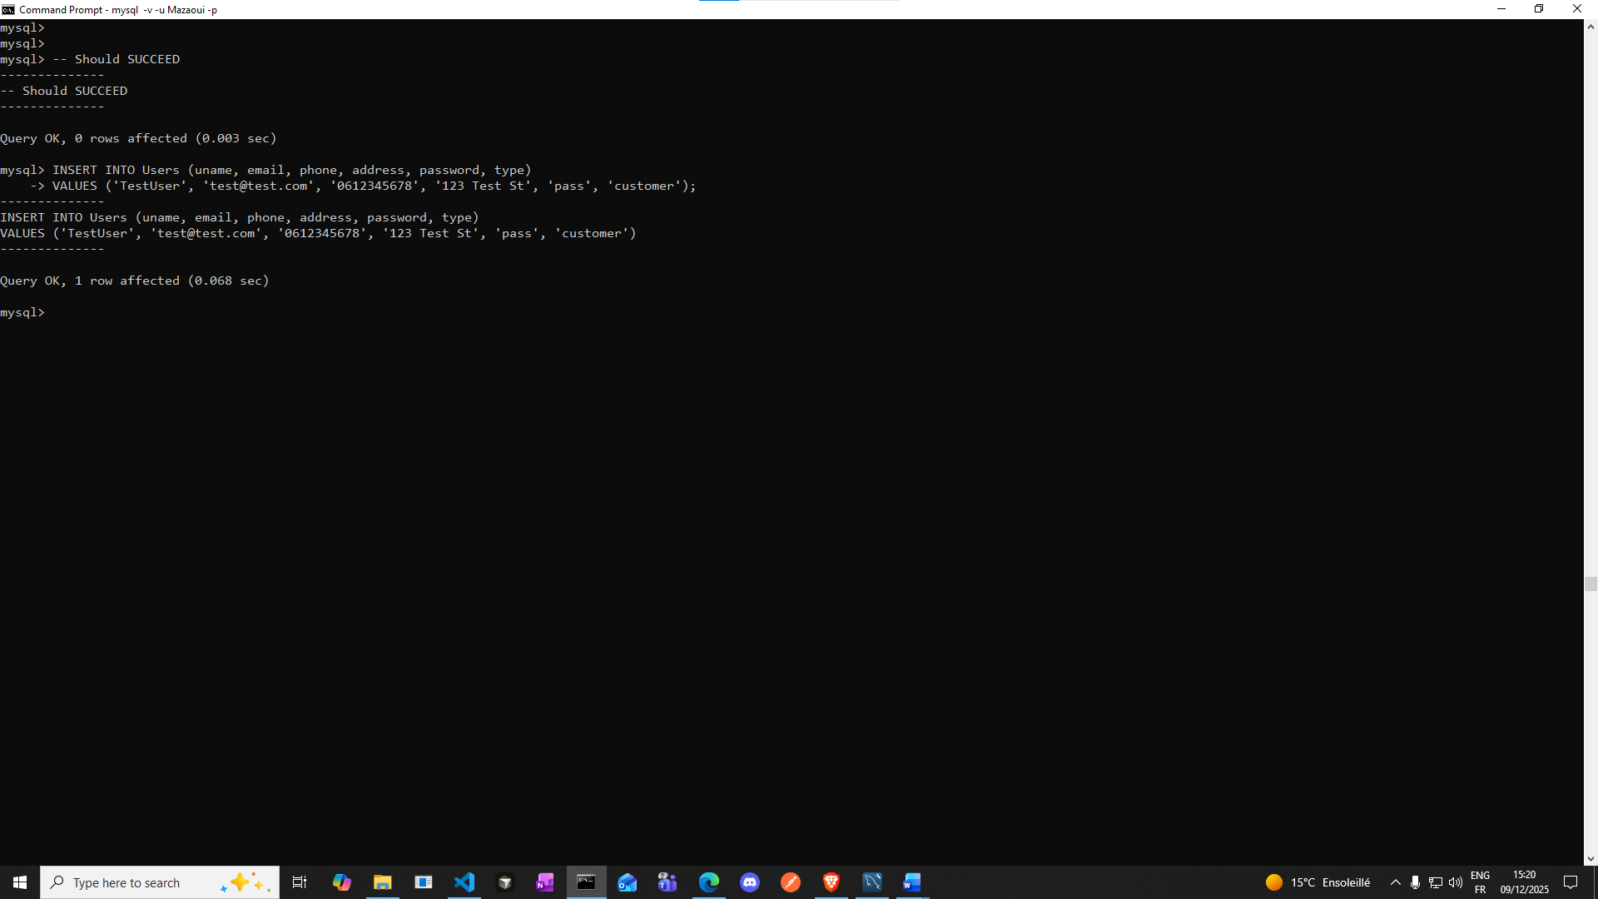

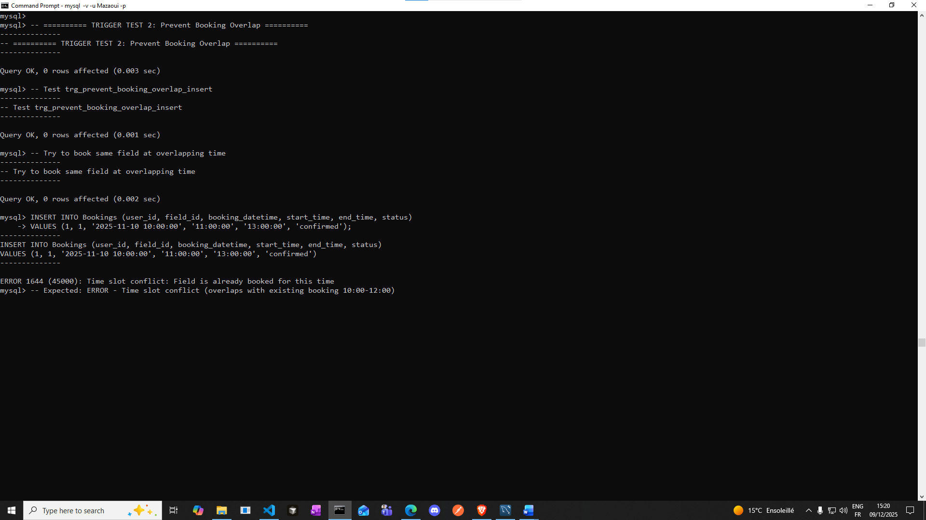

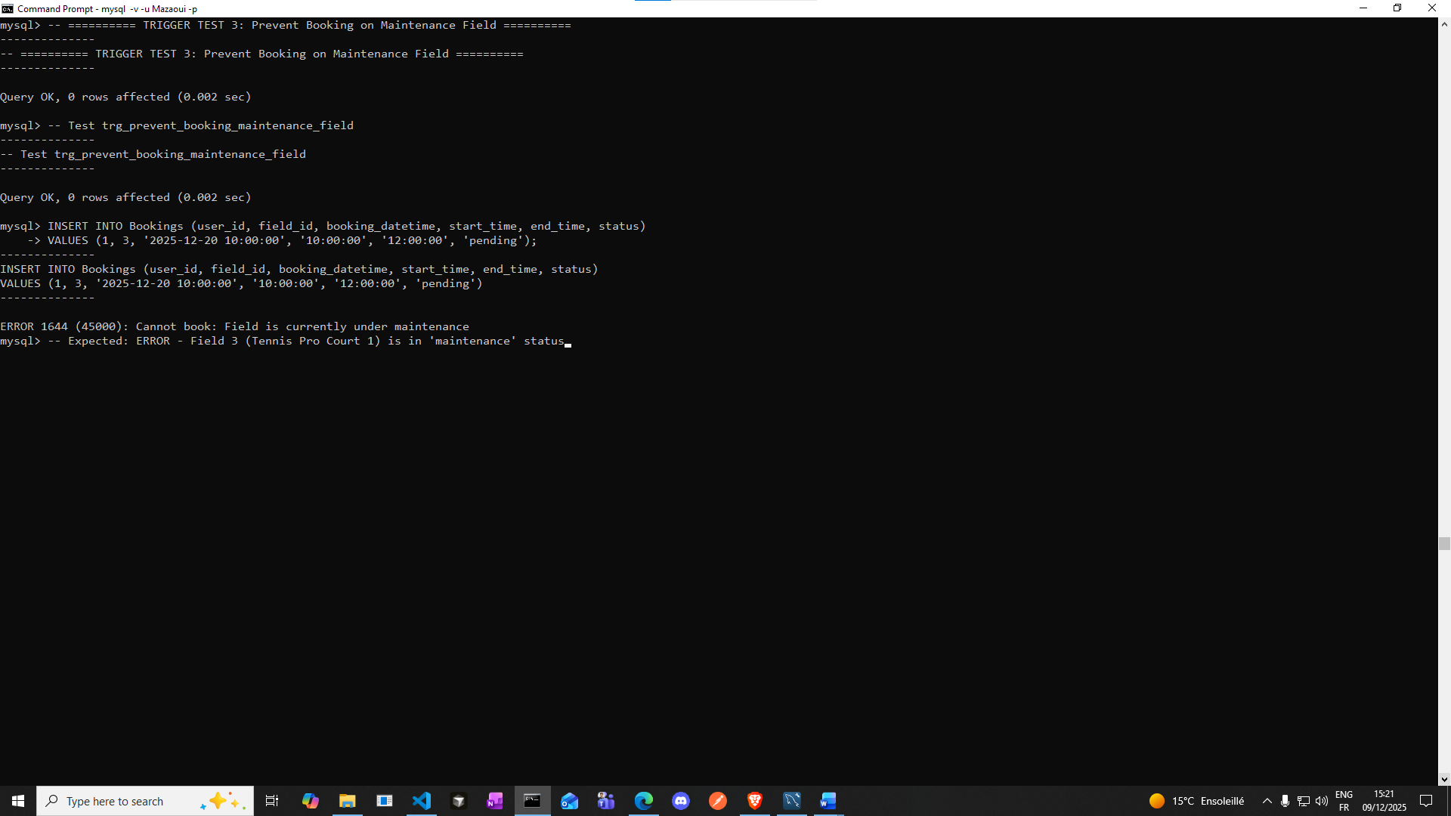

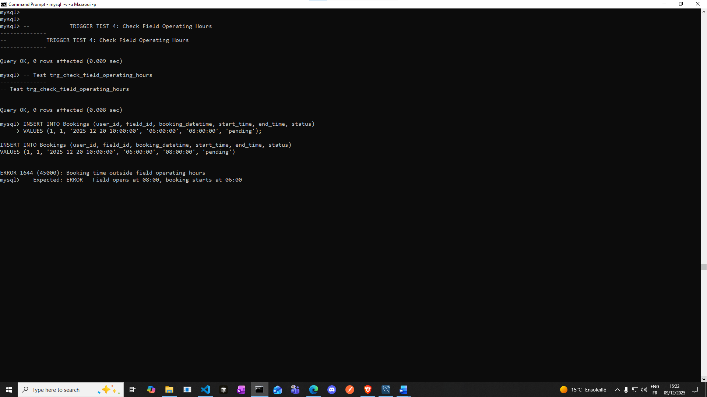

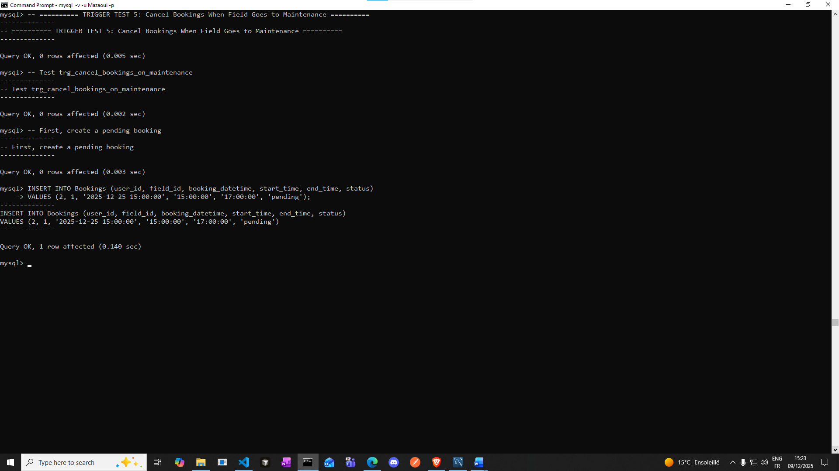

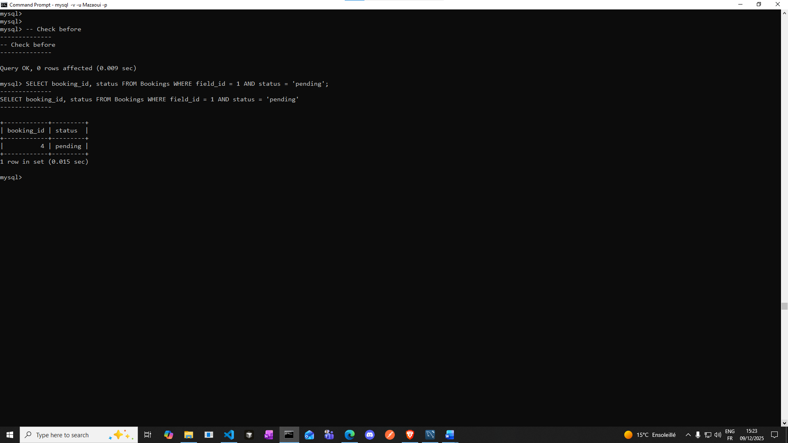

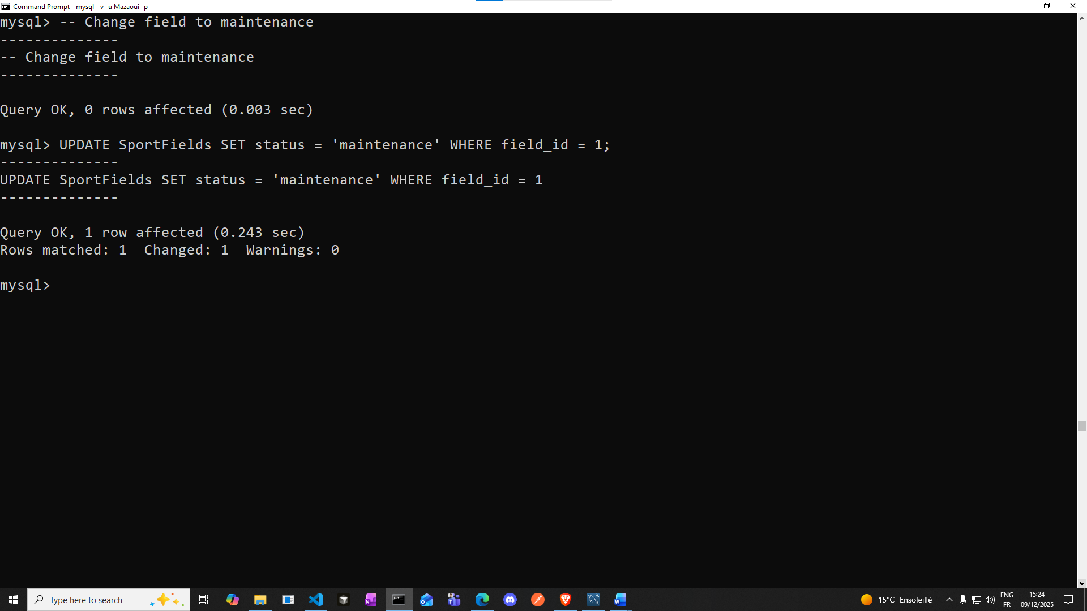

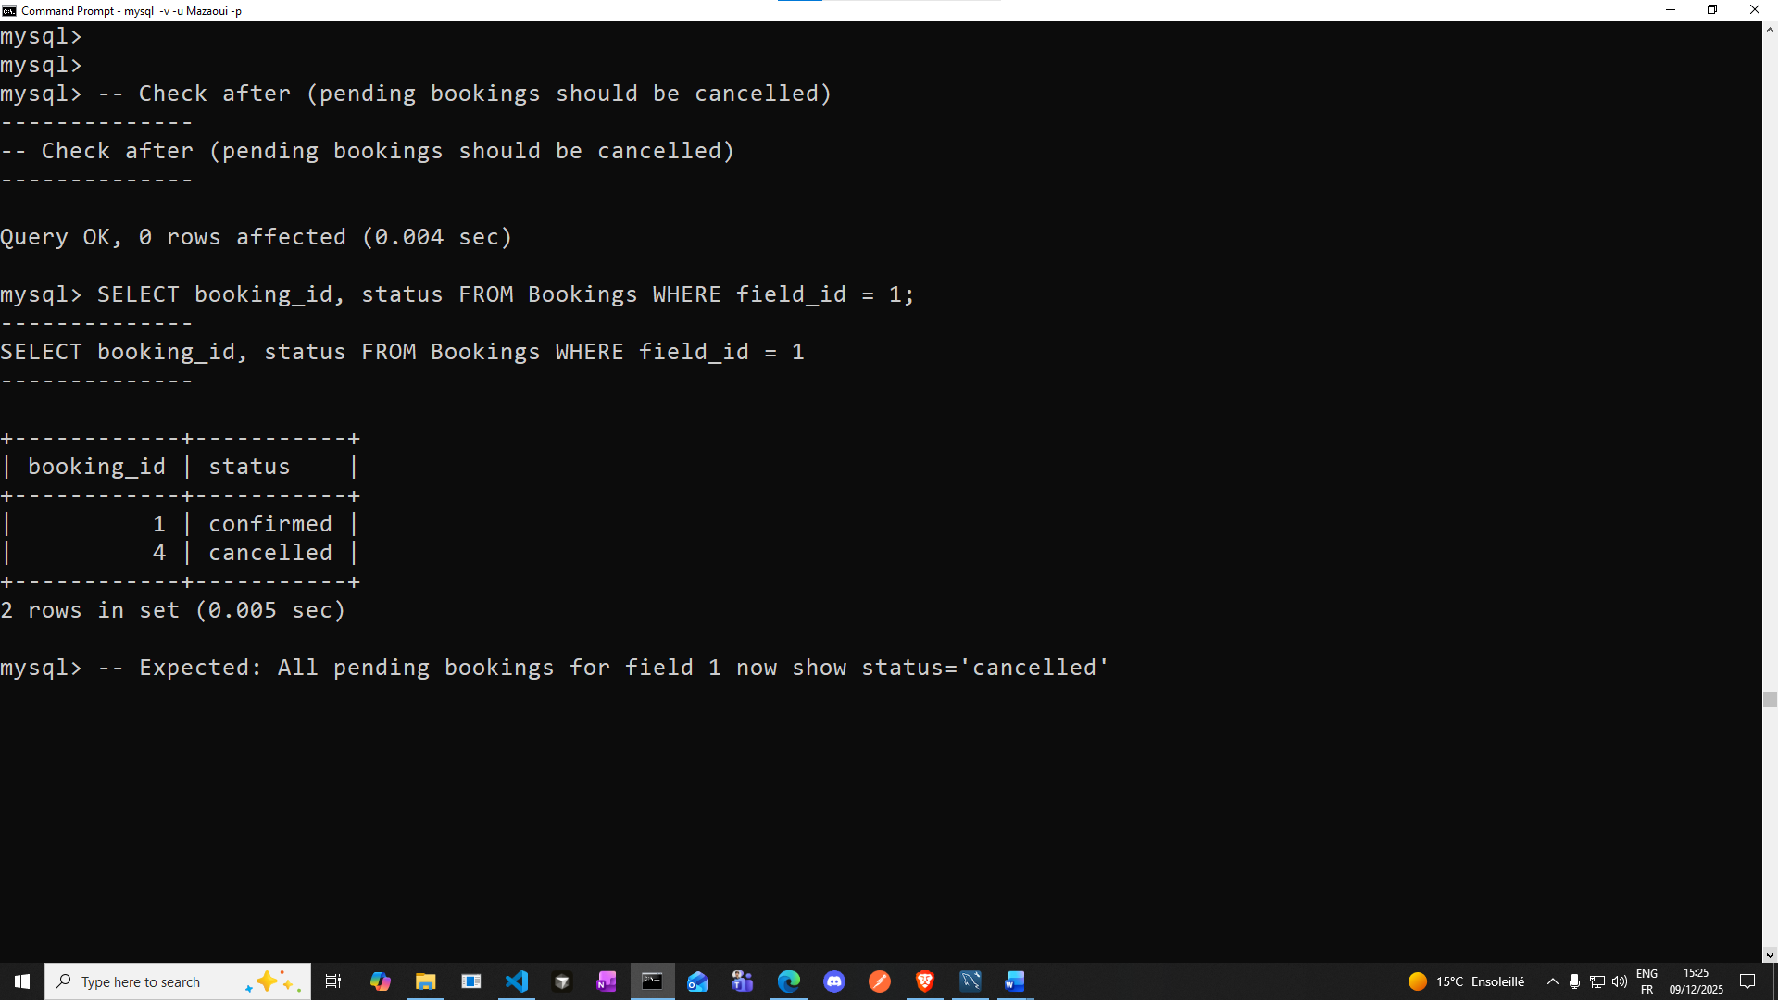

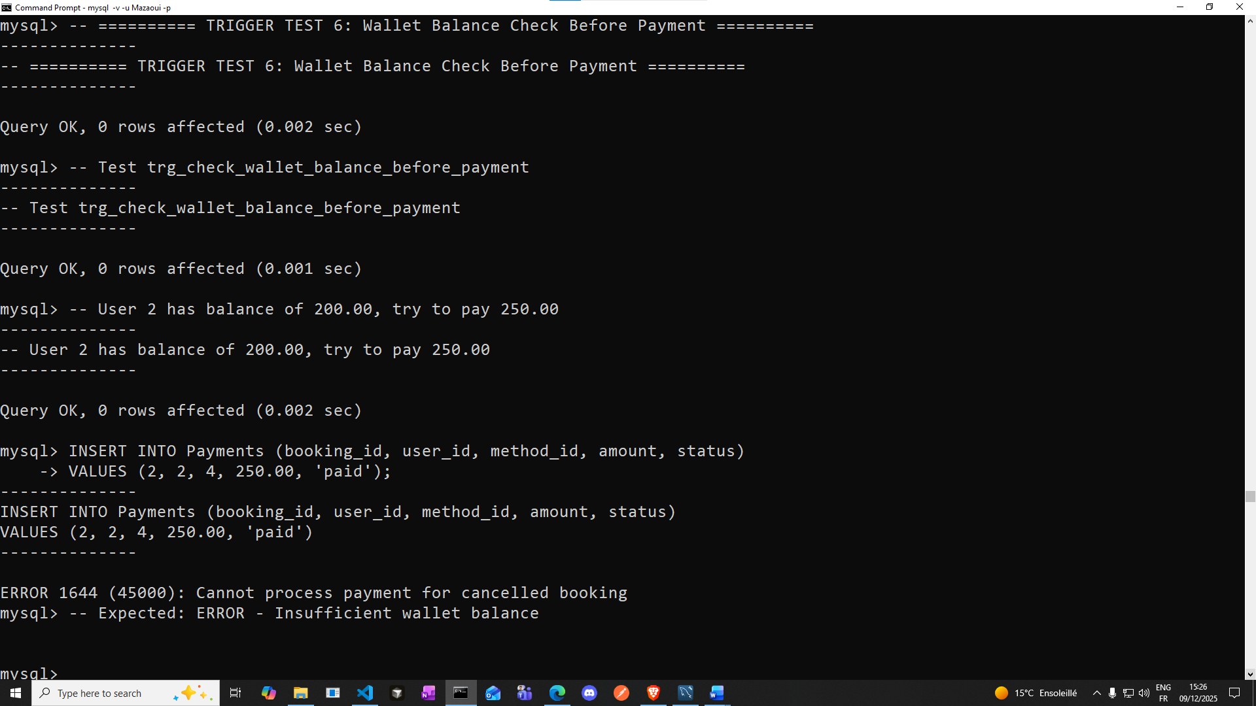

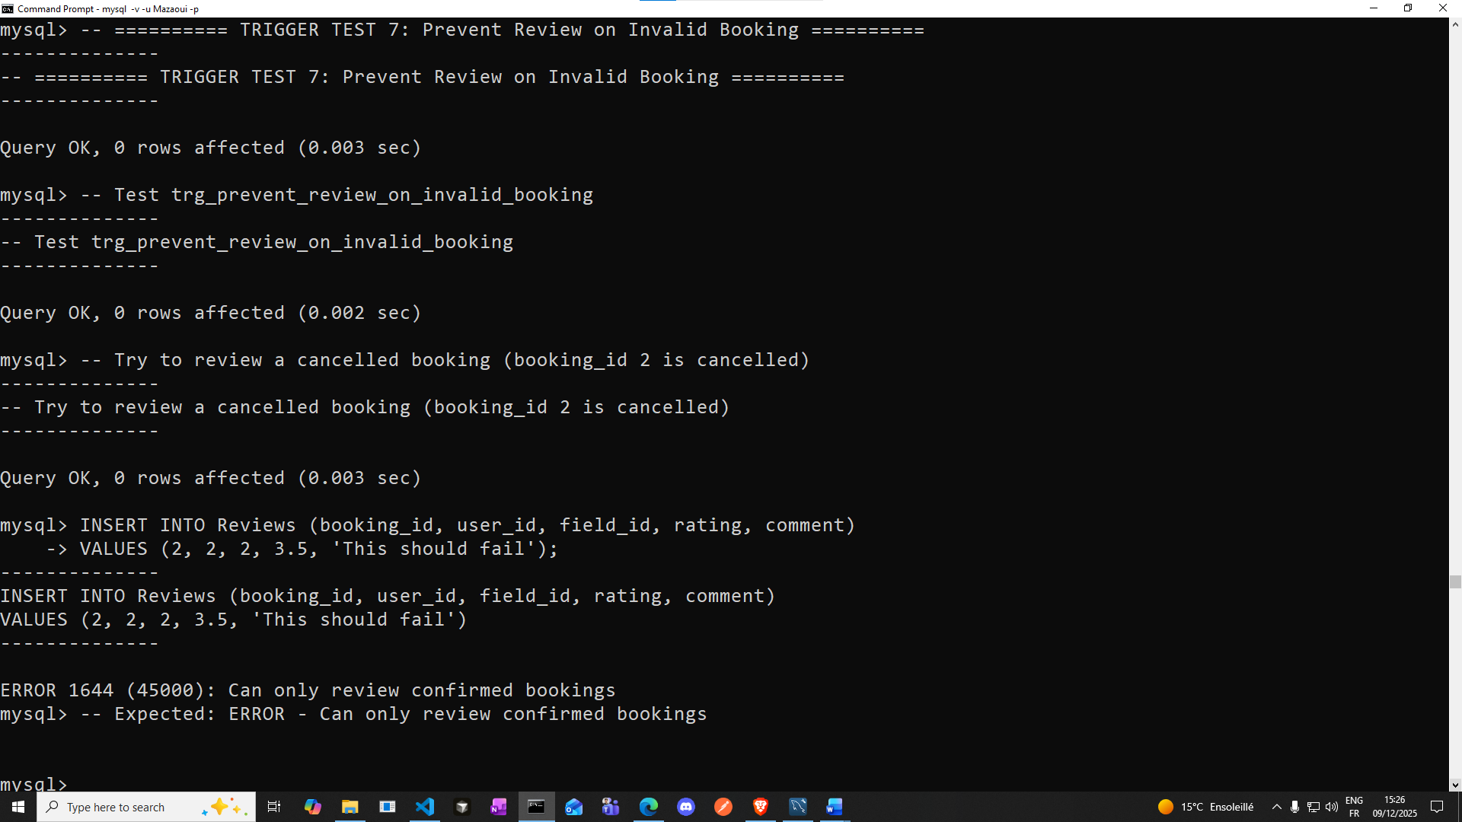

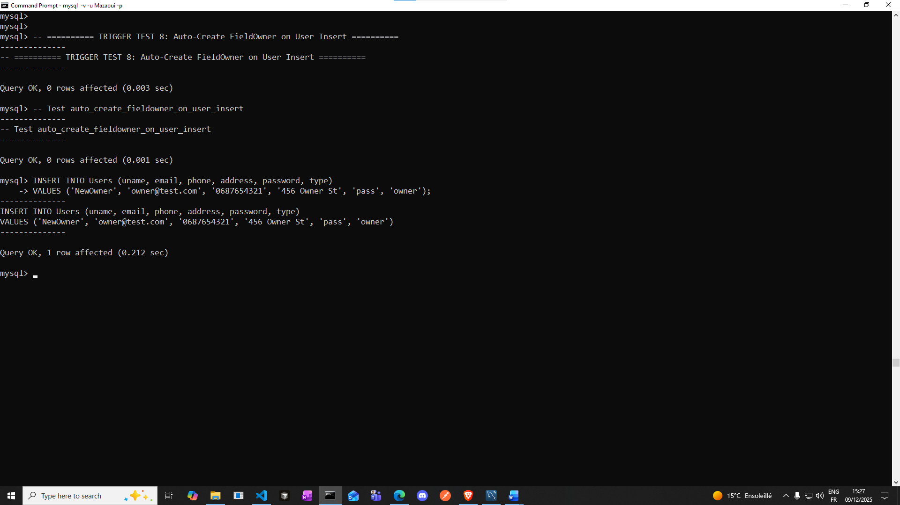

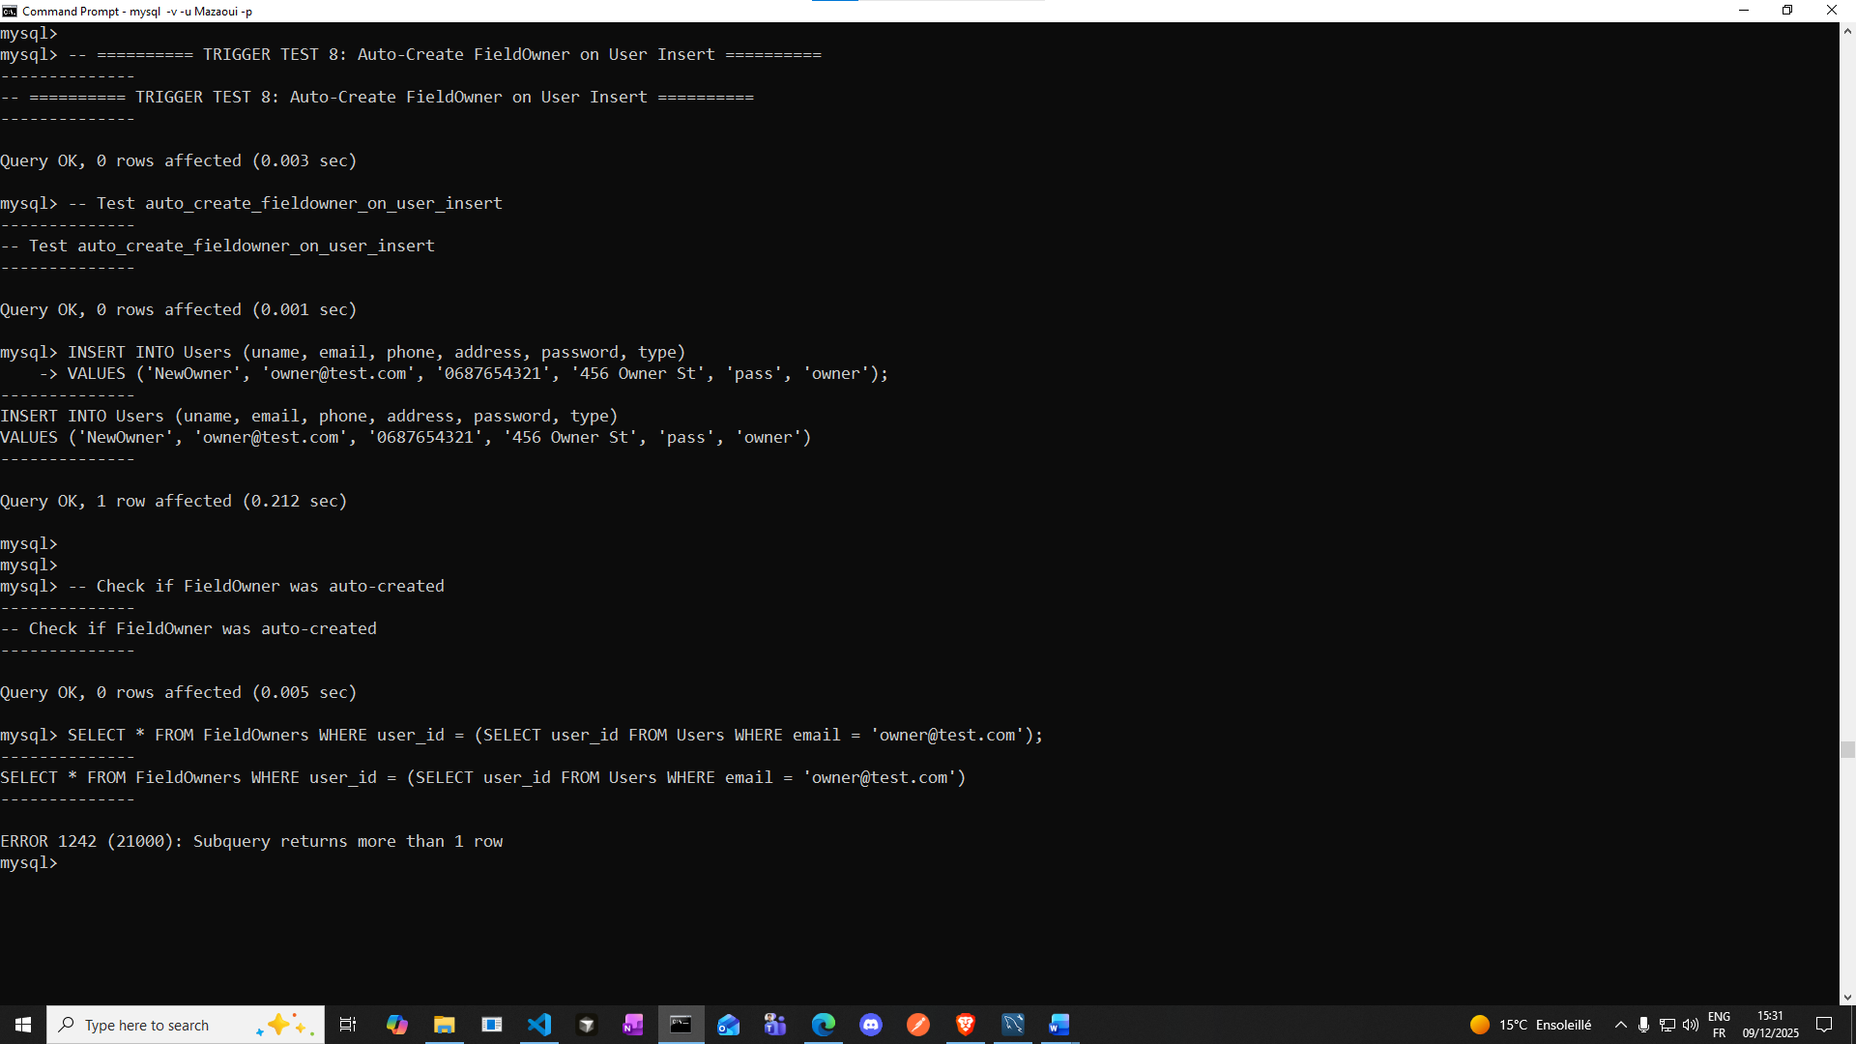

**This test above fails, because we have multiple users with similar emails (for example an admin could be also interested to book some field so he created an account of type customer with the same email to book a field)**

**So the solution is:**

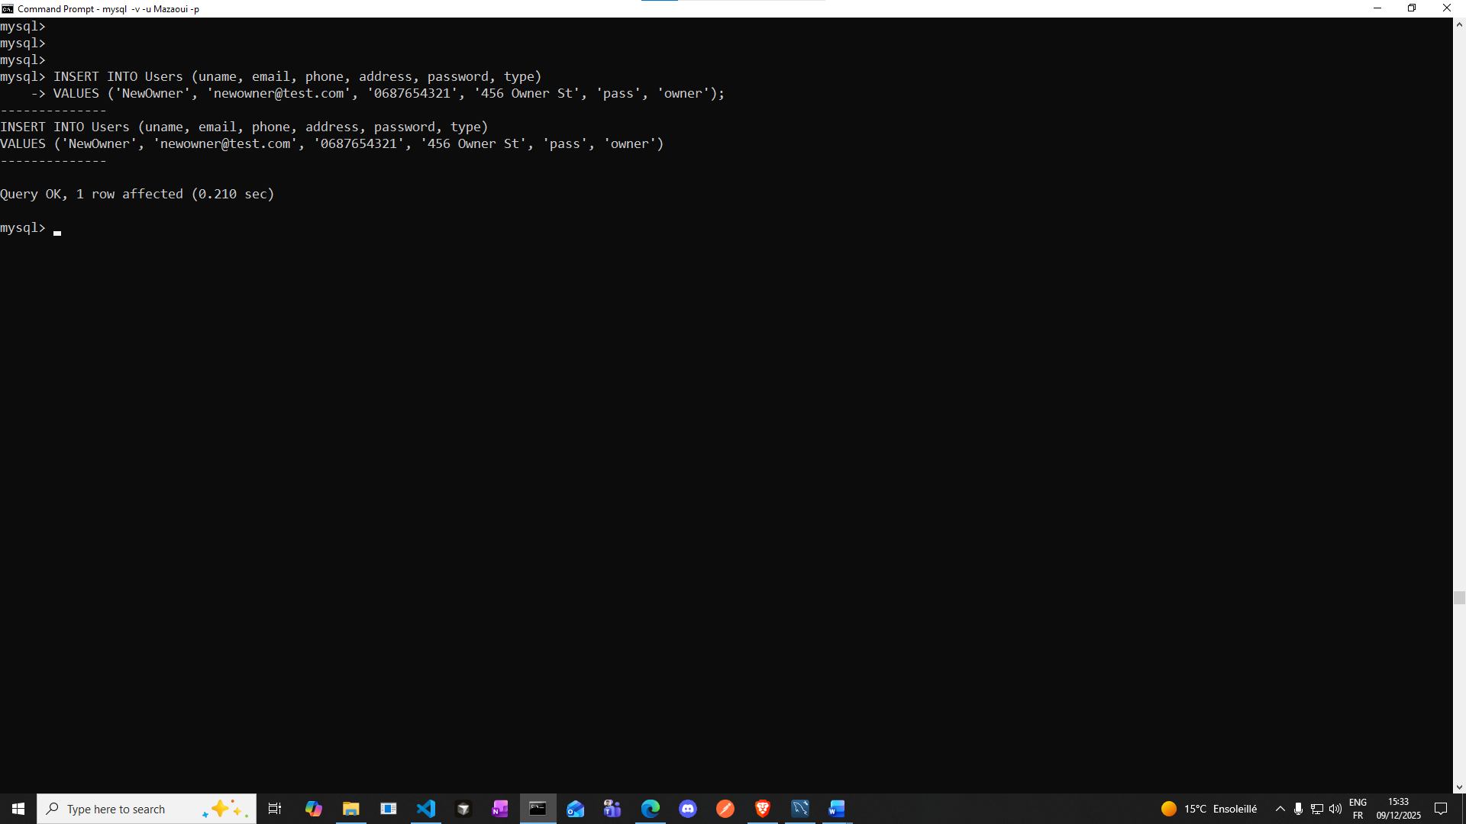

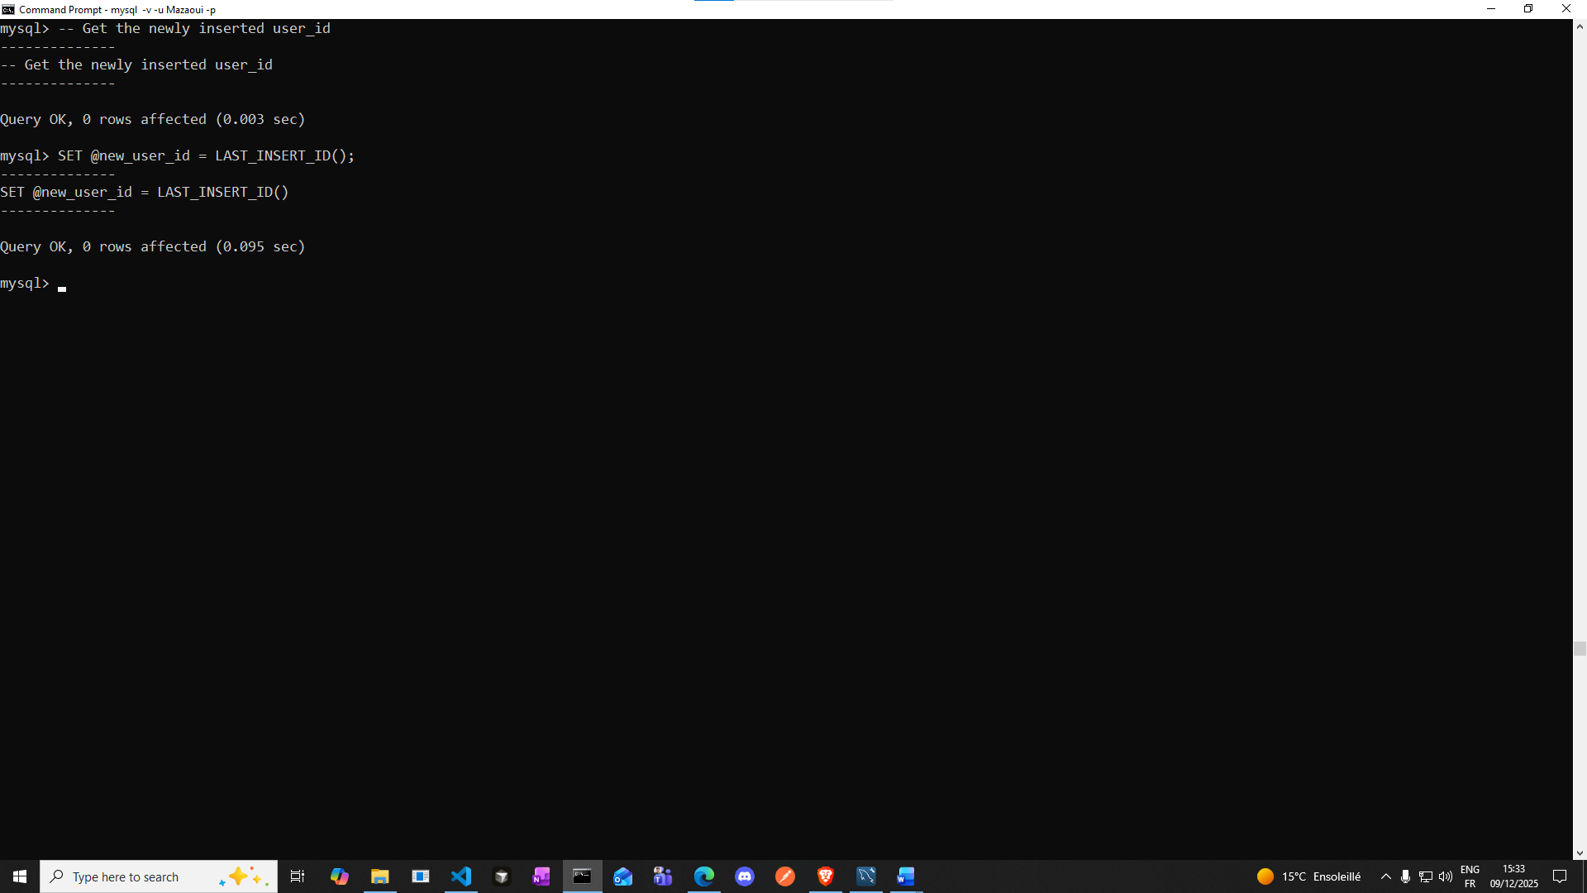

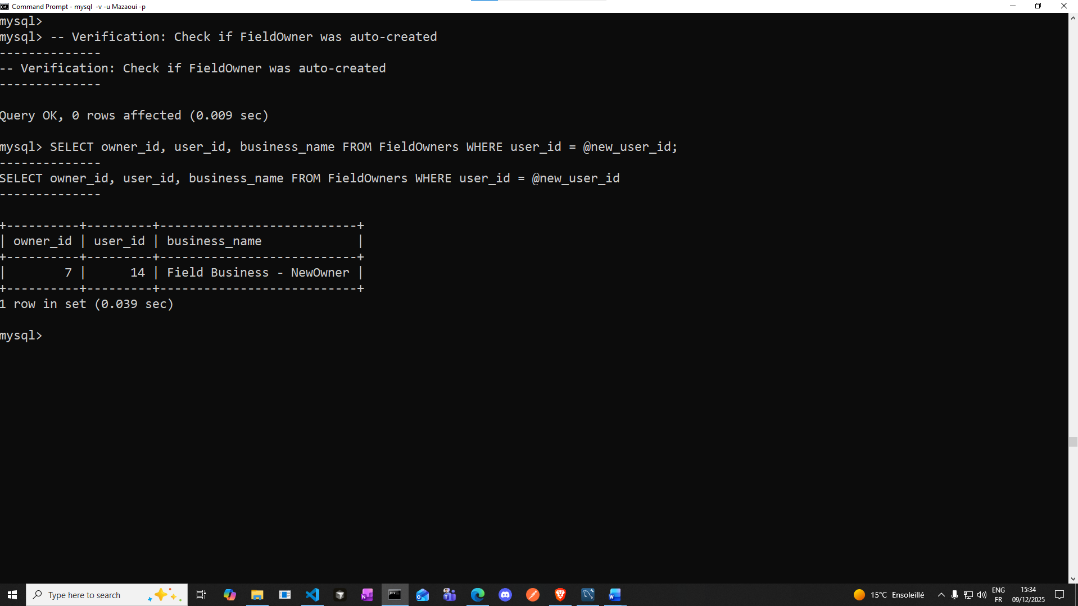

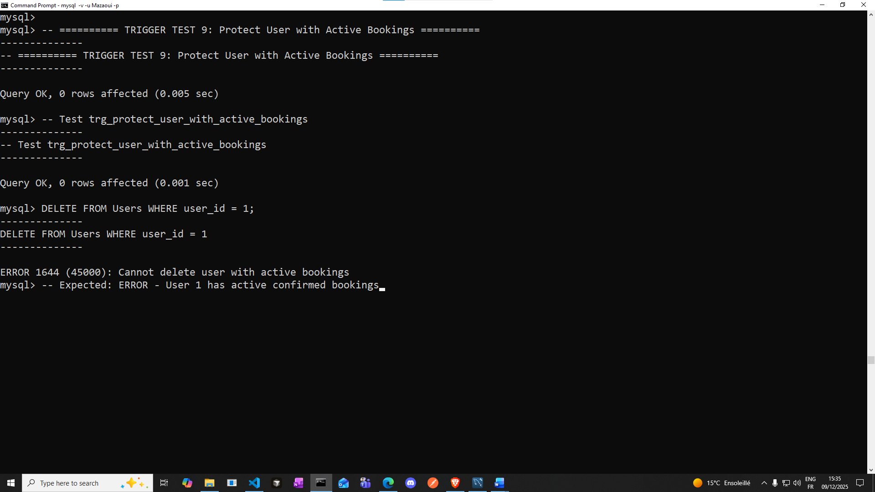

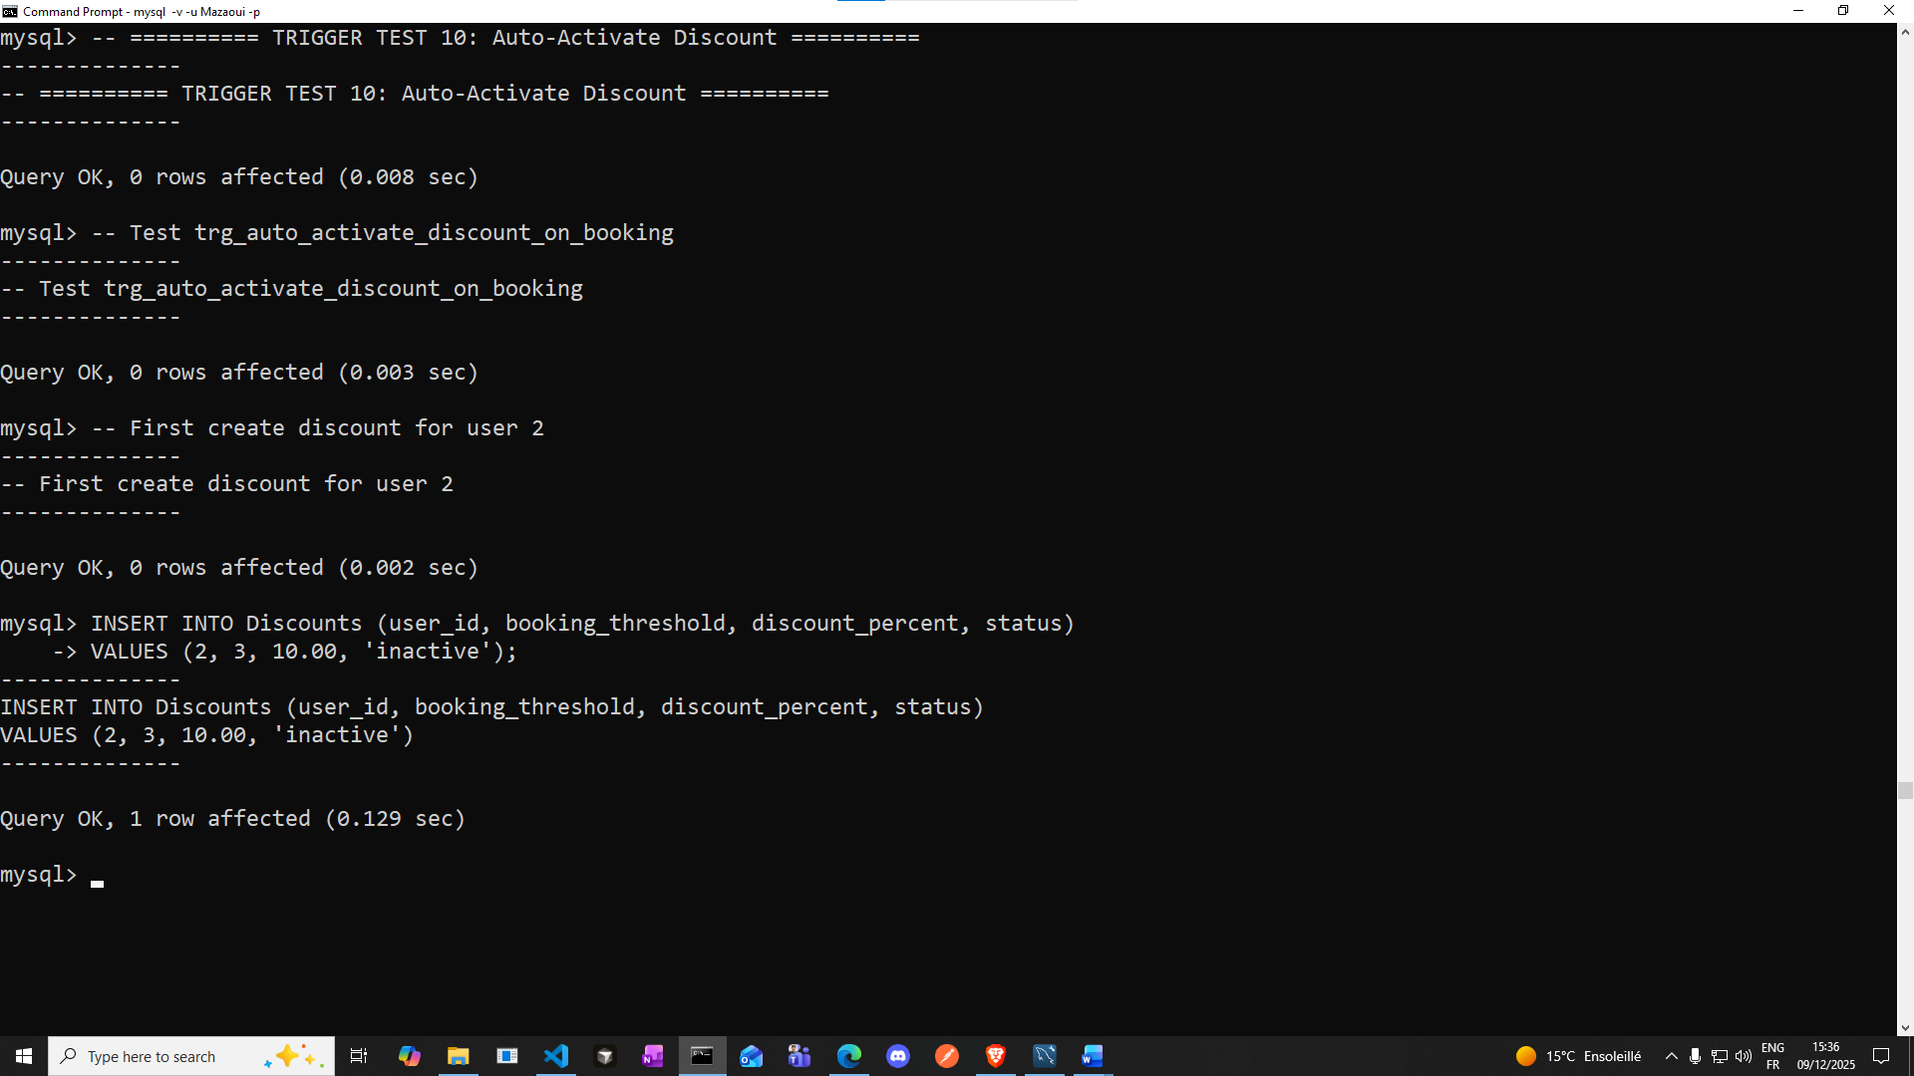

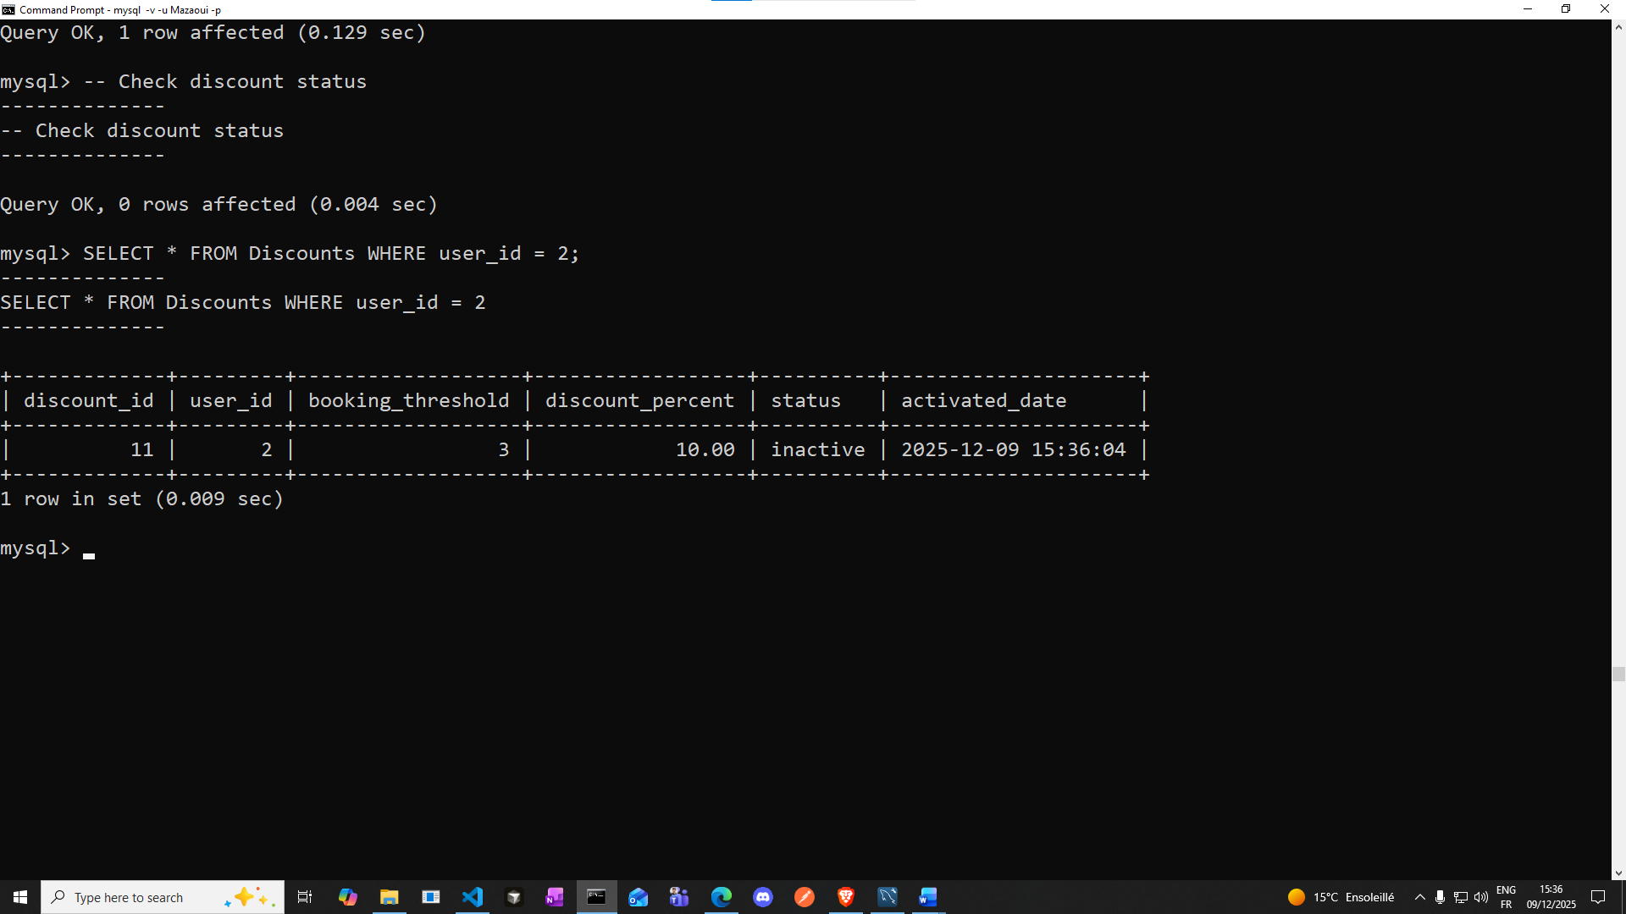

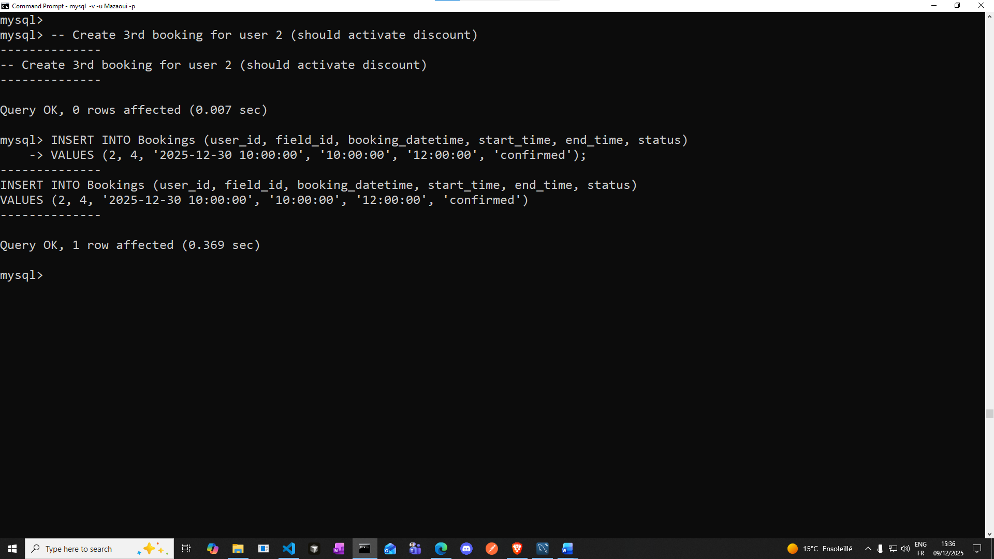

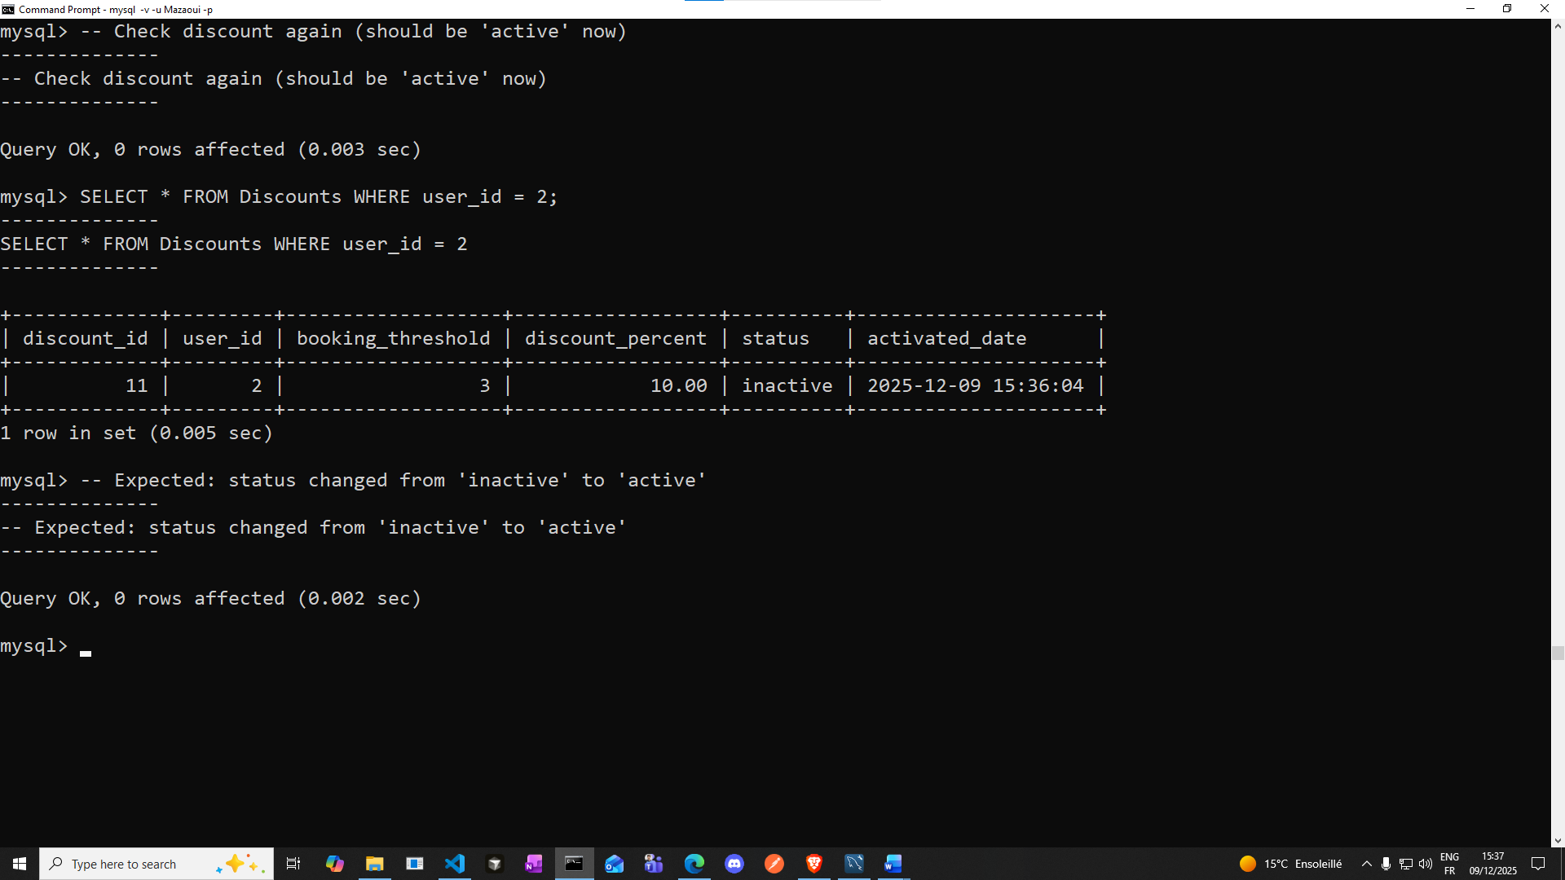

**(please zoom in)**

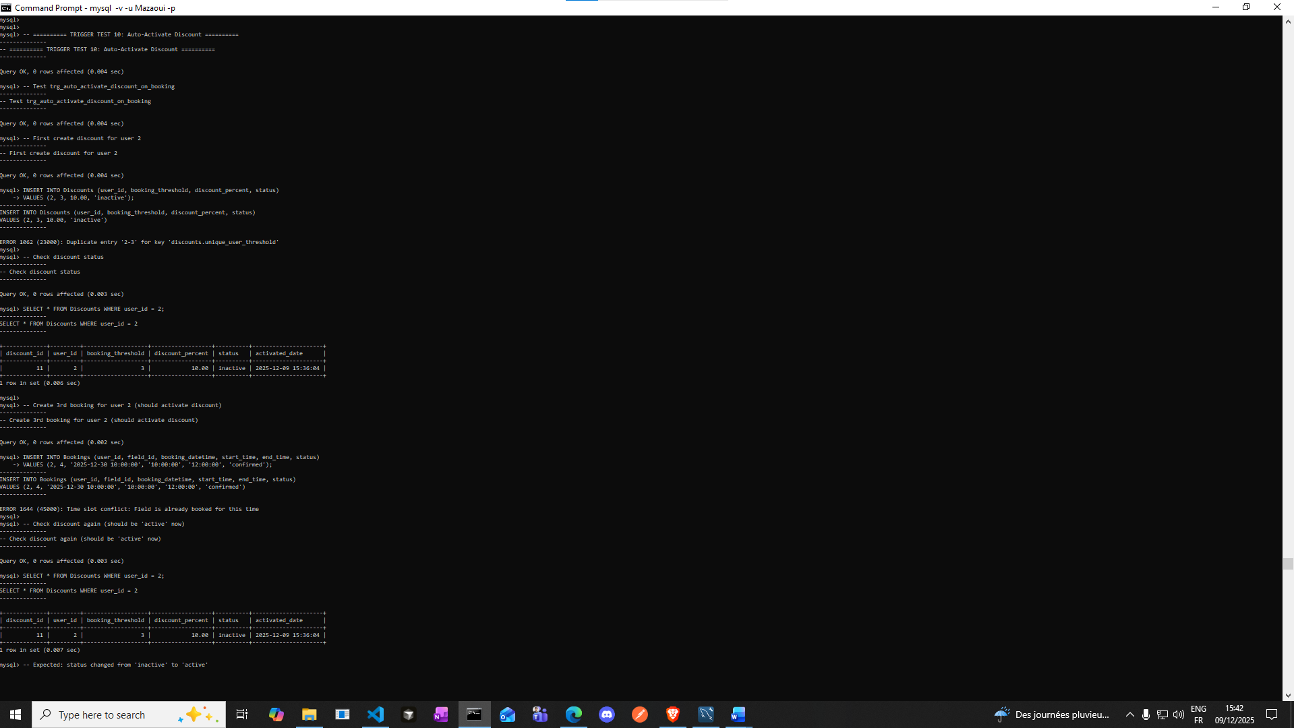

**Well here the test did not really fail, because the triggers are doing their job**

1. **First error: ERROR 1862 (23000): Duplicate entry '2-3' for key 'discounts.unique_user_threshold'**

**We tried to insert a discount for user 2 with threshold 3, but one already exists and The UNIQUE constraint prevents duplicates**

1. **Second error: ERROR 1644 (45000): Time slot conflict: field is already booked for this time because The booking overlapped with an existing booking, so the trigger trg_prevent_booking_overlap_insert blocked it**

**So Actually it’s a good sign.**

**But we can use a corrected test:**

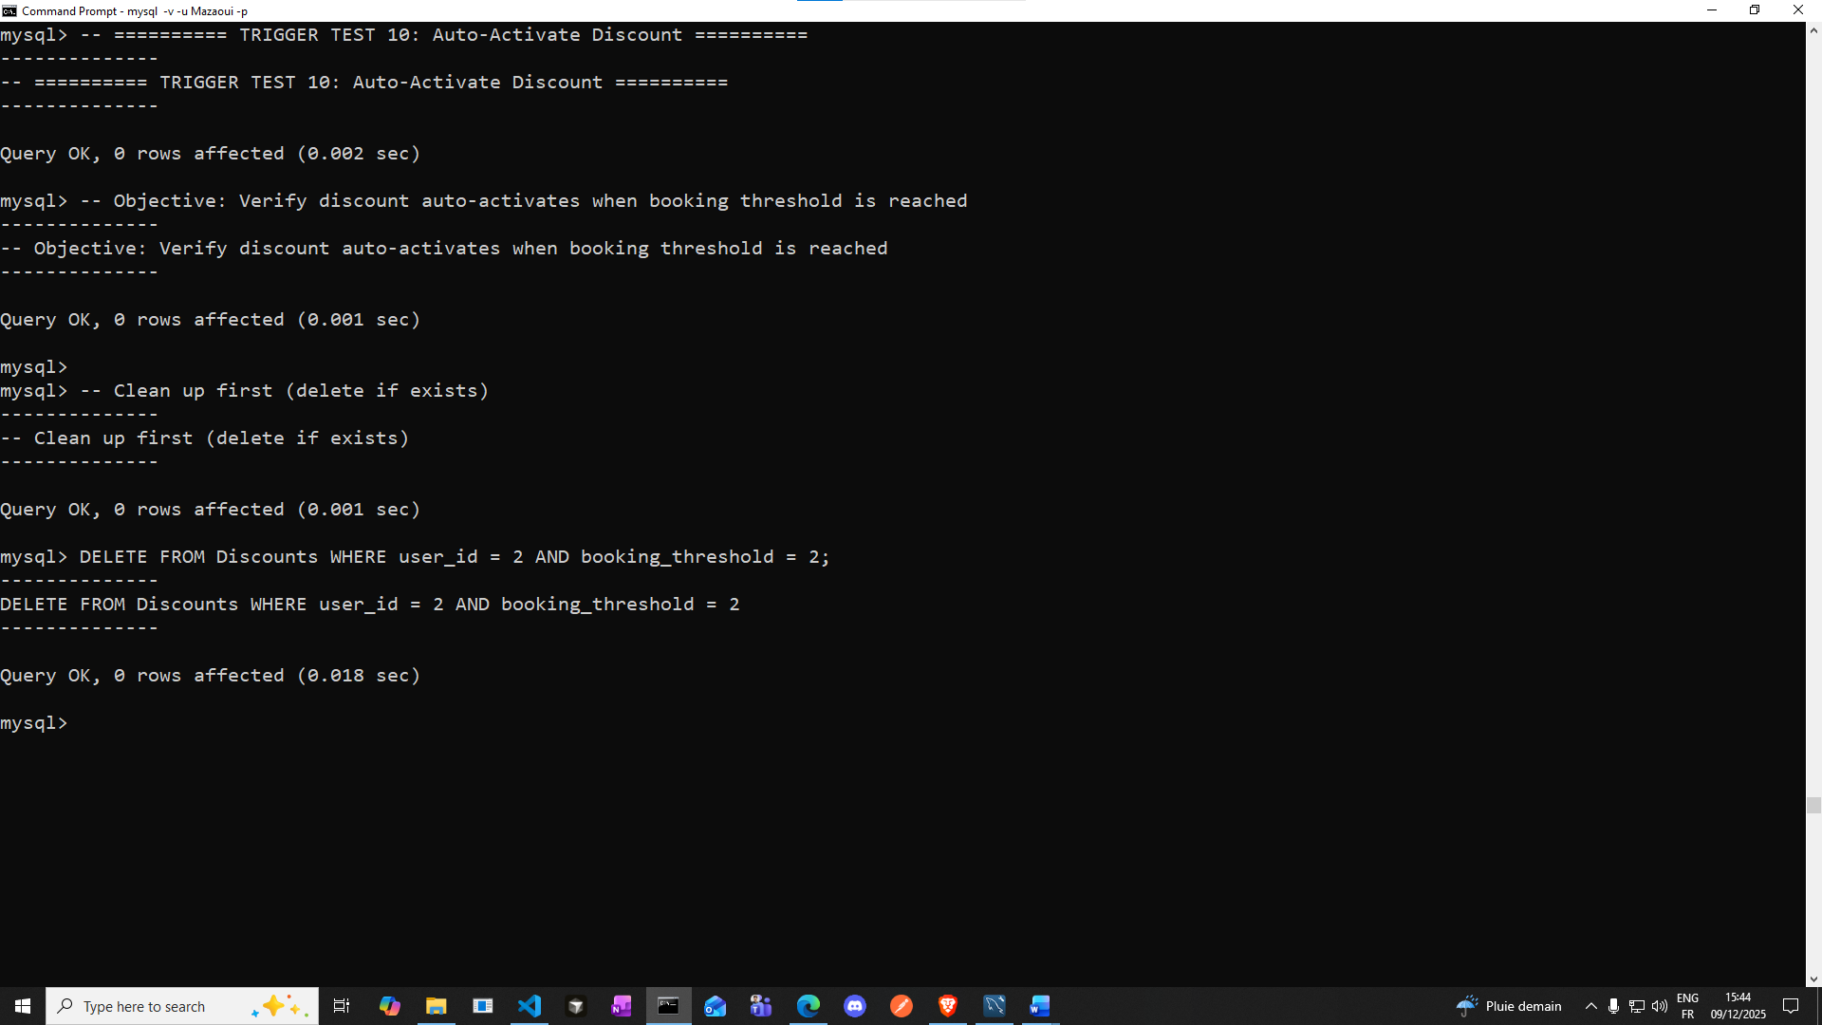

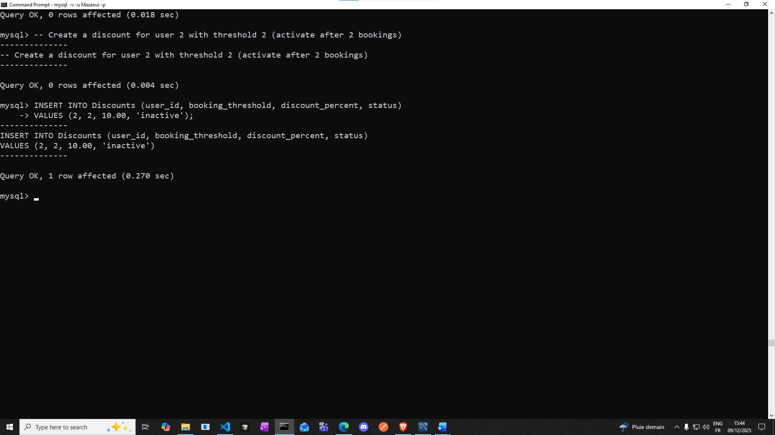

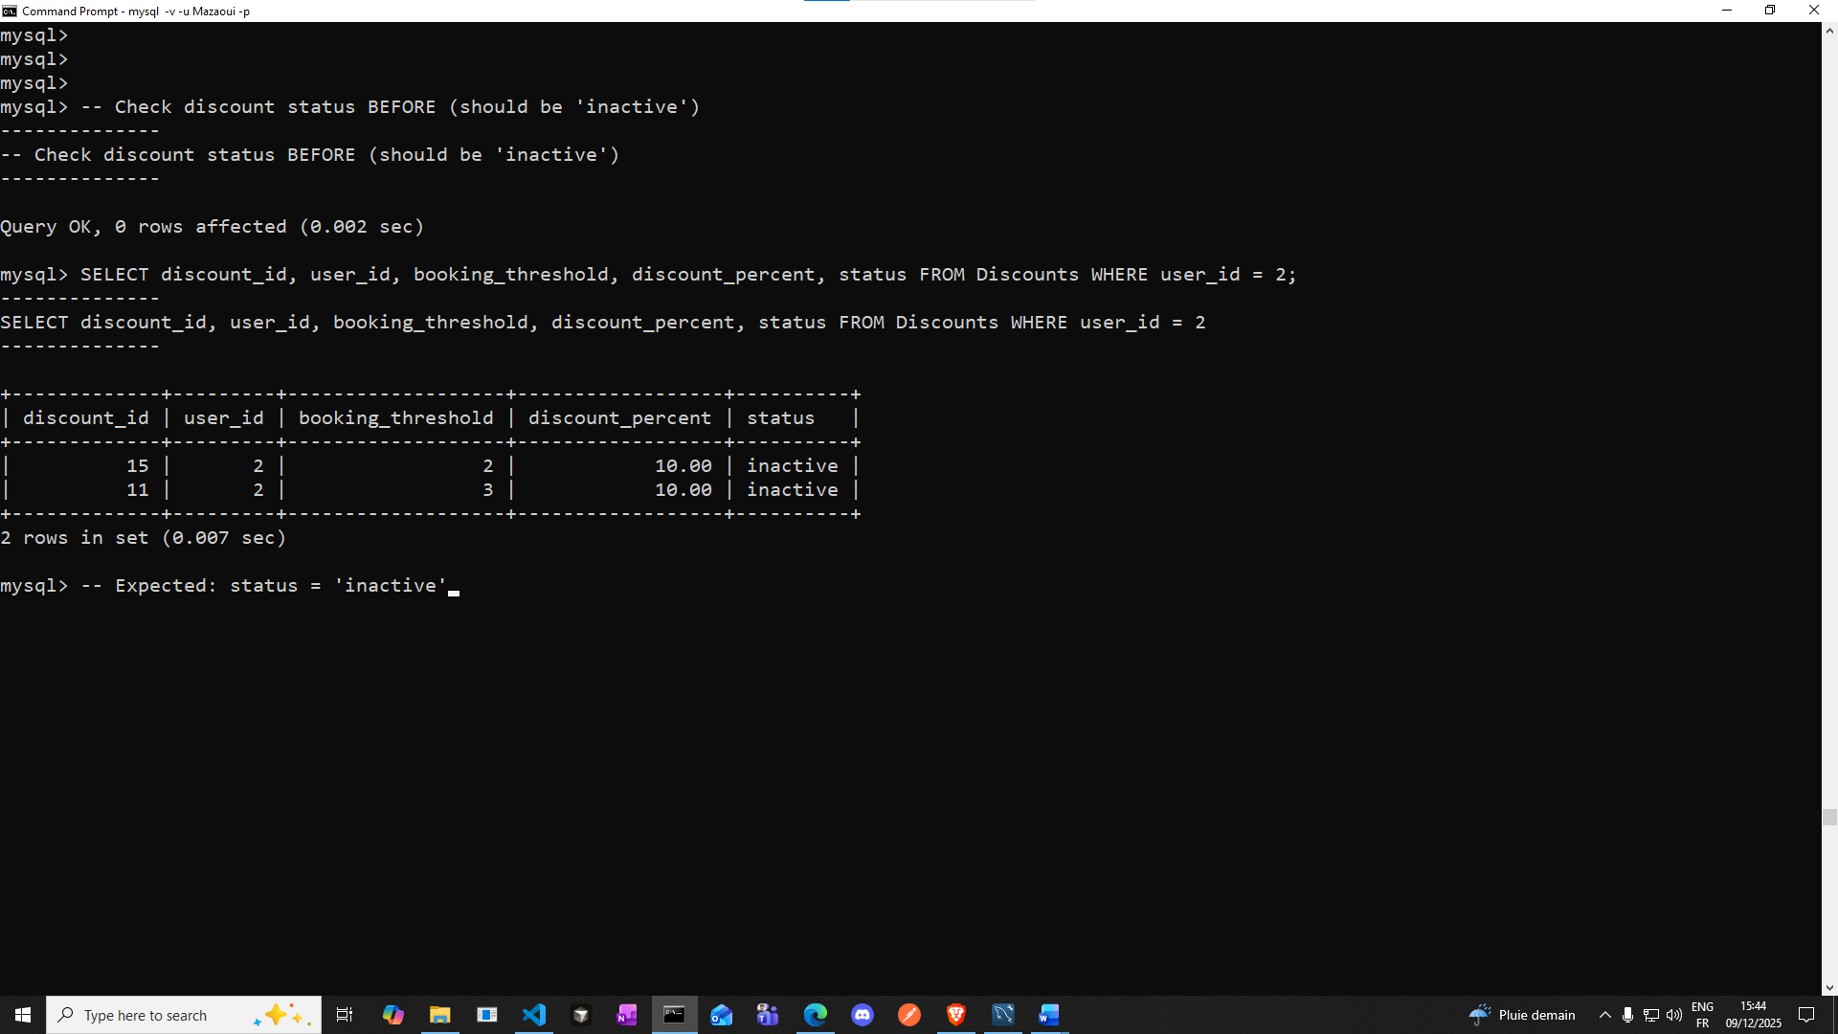

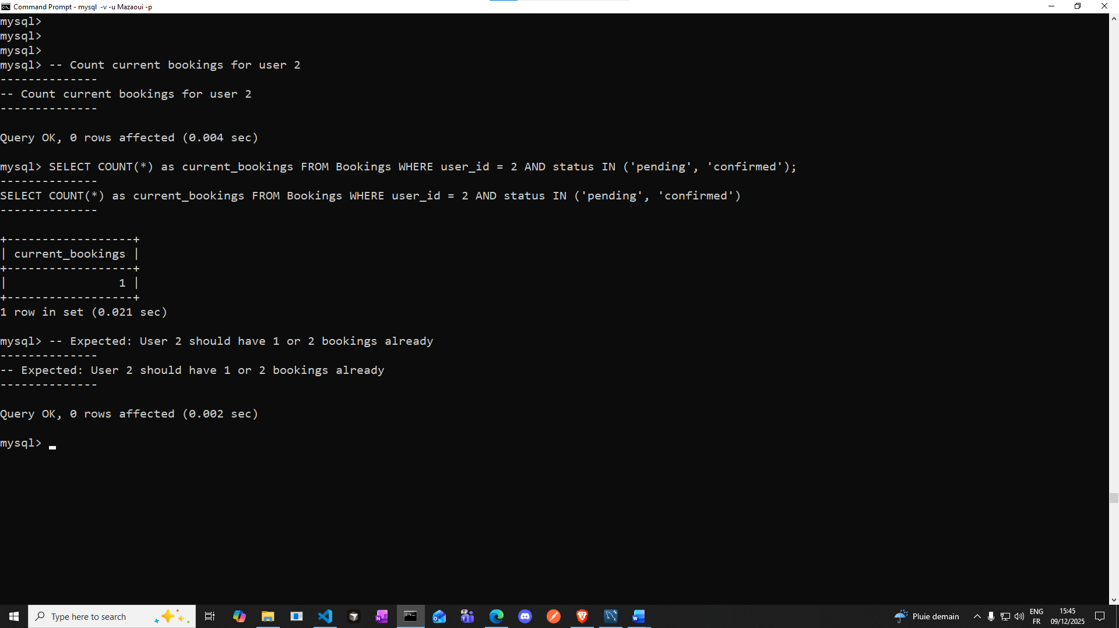

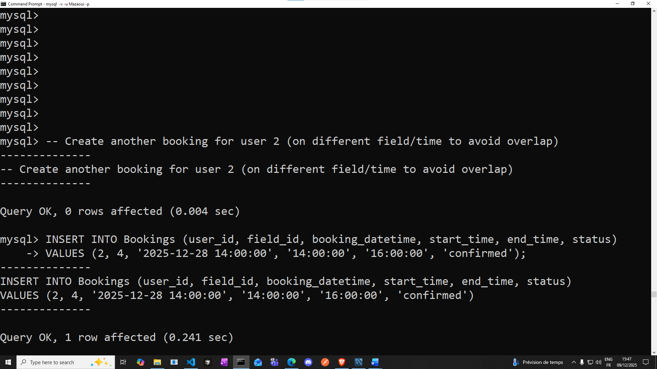

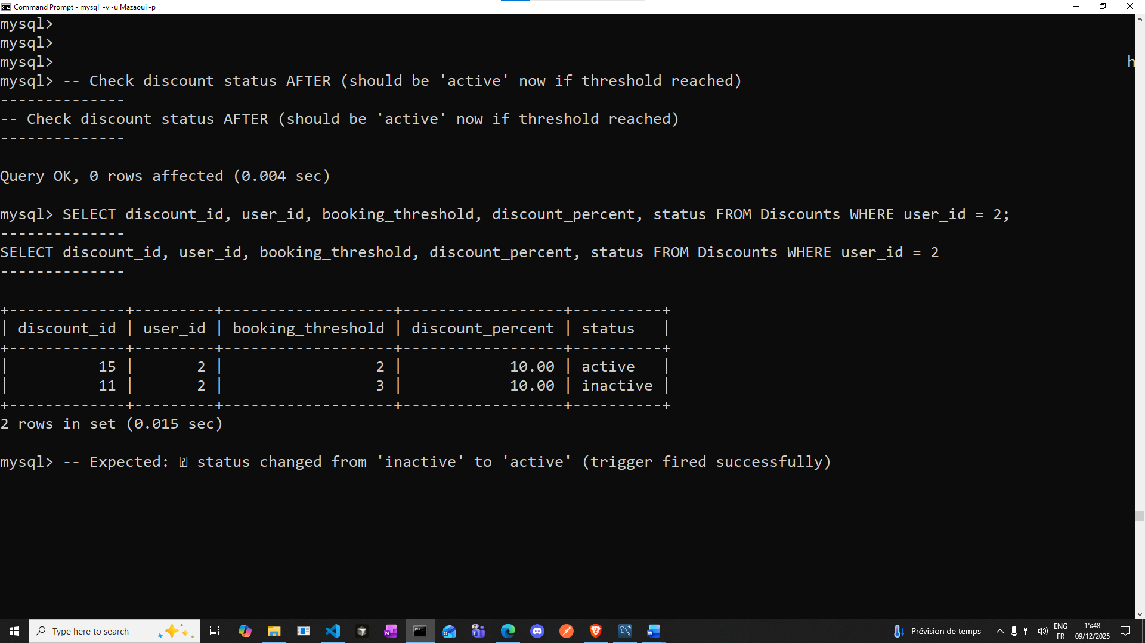

**Views & CTEs & Procedures test:**

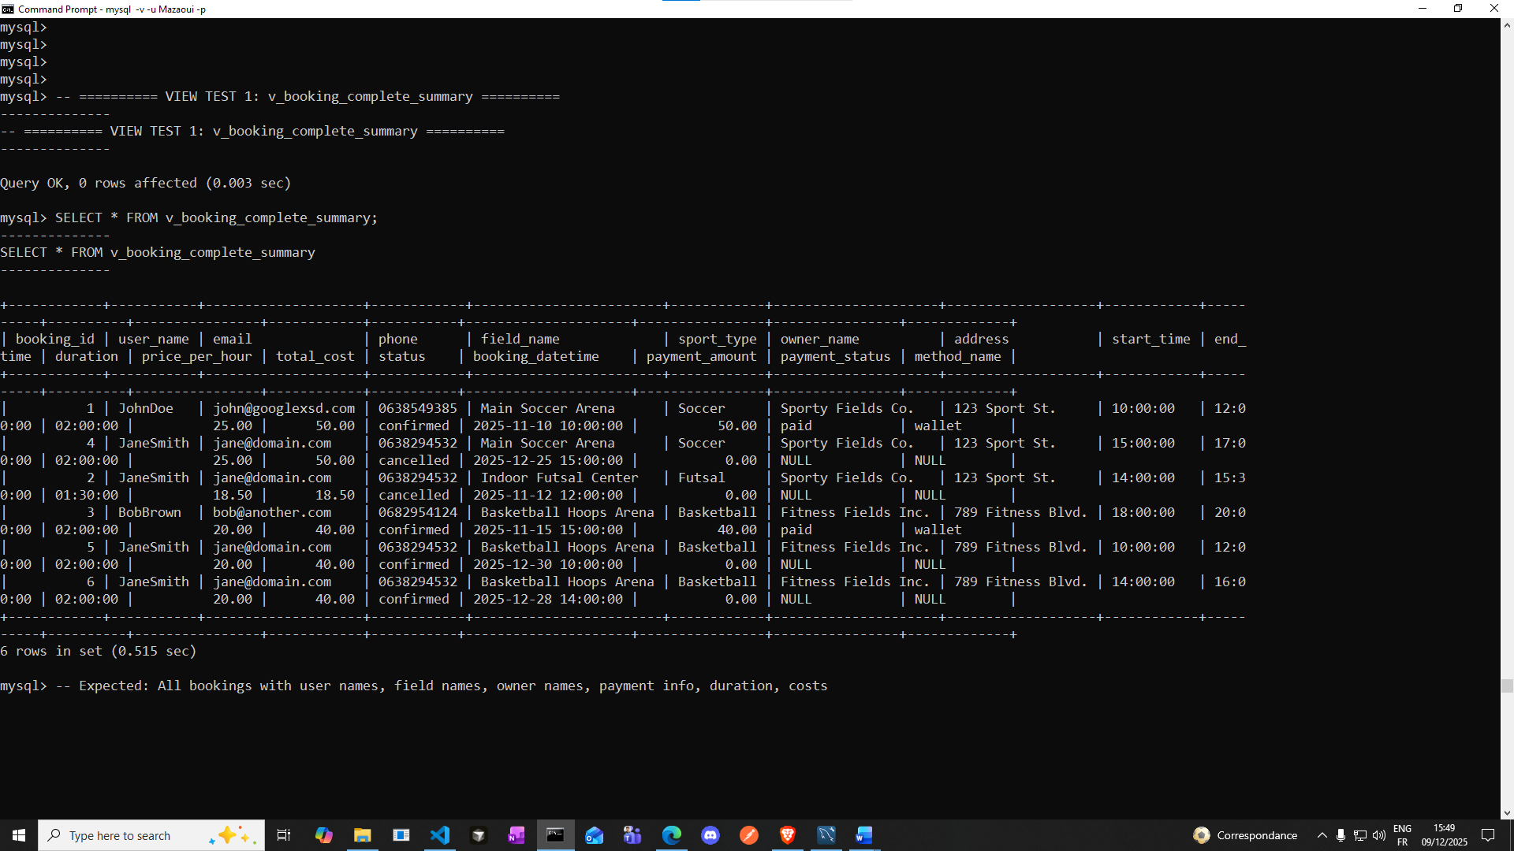

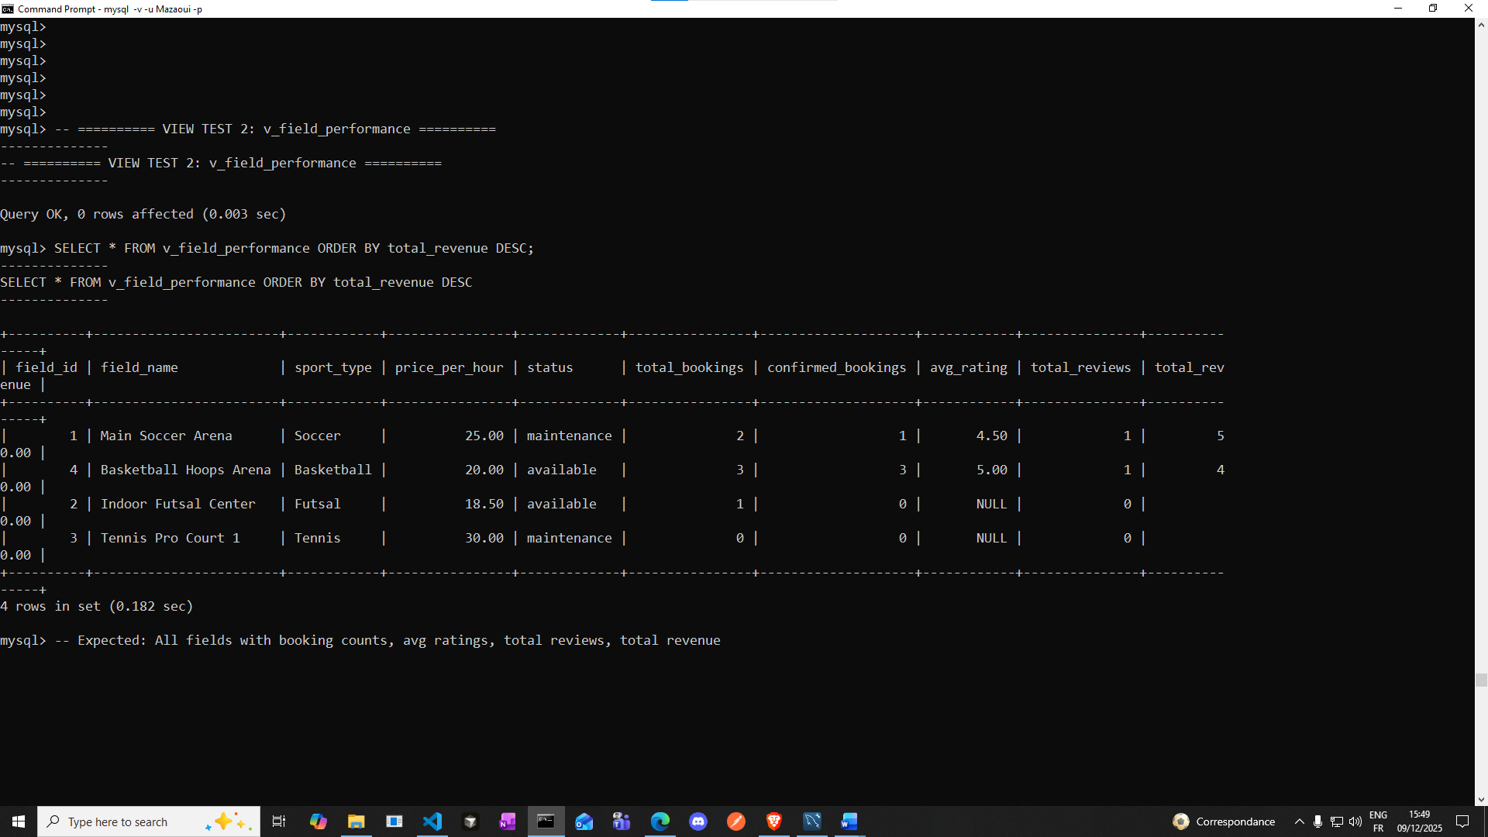

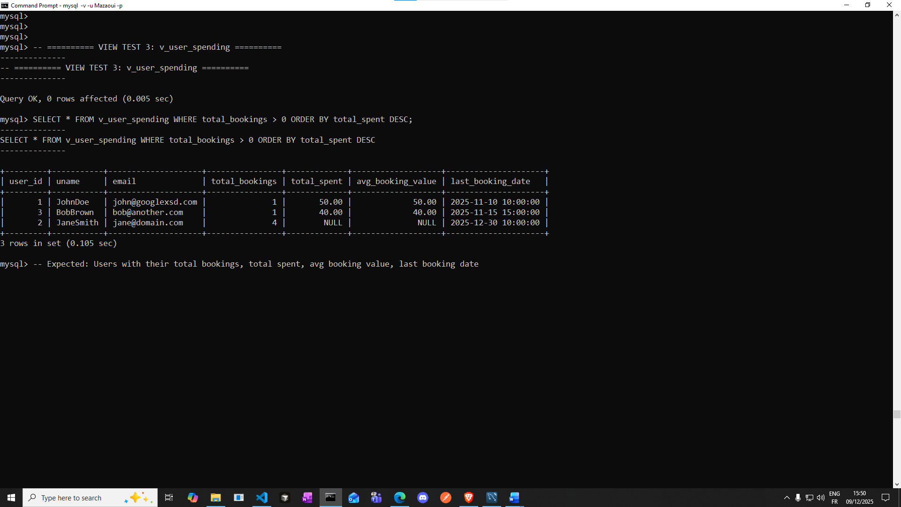

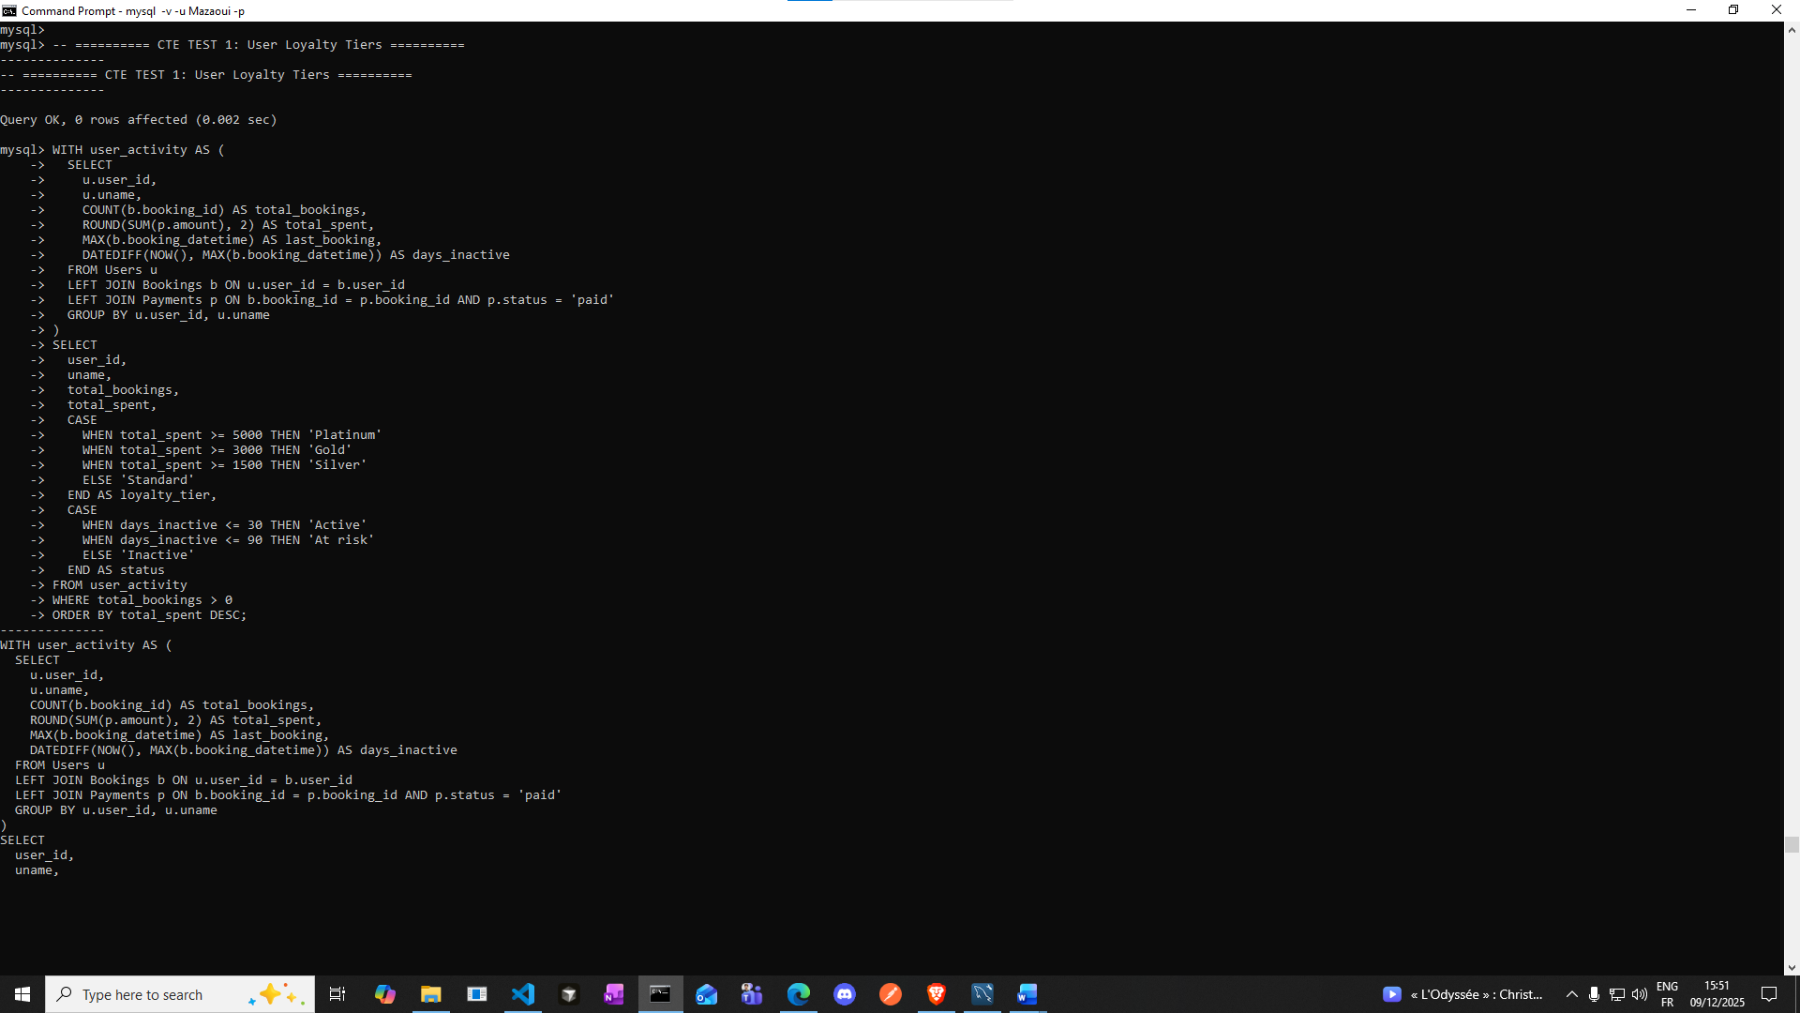

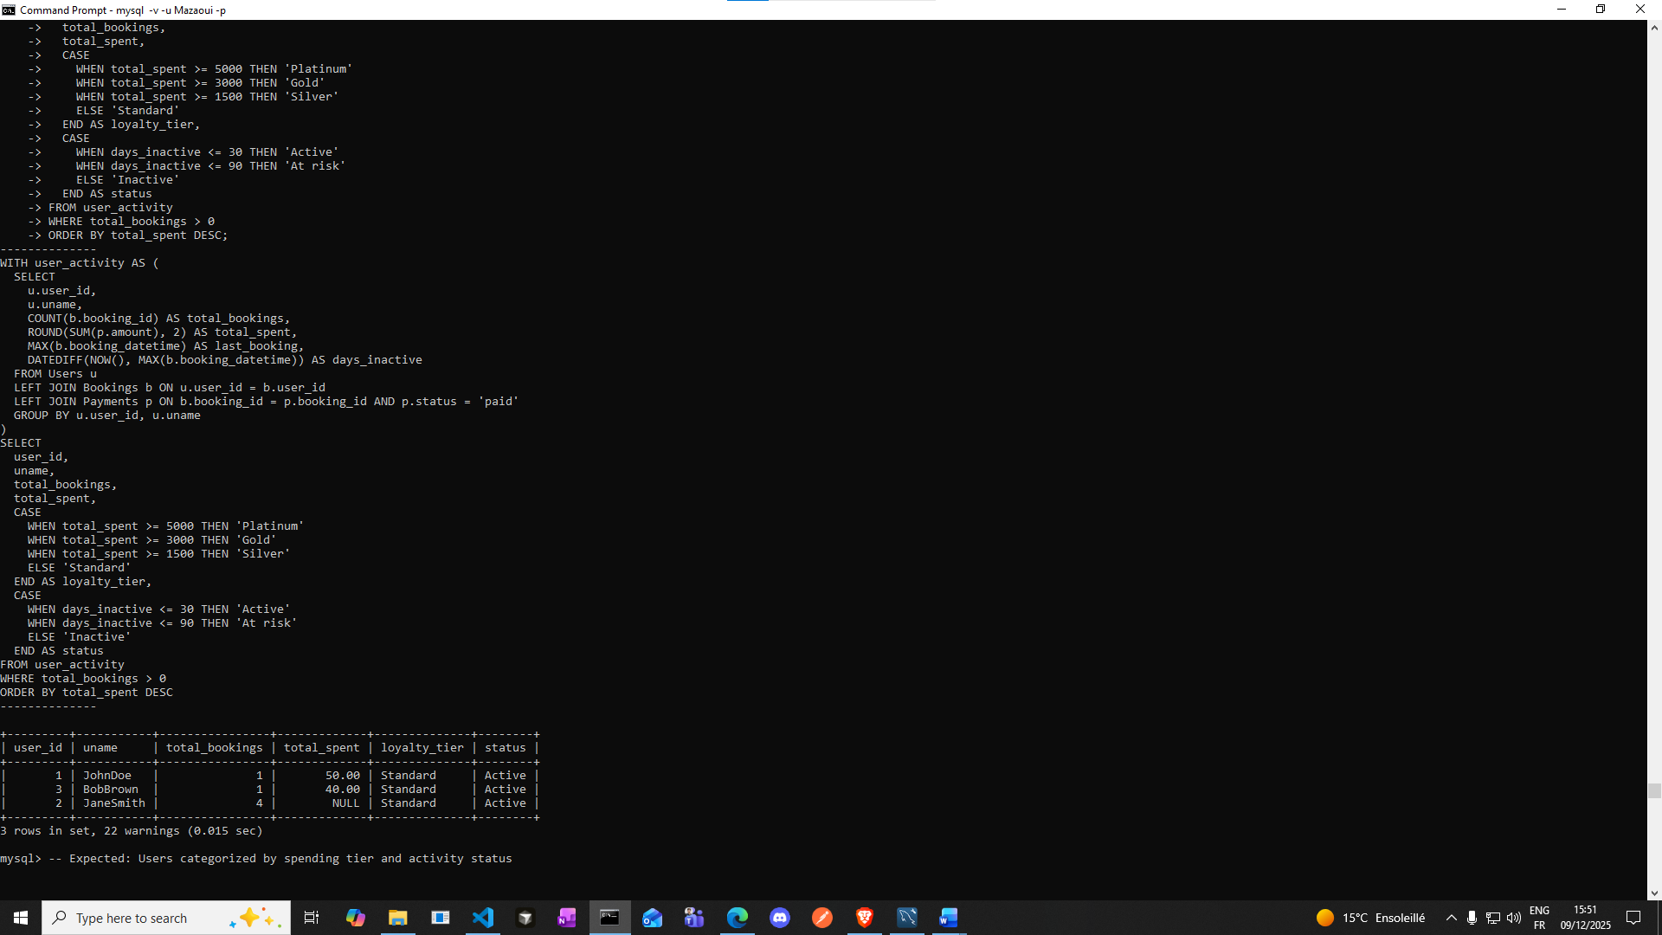

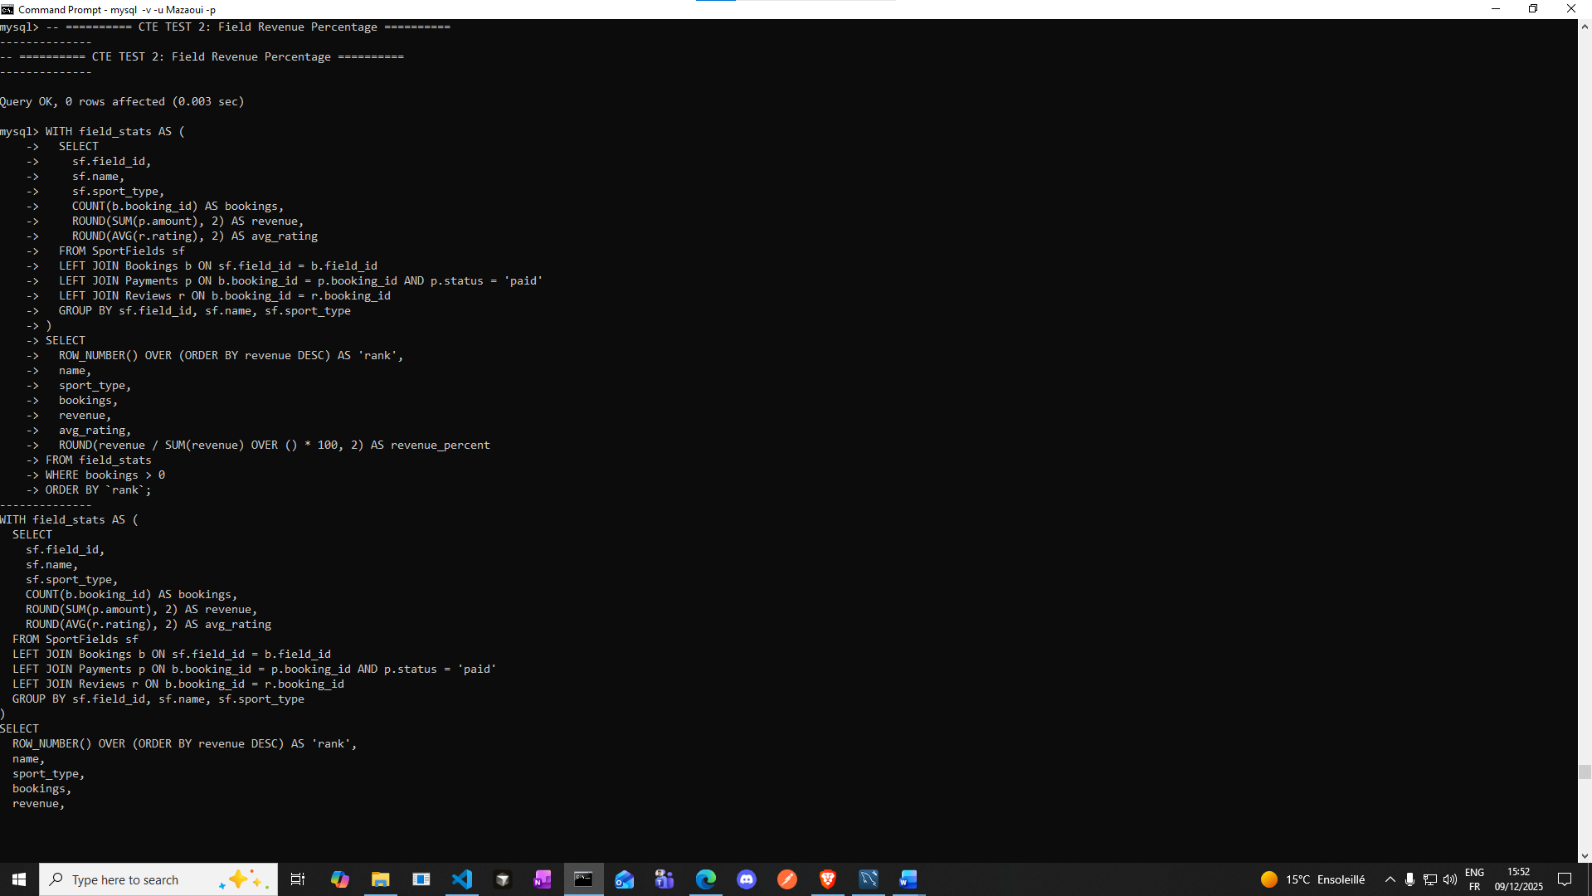

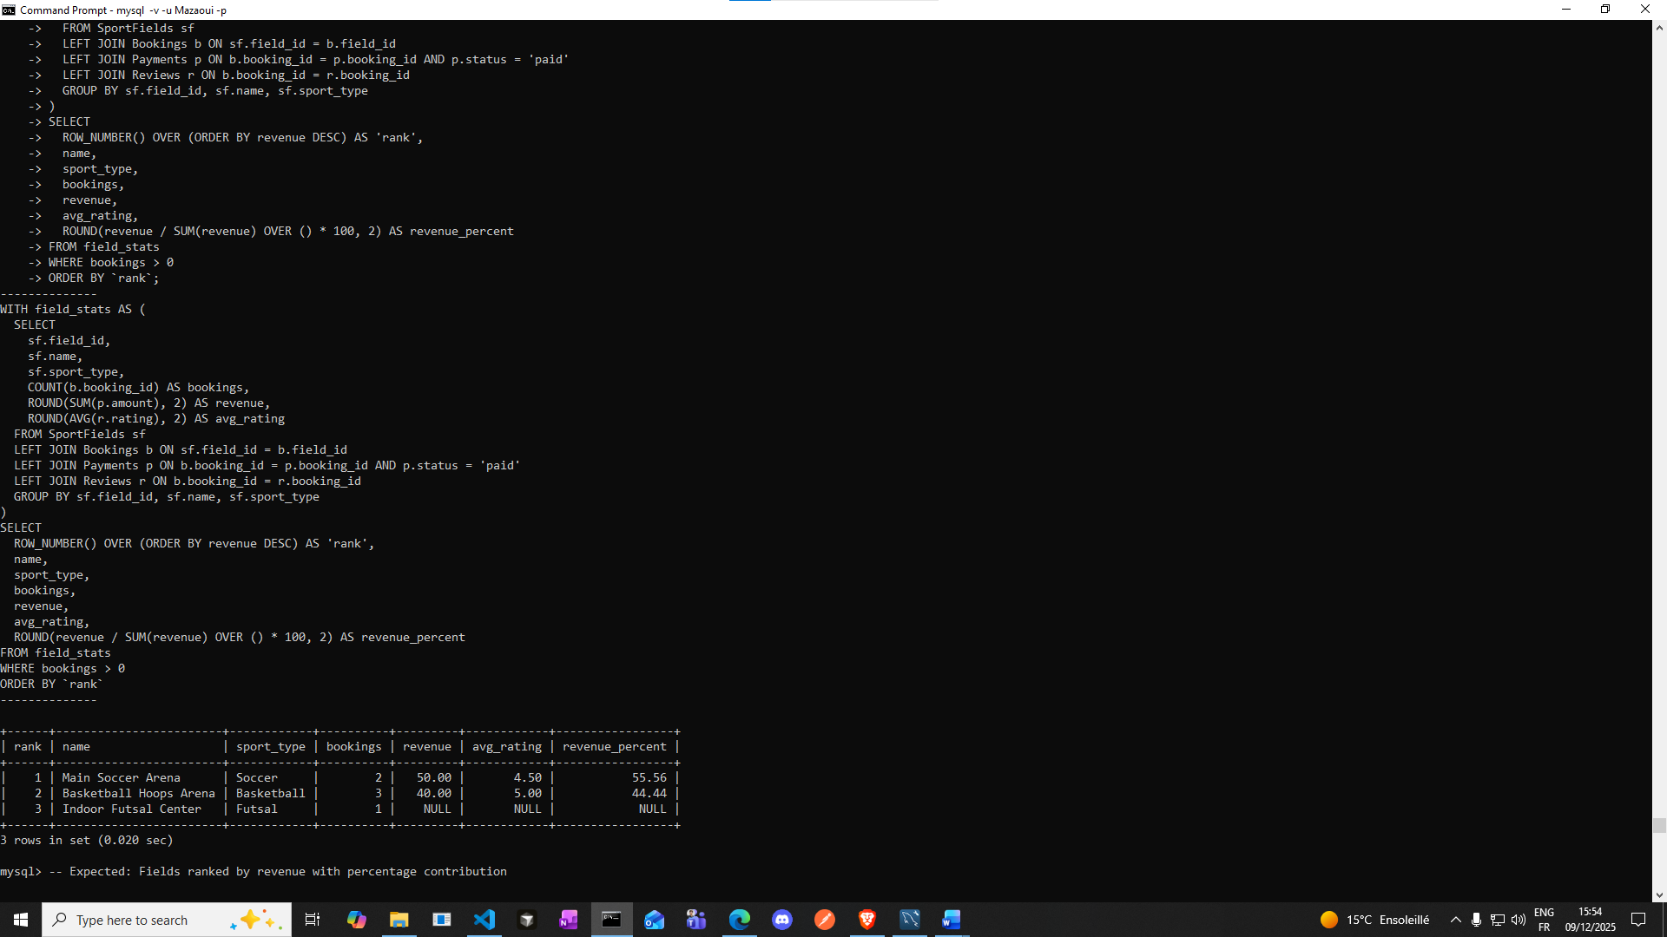

**CORRELATED QUERY**

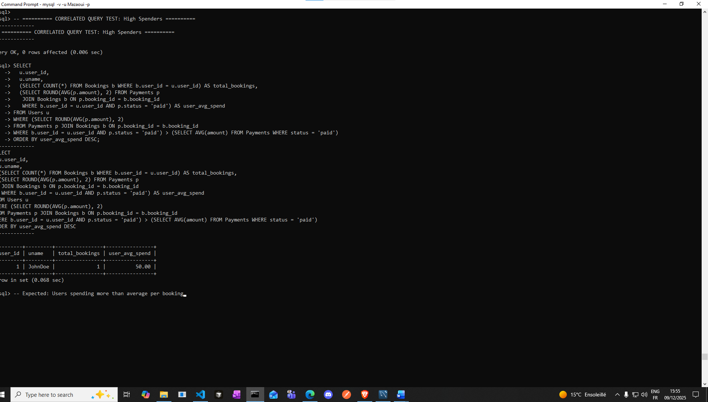

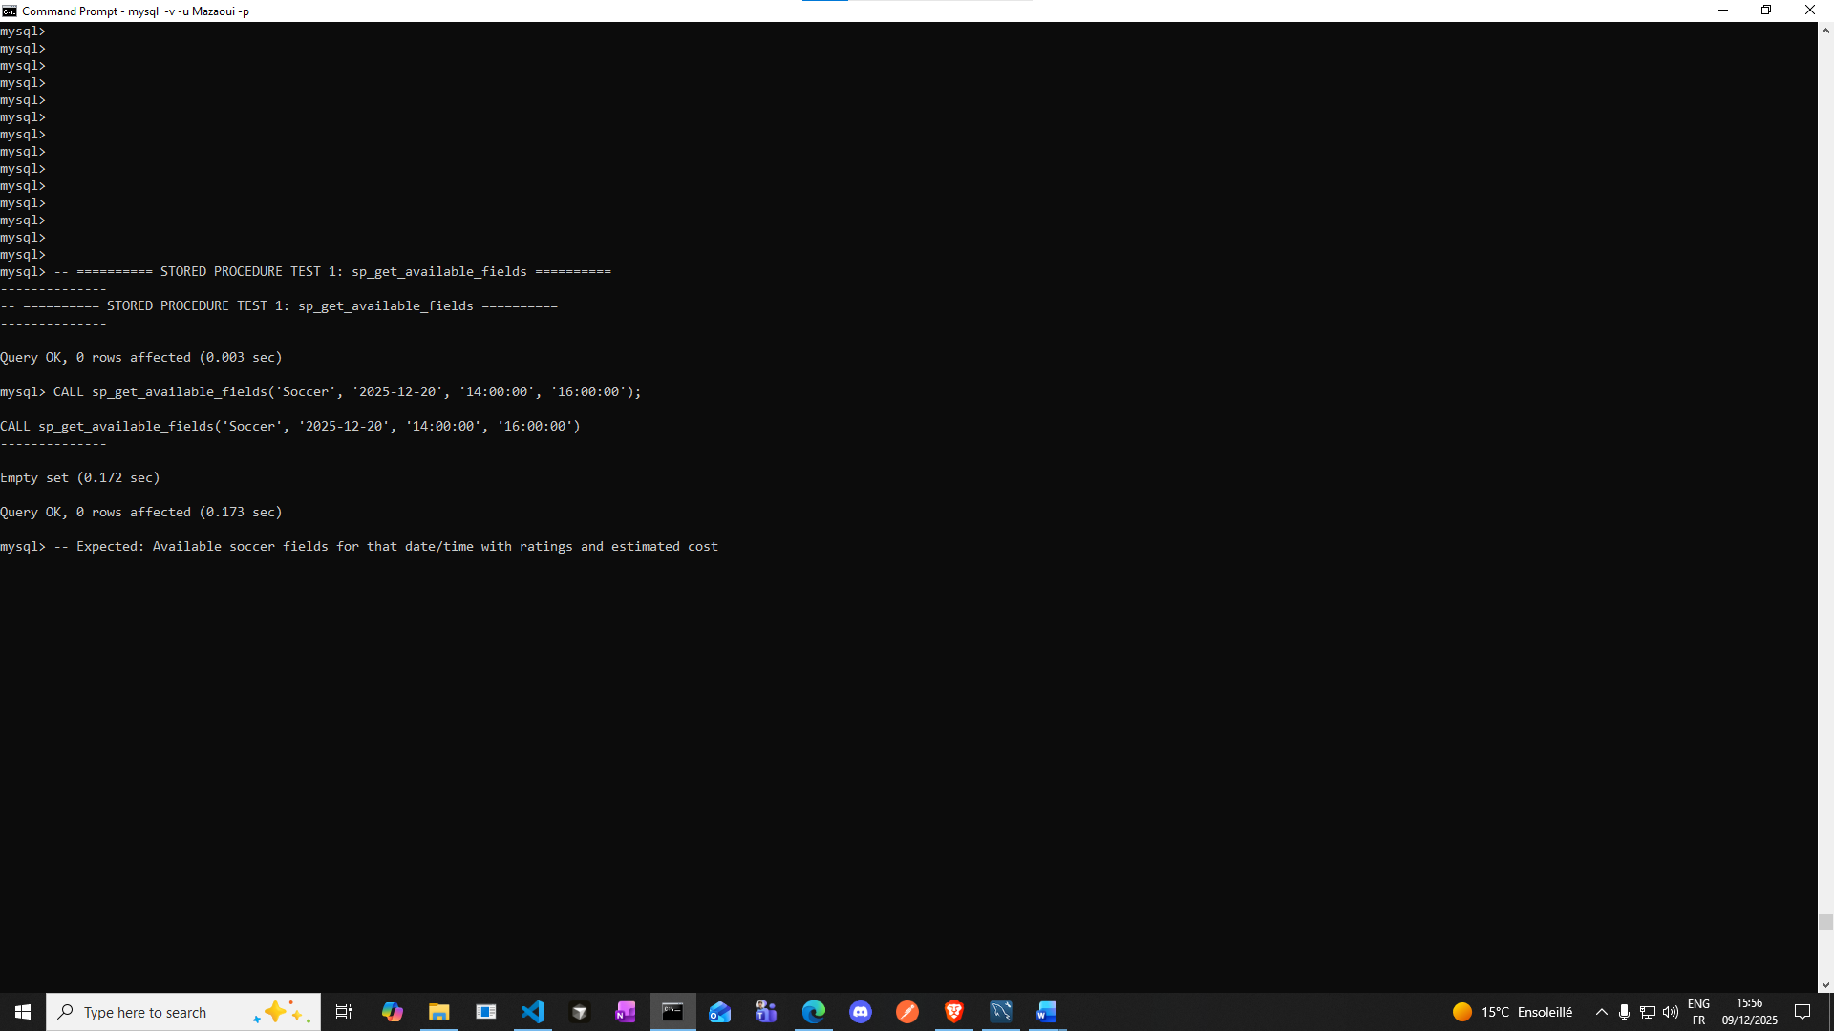

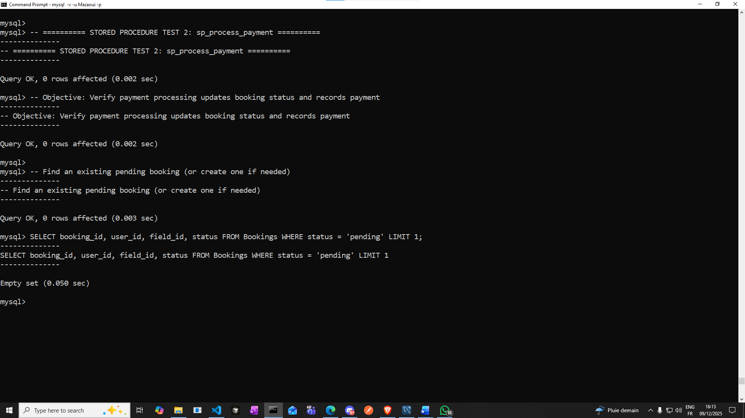

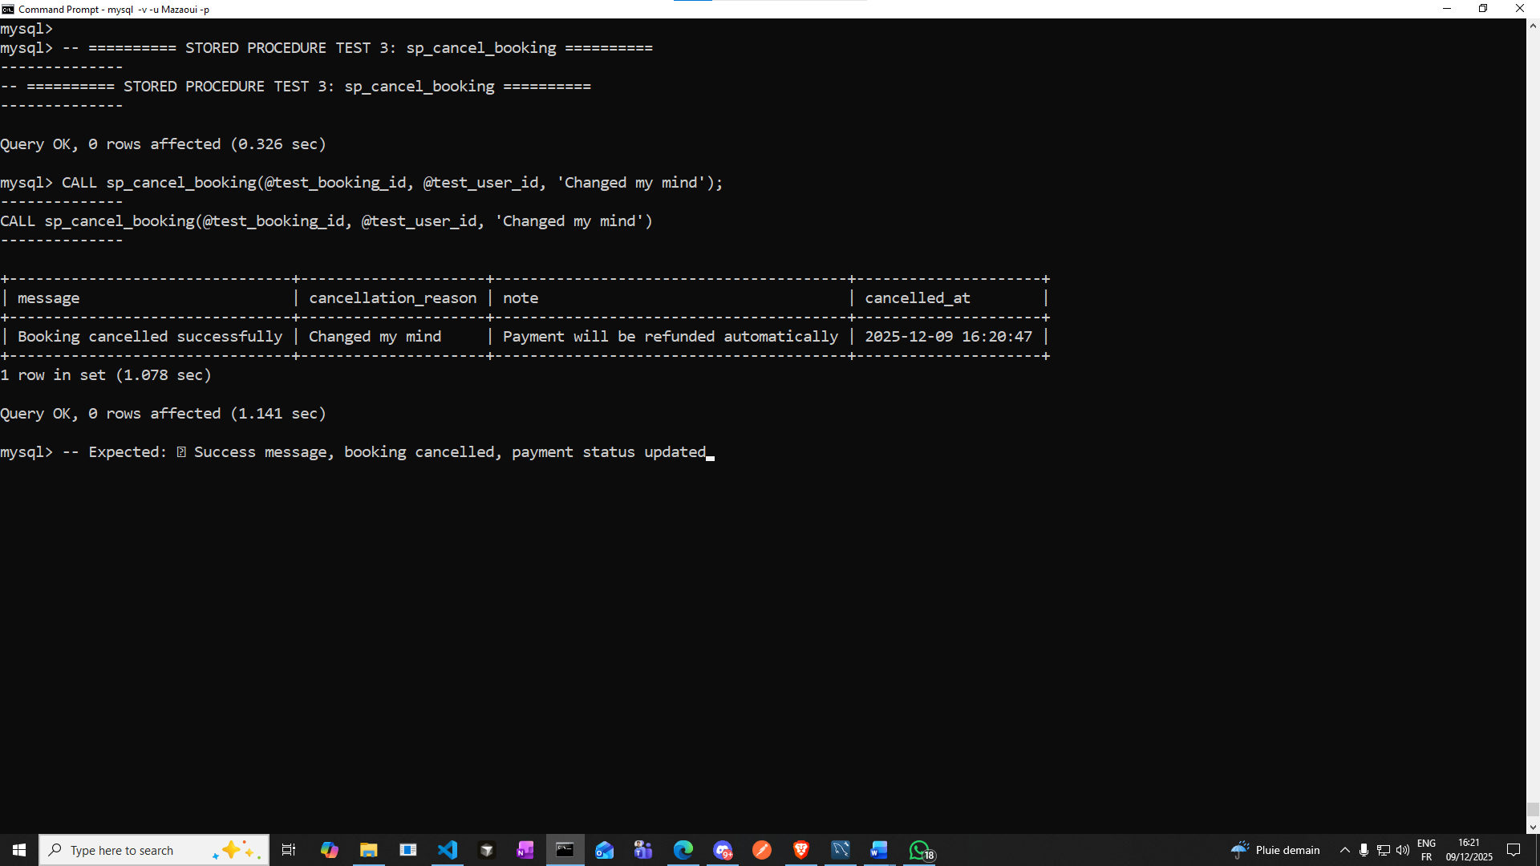

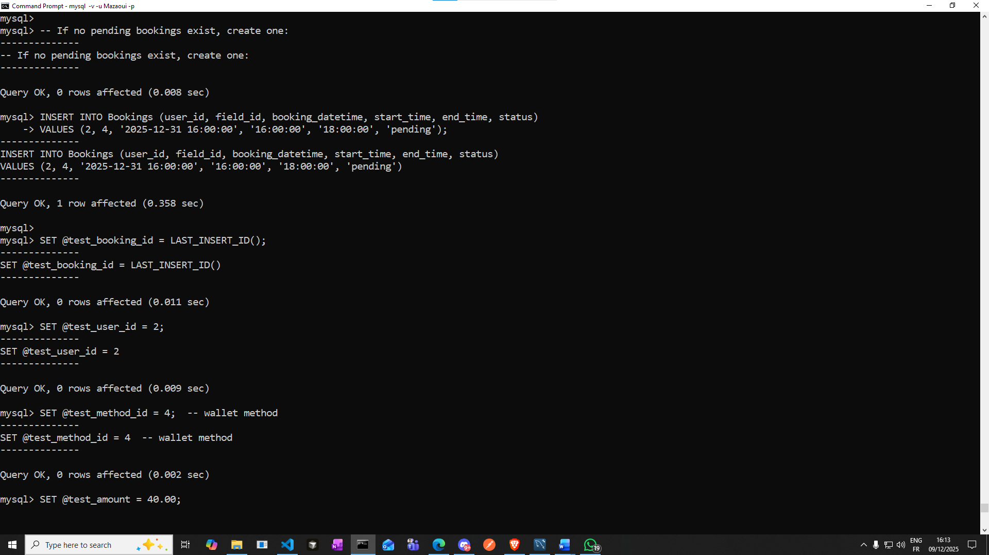

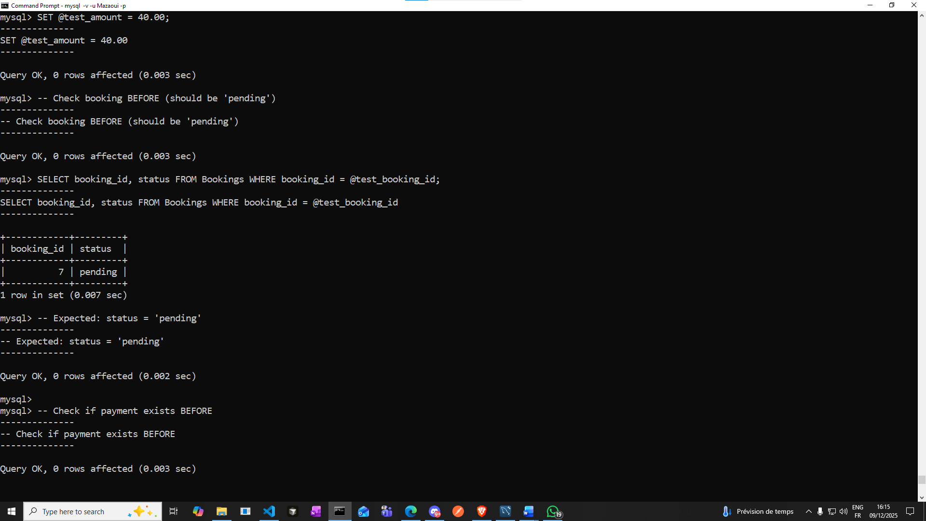

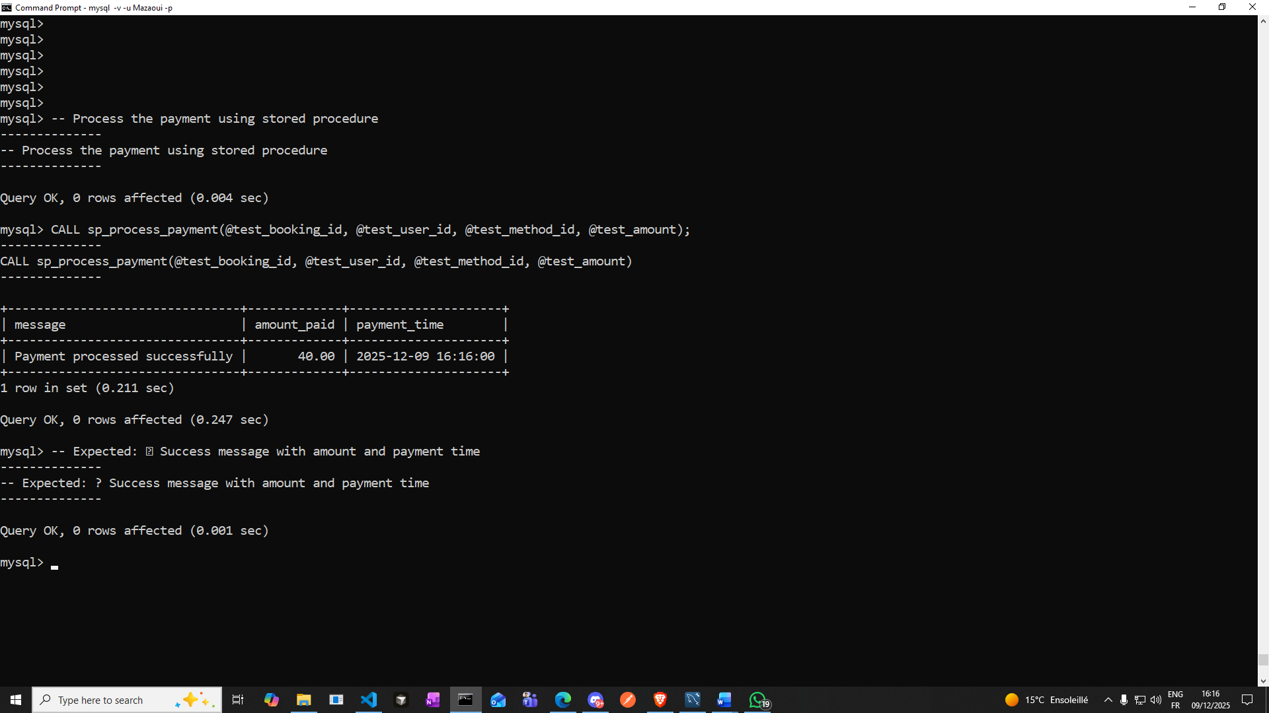

**s**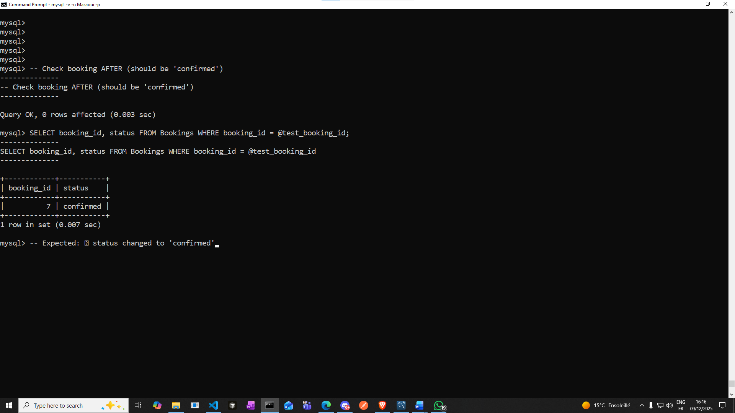

**✅ status changed to 'confirmed'**

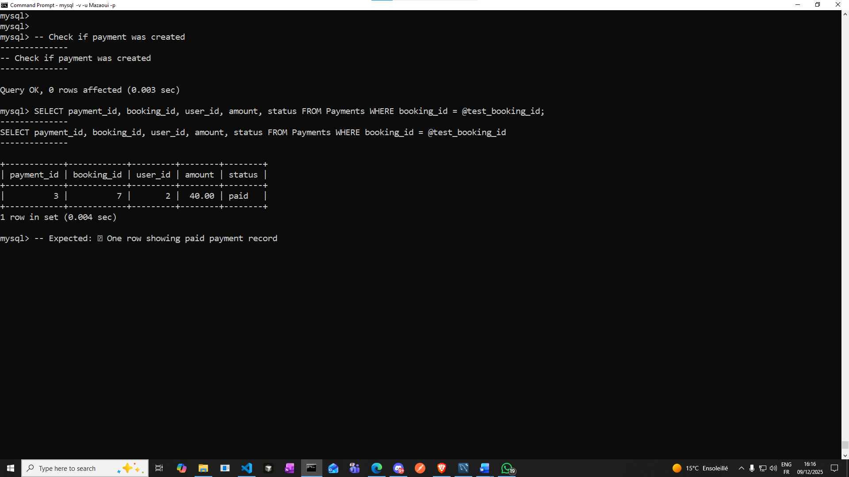

**✅ One row showing paid payment record**

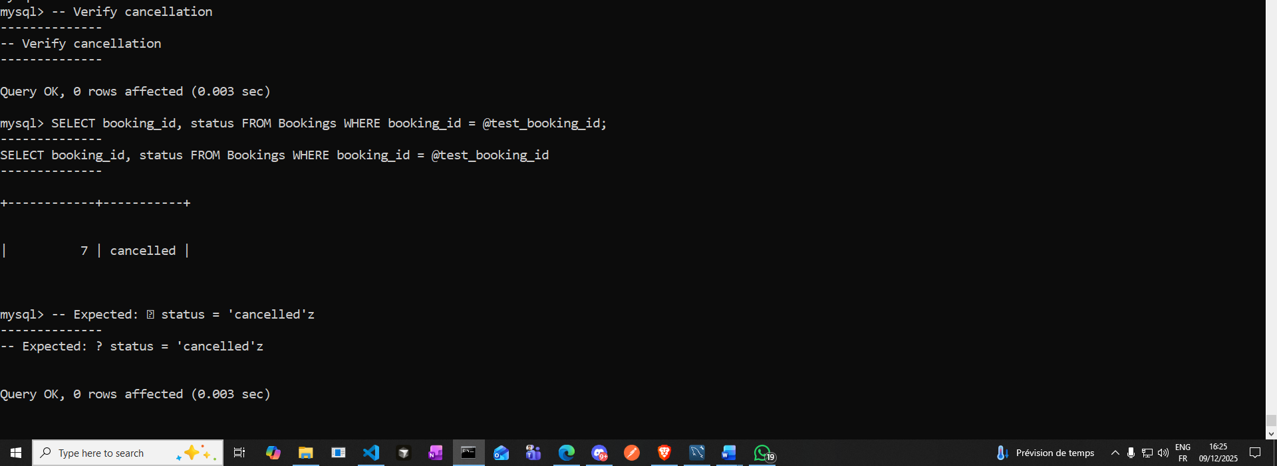

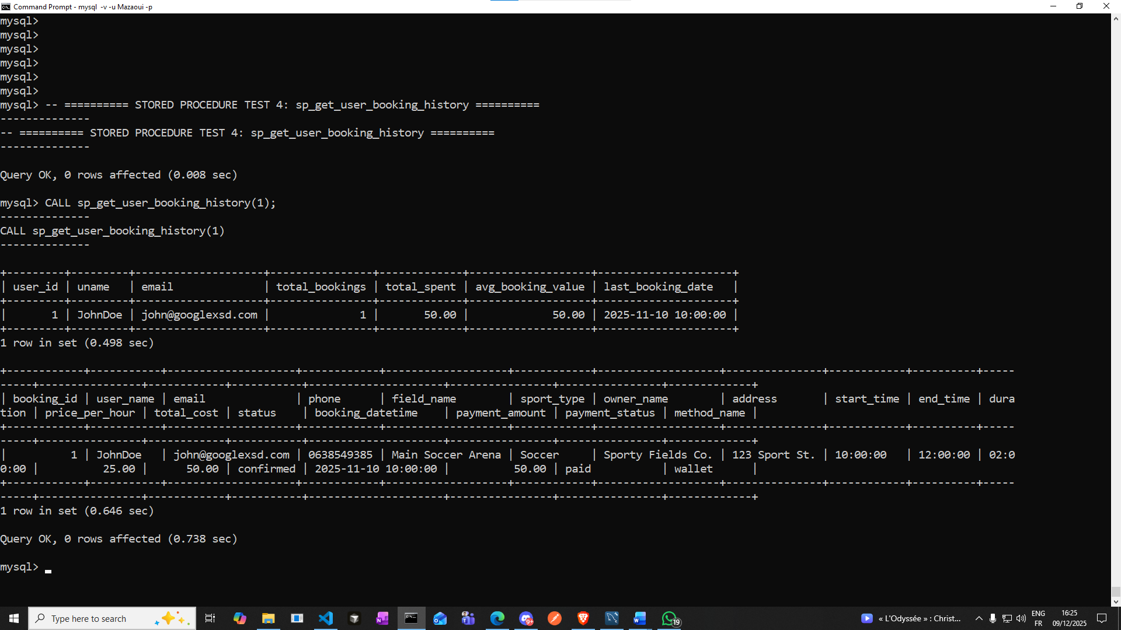

**sExpected: ✅ Two result sets:**

**1. Spending summary (total bookings, total spent, avg booking value, last booking date)**

**2. Detailed booking list with field names, payment info, owner names**

**Review Queries test**

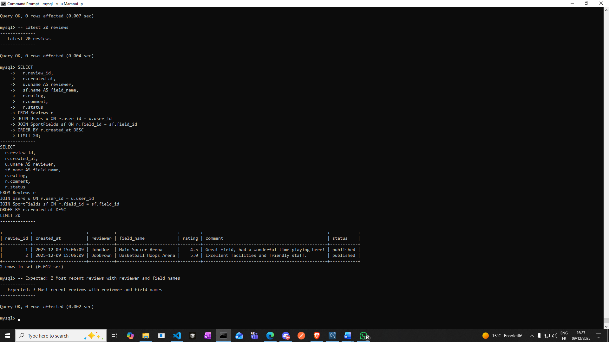

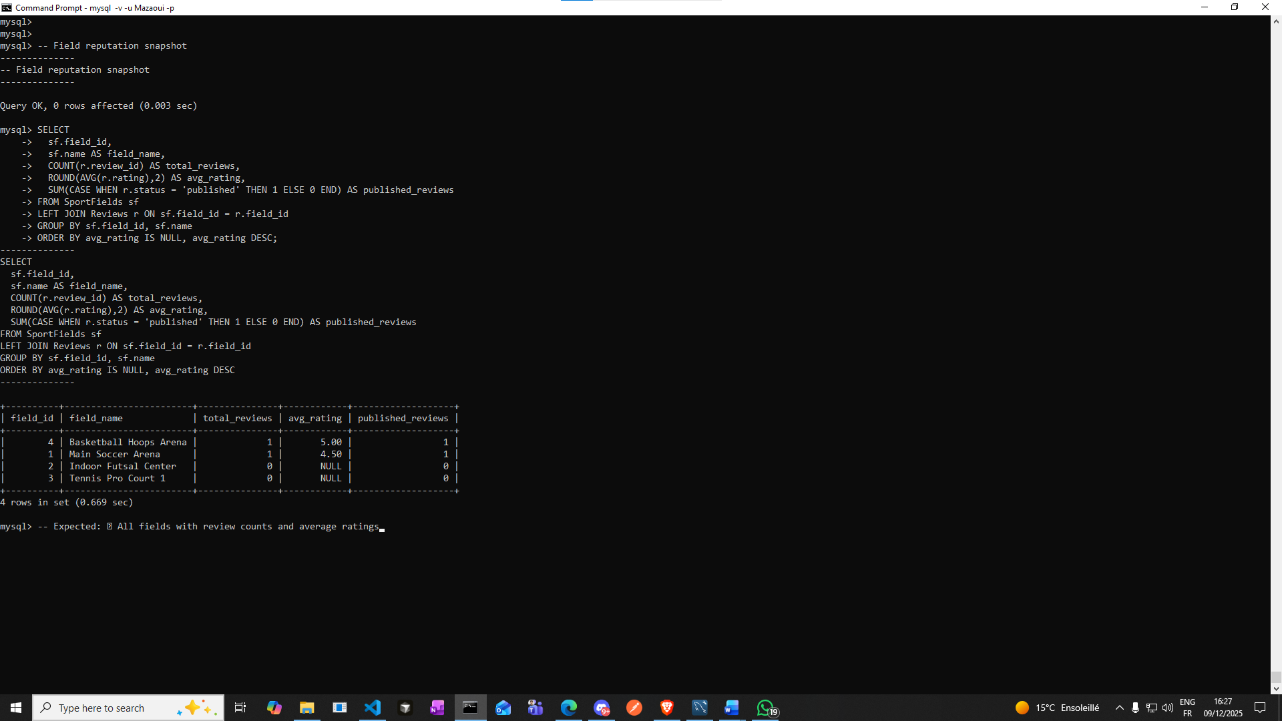

## **Conclusion**

**The SportSpot system is complete and functional, featuring complex SQL logic, full normalization, automation, and advanced analytics. It closely simulates a real-world field booking platform.**